IGNITE BI-WEEKLY NEWSLETTER
March 14, 2018

Important Work Reminders

With a little more than a month left of the Ignite program, please keep in mind these important work reminders:
- 2017 T4’s are available via the myUWinfo portal
- The University will be closed on Friday, March 30 for Good Friday and will re-open on Monday, April 2
- The absolute last day for you to work is April 22
- You are now able to add your Ignite experience to your Co-Curricular Transcript on mySuccess! Only students who have submitted their Initial, Midpoint, and Final Check-In forms will be approved.

Completion of Check-Ins

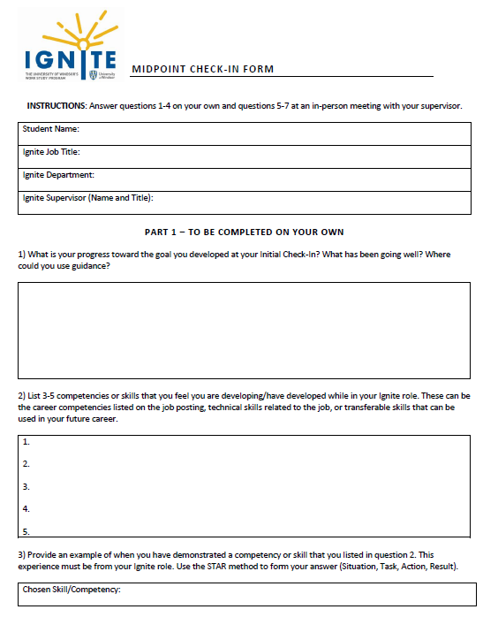
If you haven’t already done so, please complete your Midpoint Check-In with your supervisor and upload it as soon as possible. All forms and instructions can be found on mySuccess under “Work Study”.

Your Final Check-In should be completed within the last 2 weeks of your employment. The Final Check-In has 2 steps: a performance evaluation that will be completed by your supervisor, and a final reflection that will be completed online by you. Upload a signed copy of your performance evaluation on mySuccess after you have your in-person meeting with your supervisor. Your final reflection will be completed after your meeting and is done completely online on mySuccess.

Wrapping Up Your Ignite Experience
As your Ignite experience comes to a close, it’s important to end it on a positive note and think about how your Ignite job can assist you in the next steps of your career. As your final week of work approaches, make sure to do the following:

Thank your supervisor and colleagues: be sure to thank anyone who helped you succeed on the job, including your supervisor. Everyone likes being appreciated, so be sure to talk about how they have been valuable to you in the workplace.

Share your future career plans with your supervisor: if you haven’t already, take some time to meet with your supervisor and discuss your future career goals. This will allow you to establish and maintain important connections that may be helpful in your job search after graduation. Who knows – your supervisor may know someone who’s hiring full time!

Update your resume and LinkedIn profile: updating your resume and LinkedIn will help you fully describe your Ignite experience and what you learned. In addition, connecting with other coworkers on LinkedIn is a great way to begin the networking process. If you need assistance adding your Ignite role to your resume or LinkedIn, our career Peer Advisors are available from 10am to 4pm Monday to Friday in the Joyce Entrepreneurship Centre, Suite 100 to help you get started.

Reflect on the skills you’ve gained: reflecting on your role while it’s fresh in your mind will provide you with a more detailed, accurate assessment of what skills you have to offer potential employers, and can help you determine what you liked or didn’t like about your Ignite role. Think critically about the skills you developed, and try to remember key accomplishments or projects you worked on. This will help you relate your Ignite experience to your career goals and to each job you apply to later on.

Keep in contact: you have gained valuable connections throughout your Ignite experience, so keep these connections alive by staying in touch with your supervisor and old coworkers. Sending a monthly email or going out for coffee can go a long way, and shows that you are a professional student who can network effectively.

Above all, never underestimate the power of networking in the job search process. Your Ignite role has helped you gain relevant experience to put on your resume and develop and maintain personal connections, so capitalize on your experience and enjoy the last month!

Want to Win a $500 Best Buy Gift Card?

Please share your thoughts with Brainstorm for a chance to win a $500 Best Buy Gift Card!

Brainstorm is participating in a national research study of students' career and employer interests. The resulting report will help employers better understand how to attract and hire students and help them learn how to better serve you with career planning support.

All respondents to the survey are eligible to win for the draw.

The link to the survey is www.brainstormresearch.ca/survey

Co-op Week: March 19-24

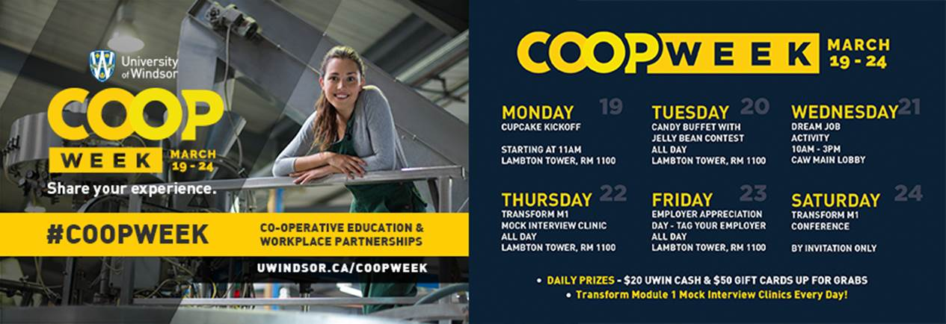

Attention current and previous co-op/internship students! Co-operative Education & Workplace Partnerships will be celebrating National Co-op Week next Monday, March 19 to Friday, March 24. Stay tuned to their social media accounts @CCES_UWindsor for updates on exciting events planned during the week that will include in-person and on-line contests, tons of cool prizes as well free food. Follow along the national contest using the hashtags #Coopweek, #HireCoop and #WILWeek across Twitter, Facebook, LinkedIn, and Instagram for daily chances to win UWindsor swag as well as daily prizes to win $50 Gift cards for companies such as, Lululemon, Starbucks, Amazon and more!

