IGNITE STUDENT NEWSLETTER
April 6, 2018

Important Work Reminders

The 2017 – 2018 Ignite program is coming to an end! The absolute last day to work for all Ignite students is April 22. You should receive your final work study pay on Friday, April 27.

Ignite students, welcome to your last newsletter of the year!

I hope you enjoyed your Ignite experience and wish you the best of luck in all your future endeavours

Ignite applications for the Fall 2018 – Winter 2019 semester will be available in August. Further information will be made available on Ignite’s website in the summer.

Don’t let Ignite be the end of your career development! If you are graduating, looking for a job, or unsure of what you want to do after your degree, Career Development & Experiential Learning offers a variety of services to assist you with your employment goals. We can help with resume and cover letter writing, interview preparation, job search strategies, career planning, and much more!

Completing Your Final Check-In

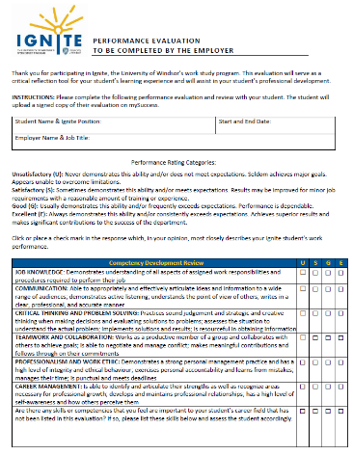
If you haven’t already done so, please make sure to complete your final check-in with your supervisor before or on your last day of work. There are 2 steps to the final check-in:
STEP 1: Have your employer complete your Performance Evaluation on their own and review it with you at an in-person meeting.
STEP 2: Upload your Performance Evaluation to mySuccess and complete the Final Reflection online after your meeting.
I have attached instructions for uploading your final check-in to this email; please read through them carefully.

Ignite Year End Feedback Survey

As a participant of the Ignite program, your feedback is important! I have developed a short survey for all participants to complete, and would greatly appreciate it if you could please take a few minutes to answer the survey as honestly as possible. It will take less than 10 minutes to fill out.

I am constantly looking for ways to improve the program, and your feedback is critical in assisting me with identifying the program’s strengths and areas for improvement. I do take your feedback seriously, and your ideas and suggestions could help shape future Ignite programming.

If you are interested, click here to access the survey. Thanks in advance to all those who complete it!

Ignite Student & Supervisor of the Year Award
Did you have an AWESOME supervisor that you would like to recognize? If so, consider nominating them for Ignite’s Supervisor of the Year Award! This award will recognize an outstanding Ignite supervisor who went above and beyond to provide a meaningful work experience for UWindsor students. Supervisors will also have a chance to nominate their student for the Ignite Student of the Year Award! All award recipients will receive an honorary plaque and will be invited to a recognition event held in May.

An online nomination form will be sent out early next week. I hope to receive some great nominations!

Adding Your Ignite Position to Your CCR
You are now able to add your Ignite experience to your Co-Curricular Record on mySuccess! The CCR is a great way to document your involvement outside of the classroom, and showcase the skills you have developed to future employers. Only students who have submitted their Initial, Midpoint, and Final Check-In forms will be approved.

