|  |  |
| --- | --- |
|  | **IGNITE BIWEEKLY EMPLOYER NEWSLETTER**  **October 18, 2017** |

In this issue, you will find:

Information about Ignite’s Employer Professional Development Workshop

Instructions for Hiring a Student (on the student and employer end)

I’ve Already Hired a Student … Now What?

Passport to Professionalism: 
A Great Skill-Building Resource for You & Your Student

Ignite employers, welcome to your first official biweekly newsletter! Starting now until the end of April, I will be sending you an email every other week that contains important information about the Ignite program.

**Register for Ignite’s Employer Professional Development Workshop Today!**

I’m very happy to announce that I will be holding Ignite’s first employer professional development workshop in November! The workshop will discuss techniques for working with students and providing meaningful feedback. We will also review the newly developed Employer Toolkit and have a short Q&A session.

2 offerings of the workshop will be held on:

* Friday, November 3 from 10:00am to 11:00am
* Friday, November 17 from 2:00pm to 3:00pm
* Both sessions will take place in the Odette School of Business, Room 110

I would greatly appreciate the opportunity to meet you and discuss your experience with the new program thus far. The deadline to register for a session is next Thursday, October 26. You can [register online](https://uwindsor.ca1.qualtrics.com/jfe/form/SV_73Dx8Nysv2OX8DX). Hope to see you there!

**How Do I Hire an Ignite Student?**

Thank you to all employers to have already hired an Ignite student. To those still conducting your hiring search, don’t worry! There are still plenty of students who are looking for employment and are eager to start working. To officially hire a student as part of the Ignite program, there are steps that need to be taken by both you and the student.

To hire an Ignite student, please do the following:

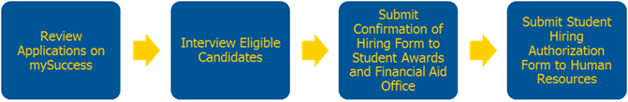

**1) REVIEW YOUR APPLICATIONS ON MYSUCCESS:** Students will apply to your job online via mySuccess. They have been instructed to NOT reach out to employers. Once in the system, you can choose to look at your applications one by one, or as a package (see below).

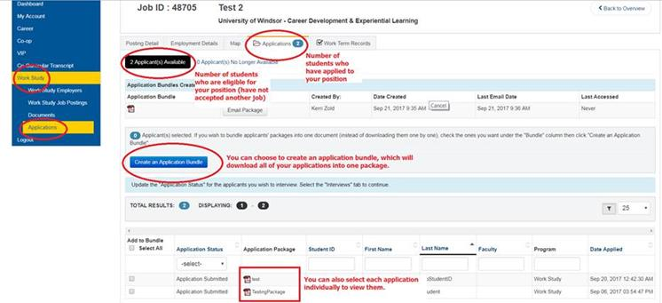

Students who did not apply to work study before the September 15th deadline cannot be considered for your position. Only approved work study students who attended a Launch session in September are eligible for Ignite jobs.

**2) INTERVIEW ELIGIBLE APPLICANTS:** Once you have decided what student(s) you would like to interview, you can view a pre-recorded interview online through their Interview Stream link (included in their application), or interview them in-person. If you’d like to interview the student in person, contact them directly via their UWindsor email address or the phone number on their resume. **Make sure to ask for a copy of their Work Study Approval Email sent to them by the Student Awards & Financial Aid office, which will confirm their approval for the Work Study Program, the number of hours allocated, and the final date for working. Some students may only be approved for the Fall or Winter term.**

**3) SUBMIT A CONFIRMATION OF HIRING FORM TO THE AWARDS OFFICE:** Once you have made your hiring decision, submit a [Confirmation of Hiring form](http://www.uwindsor.ca/cces/sites/uwindsor.ca.cces/files/2017-2018_work_study_confirmation_of_hiring_form_v2.docx) to the Awards Office thro0ugh email ([award1@uwindsor.ca](mailto:award1@uwindsor.ca)) or fax (519-973-7087). You must submit a Confirmation of Hiring form for each student that you hire. Please do NOT mail the form as it is a time-sensitive document. Both you and the student need to sign the form in order for it to be approved by the Awards Office. Once the Awards Office notifies me that they have received your form, I will follow up with you to confirm the employment of the student and how many hours they have been allocated. This can take up to 3 business days.

**4) SUBMIT A STUDENT HIRING AUTHORIZATION FORM TO HUMAN RESOURCES:** Once you have submitted a Confirmation of Hiring form to the Awards Office, your next step will be to submit a [Student Hiring Authorization form](http://www1.uwindsor.ca/hr/system/files/Student.Hiring.Authorization_0.docx) to the [Department of Human Resources (HR)](http://www1.uwindsor.ca/hr/contact-information-0). Students may only work 1 Ignite position and are not permitted to transfer to another Ignite employer once they have been hired.

**The deadline to hire a student is Wednesday, November 15.**

**What Does My Student Need to Do?**

**COMPLETE THE STUDENT HIRING PACKAGE & SUBMIT TO HR:** Ignite students **who have not worked at the University of Windsor before or in the past year** need to submit a completed [Student Hiring Package](http://www1.uwindsor.ca/hr/employment-services-student-employees) to the [Department of Human Resources (HR)](http://www1.uwindsor.ca/hr/contact-information-0) in order to be issued an employee number. All students were provided with a copy of the Hiring Package and instructed to fill it out at the Launch session they attended in September.

All required documents must be submitted to Human Resources in order to be paid. You can refer students to the [Employment Services – Student Employees](http://www1.uwindsor.ca/hr/employment-services-student-employees) website for details. Once HR processes the Student Hiring Package, the student and employer will receive a copy of the student’s UWindsor employee number.

**If the student already has a UWindsor employee number and has worked at the University within the past year**, they are not required to submit the Hiring Package again. Be sure to include their employee number on the Confirmation of Hiring Form and the Student Hiring Authorization Form. If they have forgotten their employee number, they can log on to <https://my.uwindsor.ca> and go to 'Profile' to retrieve it.

**I’ve Already Hired a Student … Now What?**

**HAVE YOUR STUDENT COMPLETE HEALTH & SAFETY TRAINING:** All University of Windsor employees must complete mandatory health & safety training within two weeks of being hired. There are 5 modules in total, and students are to be paid for this training. Students can only do this training after they have been issued an employee number. Once they have their employee number, students can login to [www.uwindsor.ca/requiredtraining](http://www.uwindsor.ca/requiredtraining) to complete their training. Students who have already completed this training are encouraged to login to the website and ensure their training is up-to-date.

**MEET WITH YOUR STUDENT AND HAVE YOUR INITIAL CHECK-IN:** A critical part of experiential learning is reflection. As an experiential learning program, Ignite aims to incorporate this key element of learning through the establishment of an Initial, Mid Point, and Final Check-In. At your first Check-In, you are encouraged to assist your student with establishing a personalized development plan that will help them build and articulate their skills and competencies. The Initial Check-In should be completed within the first two weeks of your student’s employment. **If you have hired a large amount of students, feel free to do the Check-Ins with them as a group.** After your meeting, students will submit 2 documents to mySuccess: a completed Initial Check-In Form, and an Ignite Competency Self-Assessment.

**Passport to Professionalism**



Is your student unsure of how to start developing the competency they’ve chosen for their Initial Check-In? Do you think your student could benefit from learning how to take initiative, communicate face-to-face, or use a telephone? Willamette University’s [Passport to Professionalism](http://willamette.edu/offices/careers/students/passport/index.html) can help! The passport is a module-based learning tool designed to help students learn professional behaviour and work expectations.

There are 10 modules to choose from, and almost all modules relate to the University of Windsor’s Career Competencies in some way. At their Initial Check-In, students are asked to select a competency that they would like to develop. The following learning modules are a great resource to help students develop the competency they’ve chosen:

|  |  |
| --- | --- |
| **UWindsor Career Competency** | **Suggested Passport to Professionalism Modules** |
| Communication | Communicating Face-to-Face (1)  Written Communication (2)  Customer Service (4)  Phones (5)  Teamwork (6) |
| Critical Thinking and Problem Solving | Phones (5)  Ethical Behaviour (7)  Taking Initiative (8)  Teamwork (6) |
| Teamwork and Collaboration | Customer Service (4)  Teamwork (6) |
| Professionalism and Work Ethic | Communicating Face-to-Face (1)  Written Communication (2)  Professional Etiquette (3)  Customer Service (4)  Phones (5)  Teamwork (6)  Ethical Behaviour (7)  Taking Initiative (8)  Professional Culture (9)  Career Reflections (10) |
| Career Management | Career Reflections (10) |

Once you and your student select the learning module(s) they wish to go through, students complete them on their own schedule. At the end of each module there is a worksheet that they fill out for you and your student to go over together.

Passport to Professionalism is a great resource to help you work through your Check-Ins and help students further develop the skills needed to succeed on the job!