|  |  |
| --- | --- |
| cid:image010.jpg@01D35C8E.C542B0F0 | **IGNITE BI-WEEKLY NEWSLETTER**  **November 13, 2017** |

**Student Hiring Deadline is this Wednesday, November 15**

This is a reminder that the deadline to get a job is this Wednesday, November 15. Once you have been hired, you will need an employee number. If you have not worked at the University of Windsor before, you can obtain an employee number by filling out and submitting paperwork to the Department of Human Resources. Refer to the UWindsor [Student Employee website](http://www1.uwindsor.ca/hr/employment-services-student-employees) for a list of the documents you need to provide to Human Resources.

Students who do not secure employment by November 15 will not have access to jobs after this date.

**Still Waiting on Your Employee Number?**

If you have already submitted a Student Hiring Package to Human Resources, please be patient. Human Resources will contact you when your employee number is ready. I do not process employee numbers, so please do not email to ask what your employee number is. **If you have questions about the status of your employee number, you should contact Human Resources directly.**

Keep in mind that it may take a few weeks to process your employee number, as the Human Resources staff are extremely busy working through other Ignite students’ paperwork. There are over 450 students that they need to process, plus any new additional University of Windsor employees who have been hired outside of work study.

**Midpoint and Final Check-Ins Now Available on mySuccess**

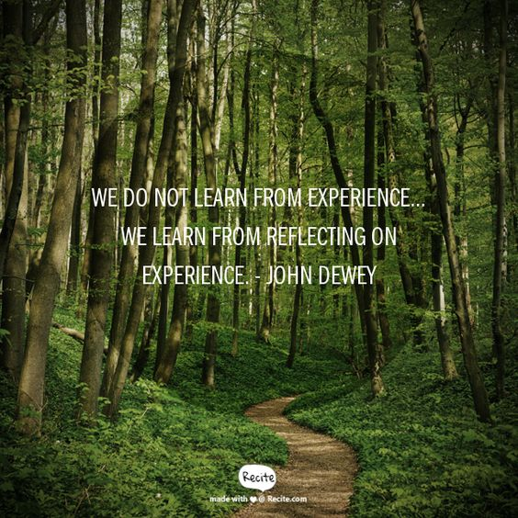The Midpoint and Final Check-In forms are now live on mySuccess! Your Midpoint Check-In should take place halfway through your employment (November for students only working in the Fall term, and January for students working in the Fall and Winter term), and your Final Check-In should take place within the last 2 weeks of your employment. Both check-ins will give you a chance to reflect on your learning and skill development. **You can upload a scanned copy of your Check-In form, or take a photo of the form and upload it online.**

MIDPOINT CHECK-IN INSTRUCTIONS

- You will complete 1 form to be signed by your employer. There are 7 questions in total on the form. You will complete questions 1-4 on your own before you meet with your employer, and questions 5-7 at an in person meeting with your supervisor.

- At your meeting with your supervisor, discuss the topics listed in questions 5-7 and write down your answer to the question in the box provided.

- Have your supervisor sign the form. You will submit the signed form to mySuccess.

FINAL CHECK-IN INSTRUCTIONS

- There are 2 forms that need to be submitted for your Final Check-In: a performance evaluation and final reflection.

- Your employer will complete the Performance Evaluation on their own and review it with you at an in-person meeting. Both you and your supervisor will sign the form to indicate that you have discussed the results of your evaluation.

- Upload a signed copy of your evaluation to mySuccess.

- After you have reviewed your performance evaluation with your employer and uploaded it, you will complete a Final Reflection online on mySuccess.

The final reflection is not available yet. I will email you when it is ready. You do not have to print out your final reflection. It will be done completely online.

For students who are working in the Fall term only, I will be sure to have the final reflection ready for you by December.

**Want to Win a $100 Bookstore Gift Card? Check out Canada Career Month!**



November is Canada Career Month. Join the University of Windsor’s Office of Career Development & Experiential Learning as we explore and celebrate the future of careers in Canada with a wide range of events all month long! Notable events include:

* Free hot chocolate (this Wednesday!)
* Free professional LinkedIn headshots (this Friday!)
* Career workshops
* It All Adds Up campaign
* …and much more!

I’ve attached a flyer with detailed descriptions and more information about what’s happening at UWindsor during Canada Career Month. **Students who participate in Canada Career Month events will be entered into a draw to win a $100 gift card from the UWindsor bookstore!** Hope to see you there!

**Need More Work Experience? Apply to VIP!**

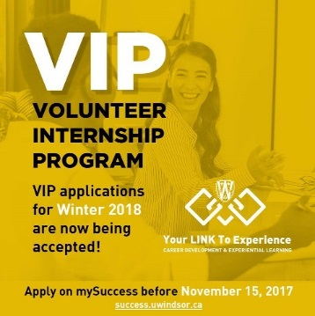

Do you want to enhance your resume with a professional and rewarding experience and get the related experience desired by employers? The Volunteer Internship Program (VIP) may be for you! VIP is a great way to get involved in the community and gain career related transferable skills. Applications for VIP are still open and are being accepted until this Wednesday, November 15. For more information about the program and how to apply, visit [www.uwindsor.ca/vip](http://www.uwindsor.ca/vip).