|  |  |
| --- | --- |
| cid:image002.jpg@01D3969D.82C9A000 | **IGNITE EMPLOYER NEWSLETTER**  **January 26, 2018** |

**Important Ignite Reminders**

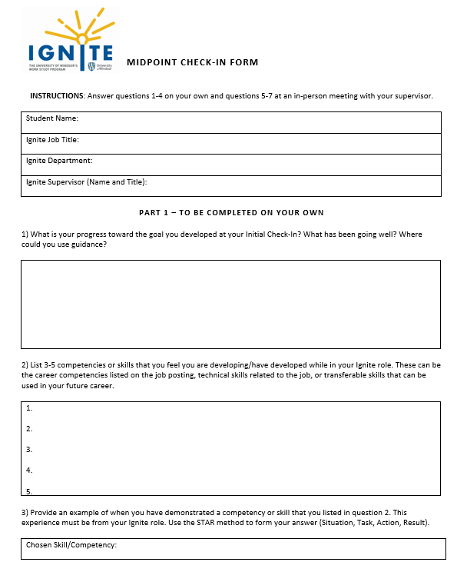

Now that your student is halfway through their employment, it’s time to complete their Midpoint Check-In with them! I have attached the Midpoint Check-In form to this email. It is also available on mySuccess.

At your Midpoint Check-In, you will review and sign 1 form with your student. There are 7 questions in total on the form. Your student will complete questions 1-4 on their own, and questions 5-7 at an in person meeting with you.

At your meeting with your student, discuss the topics listed in questions 5-7 and have your student write down their answer to the question in the box provided.

Your student will then upload the form to mySuccess.

**Student Spotlight**

This term, I would like to feature a “Student Spotlight” in each employer newsletter to highlight a stellar Ignite student’s work experience. The Spotlight would consist of a short bio, photo, and a few lines about their experience and skills they are gaining on the job. If you and your student are interested in participating, [let me know](mailto:sydney.murray@uwindsor.ca?subject=Ignite%20Student%20Spotlight) and I would be happy to set something up. This is a great opportunity to show your appreciation for your student!

**Looking to Hire a Summer Student? Deadline to apply Canada Summer Jobs Program Today!**

Do you plan on hiring a student for the summer 2018? The federal government’s Canada Summer Jobs program provides funding to help employers create summer job opportunities for students.

As a public sector employer, the University of Windsor is eligible to receive funding for up to 50% of minimum hourly wage for positions between 30 and 40 hours per week for 6 to 16 weeks over the summer.

The Office of Career Development and Experiential Learning will work in partnership with the Department of Finance to coordinate one Canada Summer Jobs application on behalf of the University of Windsor to include all of the individual job proposals received by the internal deadline.

The deadline to submit a proposal and have it included in the University of Windsor application is today, Friday, January 26. [Find out more here!](http://www.uwindsor.ca/cces/785/canada-summer-jobs-2018)

**Tracking Your Student’s Hours**

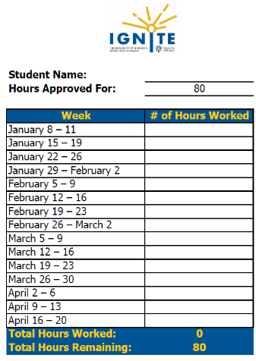

As you are aware, Ignite students may work 80 hours per term. Please ensure that you are tracking your student’s hours appropriately so they do not go over their allocation. If your student works more than 80 hours this semester, the extra hours will be charged to your departmental budget.

I have developed an hours tracker to assist you with tracking the number of hours your student works each week. It is available in the employer toolkit on [mySuccess.](success.uwindsor.ca)