IGNITE EMPLOYER NEWSLETTER
February 9, 2018

*** IMPORTANT: New Account Number for Payroll Time sheets ***

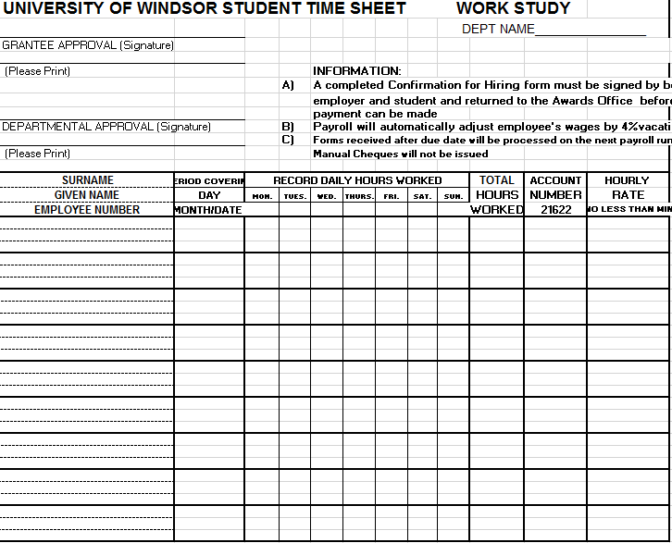
The launch of the new UWinsite Finance system has resulted in changes to the work study account number. Starting January 29, all time sheet and time cards submitted to Payroll need to have the new account number on them in order to be processed. The new account number for work study is 01.2720.27201.000000.81520.000.00.000

Please use this account number on all time sheets until a new time sheet is made. I will send it out once it is available.

The current work study timesheet is pre-populated with the old account number (21622), so I would suggest writing the new account number on a label and placing it over the old account number on your student’s time sheets.

After February 25 all time cards that do not have the new account number listed on them will be sent back to the department for correction and will get processed on the next pay run. Please check the payroll website or the time sheet submission deadlines to ensure your students are being paid in a timely manner.

Check-In Reminders

Now that your student is halfway through their employment, it’s time to complete their Midpoint Check-In with them! I have attached the Midpoint Check-In form to this email. It is also available on mySuccess. Students were instructed to complete their Midpoint Check-In forms by the end of January, so if your students needs an extension for this, just have them email me with the date they anticipate to upload the form.
If you or your students have any questions about the process, do let me know. Please remember that reflection is a key component of this program and the Check-Ins are mandatory, as outlined in the work study agreement and Confirmation of Hiring Form. Incomplete Ignite Check-Ins may limit the opportunity to participate again in the future.
Student Lifecycle Needs: February
Student energy is often low in February as preparation for university midterms begin during this time. However, many may be developing strategies for pursuing summer job opportunities, or thinking about leadership opportunities for next year.
If your student has indicated they will be looking for a summer job soon, encourage them to be proactive and visit the Office of Career Development & Experiential Learning to get assistance with their job search. Our office offers 15 minute drop in appointments with a student Peer Advisor, 1-1 career appointments with a Career Advisor, workshops, and much more!

Alexander Astin’s Theory of Student Involvement states that students learn by becoming involved, and are more successful if they are involved in their academic and social experience. Getting involved on campus is an excellent way for students to gain transferable skills, meet others, and develop professionally and personally. Lead@UWindsor is a great opportunity for students to get involved and discover their leadership potential. Applications for 2018-2019 volunteer positions will go live in February. For more information, visit their website.

