IGNITE BI-WEEKLY NEWSLETTER
January 26, 2018

This week’s newsletter theme is Teamwork & Collaboration!

Reminder about Check-Ins

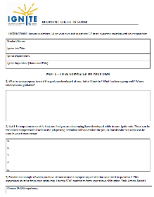
If you haven’t already done so, please upload your Midpoint Check-In before the end of this month. All forms and instructions can be found on mySuccess. Keep in mind that you are responsible for uploading your own Check-In forms. Students who fail to submit their Check-Ins may jeopardize their ability to participate in the Ignite program in the future. If you are have any concerns about completing your Check-Ins, please let me know and I would be happy to assist!

Developing Your Skills: Teamwork & Collaboration

Teamwork is an essential skill to develop and demonstrate prior to graduation and throughout your professional life.
Did you know…

“The ability to work in a team” was listed as the top skill employers were looking for in a 2017 survey conducted by NACE?

Effective teamwork skills involve working as a productive member of a group and collaborating with others to achieve set goals. Many of you may already have experience with this if you have completed a group project with other classmates or have played a team sport.

You are a strong team contributor and collaborator when you are able to negotiate and manage conflict, and are open minded to viewpoints different than your own. Good team players are committed and supportive to the team, its goals, and its members, and make meaningful contribution and follow through on their commitments.

Teamwork Skills in Action

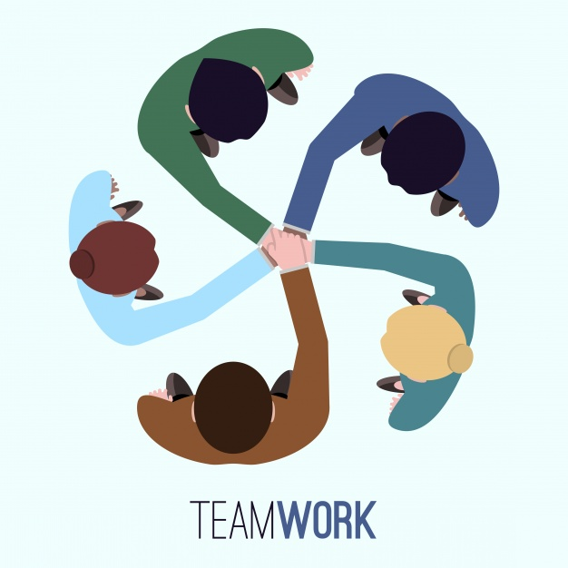
As you navigate your Ignite role, opportunities to work with others are sure to arise. This can apply to the workplace, your academic classes, or any extra curricular activities you are involved in.

If you selected Teamwork & Collaboration as the competency you’d like to develop at your Initial Check-In, or if you’re looking to improve your teamwork skills, consider doing the following in your Ignite role:
- Show your team that you understand project objectives and deliverables
- Ask for and be open to constructive feedback
- Consider different perspective and recognize and draw upon the strengths of your team members
- Motivate your fellow team members to be strong contributors
- Negotiate and manage conflict
- Ask to be included in your supervisor’s departmental meetings
- Share your ideas with others and bounce ideas or solutions to problems with your coworkers
- If you feel confident enough, ask to lead a team project or task
- Follow through on your commitments, especially when it comes to deadlines, meetings, or important tasks that your team members are counting on you for

Passport to Professionalism

Willamette University’s Passport to Professionalism offers a great training module on how to improve your teamwork skills. After completion of this module, you will be able to identify your unique teamwork style and learn how you can increase your teamwork productivity.
g

