|  |  |
| --- | --- |
| cid:image002.jpg@01D39F4C.B3E05230 | **IGNITE BI-WEEKLY NEWSLETTER**  **February 6, 2018** |

This week’s newsletter theme is Professionalism & Work Ethic!

**Reminder about Check-Ins**

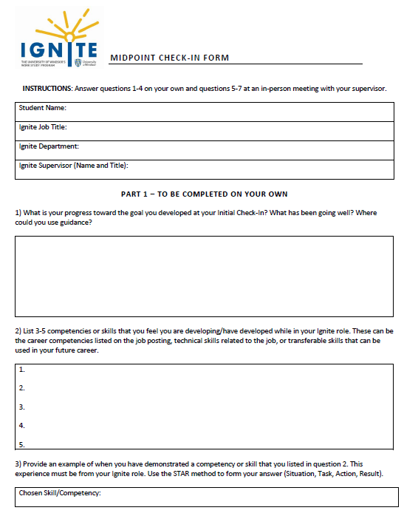

Now that you are halfway through your placement, it’s time to complete your Midpoint Check-In with your supervisor, so make sure to upload your Midpoint Check-In form as soon as possible. All forms and instructions can be found on [mySuccess](success.uwindsor.ca).

Remember that the Check-Ins are a mandatory part of your work study agreement, which you signed and agreed to. Keep in mind that students who do not submit their Check-Ins may jeopardize their ability to participate in Ignite again next year.

If you need an extension for your Midpoint Check-In, please discuss this with your supervisor and let me know the date that you intend to upload your form.

**Developing Your Skills: Professionalism & Work Ethic**

Professionalism is defined as the demonstration of strong personal management practices and a high level of integrity and ethical behaviour.

Professionalism is different for every workplace, but there are some universal truths or basic guidelines that every student should follow. Skills like communication, resourcefulness, appearance (yes, this is a skill!) and problem solving go hand-in-hand with professionalism.

Did you know…

In a survey conducted by 600 HR professionals, 34% indicated that interpersonal skills are the top indicator of professionalism?


In your Ignite role you are not just a student; you are an employee of the university. As a University of Windsor employee, it’s important to adhere to UWindsor service standards. A copy of our standards can be found [here](http://www1.uwindsor.ca/serviceexcellence/system/files/6754%20ServiceExcellenceManual2013_oct28_web.pdf).

**Professionalism & Work Ethic in Action**

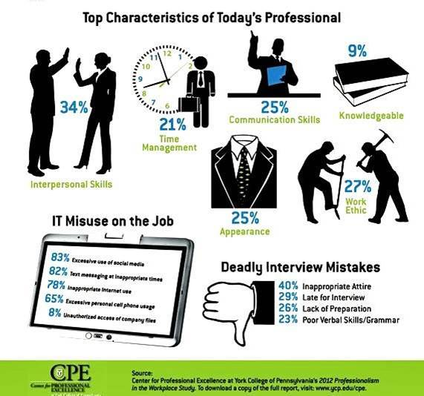

If you selected Professionalism & Work Ethic as the competency you’d like to develop at your Initial Check-In, or if you’re looking to improve your professionalism, consider doing the following in your Ignite role:

* **Exercise personal accountability and learn from mistakes:** if you accidentally make a mistake when completing a task, own up to it! Your supervisor understands that you are a student and may make mistakes.
* **Manage your time:** this includes being punctual and meeting deadlines. Showing up to work 10 minutes late everyday is extremely unprofessional in the workplace. It’s best to always arrive at your scheduled shifts at least 5 minutes earlier.
* **Understand the impact of non-verbal communication:** our body speaks for itself. Eye rolling, lack of eye contact, and crossed arms may be seen as signs of defensiveness or indifference by your employer.
* **Show interest, initiative, effort and enthusiasm:** it’s important to put in the work and stay focused in your Ignite role. Rather than waiting for your supervisor to tell you what needs to be done next, take initiative and start a task on your own.
* **Problem solve:** always try to seek out the answer to something before you ask your supervisor. Google can go a long way! Presenting a potential solution to the problem to your employer is a great way to show you have a strong work ethic.

**Want to Learn More?**

Check out the following additional resources:

**The 10 Characteristics of Professionalism** “*True professionals possess a number of important characteristics that can apply to virtually any type of business…*” [Read more](https://www.linkedin.com/pulse/10-characteristics-professionalism-greg/)

**Formal Vs. Casual Emails: How To Keep The Professionalism In Your Correspondences** “*It can be difficult to know where the line gets drawn for casual emails in the workplace. How do (or should) you maintain your level of professionalism in your day-to-day email correspondences at work?*” [Read more](https://talentegg.ca/incubator/2015/07/10/formal-casual-emails-professionalism-correspondences/)

**Your Work Self** “*Since it is expected that people will change jobs and companies several times over their career, the ability to assess a specific work environment and learning to adapt to it should be a well-honed skill in a job seeker’s toolbox…*”[Read more](https://www.jobpostings.ca/career-guides/blog/your-work-self)