|  |  |
| --- | --- |
| cid:image011.jpg@01D3B240.1DF3BBC0 | **IGNITE EMPLOYER NEWSLETTER**  **March 2, 2018** |

**\*\*\* IMPORTANT: New Account Number for Payroll Time Sheets \*\*\***

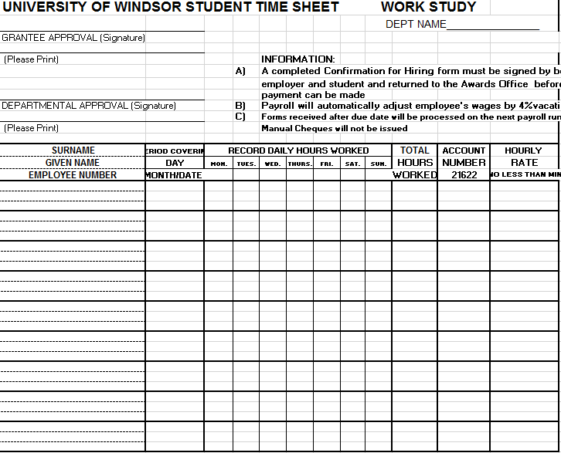

As you know, the launch of the new UWinsite Finance system has resulted in changes to the work study account number. The new account number for work study is **01.2720.27201.000000.81520.000.00.000**

After February 25 all time cards that do not have the new account number listed on them will be sent back to the department for correction and will get processed on the next pay run. Please check the [payroll website](http://www.uwindsor.ca/finance/payroll) or the [time sheet submission deadlines](https://www.uwindsor.ca/finance/sites/uwindsor.ca.finance/files/2018_biwkly_staff_student_payroll_submission_calendar.pdf) to ensure your students are being paid in a timely manner.

**Now Hiring Student Career Peer Advisors for 2018-2019!**



Our office is currently hiring **paid** Career Peer Advisors for the Fall 2018/Winter 2019 academic year. This would be a great opportunity for students to use the skills they have gained through their academic and extracurricular experiences to help other students along their career path. We are looking for individuals to both coach and engage students to promote our services. If you know any students that may be a good fit, please reach out and encourage them to apply!

For more information, students can visit [mySuccess](success.uwindsor.ca) (**Job ID # 52012**) to **apply by March 11th**.

**Check-In Reminders**



If you haven’t already done so, make sure to complete your midpoint check-in meeting with your student. I have attached the form to this email.

If you or your students have any questions about the process, do let me know. Please remember thatreflection is a key component of this programand the **Check-Ins are mandatory, as outlined in the work study agreement and Confirmation of Hiring Form.** Incomplete Ignite Check-Ins may limit the opportunity to participate again in the future.

**Student Lifecycle Needs: March**

Students face many potential stressors during the month of March, including:

* Academic stress due to an increase in workload before final exams in April
* Concern about housing for next year
* Self-doubt about program choice or intellectual capabilities (especially if they did not do well on their first round of midterms)

Resources available to address these issues include:

* [Academic Advising](http://www1.uwindsor.ca/advising/), where students can discuss program options with an academic advisor
* [Student Counselling Centre](http://www1.uwindsor.ca/scc/welltrack-start-feeling-better-today) or [Peer Support Centre](http://www.uwsa.ca/uwsa-services/psc/), where students can discuss stress management techniques
* [WellTrack](http://www1.uwindsor.ca/scc/welltrack-start-feeling-better-today), an online, interactive self-help therapy program for students
* [Places4Students](https://www.places4students.com/) for a list **of available off-campus housing**

Have a great weekend,

Sydney