IGNITE EMPLOYER NEWSLETTER
March 14, 2018

Important Financial Information re. T4’s
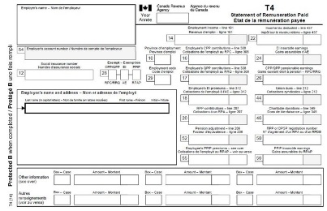
T4 slips for the 2017 tax year have been processed and are available online on the myUWinfo employee portal. Faculty, staff and student employees are able to access and print their tax slips 24/7. Before users can view or print their tax slips, they must consent to accept their tax slips online. If you have not previously consented, your tax slip has been mailed to your home address. Find further instructions on the MyUWinfo → myPAY section.

Important Financial Information re. Payroll

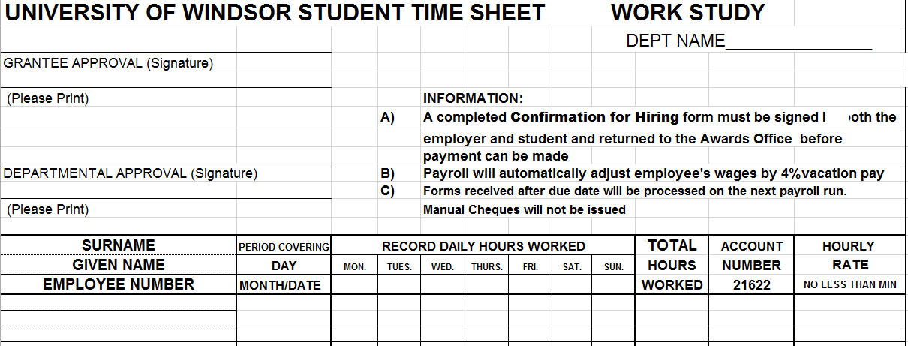
The work study payroll account number has changed. The new account number for work study is 01.2720.27201.000000.81520.000.00.000

Please ensure that you put this new account number on your student’s timesheets. After February 25 all time cards that do not have the new account number listed on them will be sent back to the department for correction and will get processed on the next pay run.

You can check the payroll website or the time sheet submission deadlines to ensure your students are being paid in a timely manner.

Summer Experience Program Application Now Available!
The Summer Experience Program (SEP) has been launched for 2018. The program provides Ontario students with an opportunity to gain valuable work experience as well as career related transferable skills that will assist students in their future career paths. Approved positions will receive a maximum of $3,658.00 per position that fall within the ministry’s approved program allocation.
The deadline to apply for SEP is next Monday, March 19th at 4:30pm. Job proposals need to be submitted online. Interested employers can learn more about funding and eligibility requirements and access the job proposal form on our website.
I will be collecting the job proposals and sending them to the ministry. If you have any questions, please contact me directly via email or phone (ext. 2577).
Check-In Reminders

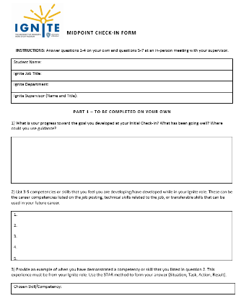
If you haven’t already done so, make sure to complete your midpoint check-in meeting with your student. I have attached the form to this email.

Just a reminder that your student’s final check in is coming up! The last day for students to work is April 22, and your student’s final check in needs to be completed within the last 2 weeks of their employment. You will complete a performance evaluation and go through the results of the evaluation with your student(s) at an in person meeting. The student will then submit the form online after your meeting and complete an individual self reflection.

I have attached the performance evaluation form to this email. If you or your students have any questions about the process, do let me know.

