|  |  |
| --- | --- |
|  | **IGNITE BI-WEEKLY NEWSLETTER**  **March 1, 2018** |

This week’s newsletter theme is Career Management!

**Reminder about Check-Ins**

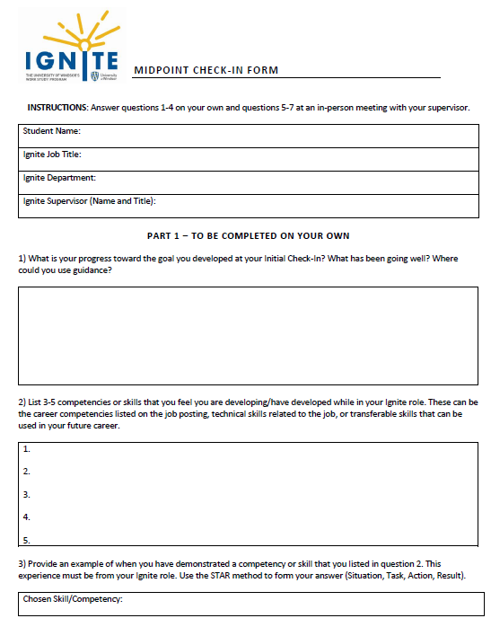

If you haven’t already done so, please complete your Midpoint Check-In with your supervisor and upload it as soon as possible. All forms and instructions can be found on [mySuccess](success.uwindsor.ca).

Remember that the Check-Ins are a mandatory part of your work study agreement, which you signed and agreed to. Students who do not submit their Check-Ins may jeopardize their ability to participate in Ignite again next year.

If you need an extension for your Midpoint Check-In, just email me to let me know the date that you intend to upload your form and I would be happy to accommodate.

**Now Hiring Career Peer Advisors for 2018-2019!**



Our office is currently hiring **paid** Career Peer Advisors for the Fall 2018/Winter 2019 academic year. This would be a great opportunity for you to use the skills you have gained through your academic and extracurricular experiences (including Ignite!) to help other students along their career path. We are looking for individuals to both coach and engage students to promote our services.

For more information, view the attached job posting and visit mySuccess (**Job ID # 52012**) to **apply by March 11th**.

**Developing Your Skills: Career Management**

Career Management is defined as the ongoing process of assessing yourself, Did you know…

Only 25% of job opportunities get advertised to the general public? If you only spend your job search efforts on posted jobs online, you’re ignoring ¾ of your job possibilities!  These unadvertised positions are what we call the “hidden” job market.
exploring options, expanding your skills and marketing yourself to new opportunities. Every time you work a shift in your Ignite role, you are practicing career management in some way, shape, or form.

As a student, this is a great time for you to network with others, explore opportunities, and build your own personal brand. **Networking** is the art of building alliances. You probably don’t even realize you are doing it in your own Ignite role! Networking is a great way to meet others in your field and uncover job opportunities that may not be publicly available.

Your **personal brand** is the means by which people view or remember you. Your personal brand should answer the following questions: this is what I do, this is why I do it, and this is how I can help. To help you get started, consider 5 adjectives that you want people to associate with you (hardworking, analytical, innovative, detailed, generous, leader, etc.) and try to emulate those adjectives when you interact with others. Remember, your personal brand will likely change as you continue to clarify your career goals.

**Career Management in Action**

Actively reflecting on your experiences will help you develop competency in Career Management and take control of your career. The Check-Ins are a form of reflection, and are designed to help you think critically about what skills you are gaining in your Ignite role so you can market yourself effectively to employers in the future, whether that’s through a resume, job interview, or networking event.

Try these helpful tips to help you manage your own career:

* Consider using our [career planning guide](http://www.uwindsor.ca/cces/sites/uwindsor.ca.cces/files/uofw_careerservicescatalogue_winter18_web.pdf) to help you get started on developing your career plan and see what on-campus resources are available
* Attend a [career interest assessment workshop](success.uwindsor.ca) to help you discover your career interests
* Book a [1-1 appointment with a career advisor](success.uwindsor.ca) to discuss your career needs, including resume and cover letter writing, job search, career planning, and more!
* Create a [LinkedIn profile](http://www.uwindsor.ca/cces/sites/uwindsor.ca.cces/files/linkedin_the_professional_network_2.pdf) to help you network with others and build your personal brand
* Conduct an informational interview with someone working in a field that you’re interested in to gain insight into the profession (resource attached)

**Want to Learn More?**

Check out the following additional resources from Lynda.com, an online video training resource in software, creative and business skills. To access the videos, go to [the website](https://www.lynda.com/) and look for the University login to be begin using this powerful, content rich online resource.

**A Beginner’s Guide to Networking** *Establishing and maintaining an internal network is a lifelong skill that will help you succeed! Learn the basics of networking in this* [*short, informative video.*](https://www.lynda.com/Career-Development-tutorials/Networking/461034/500327-4.html)

**Taking Charge of Your Career** *There is no predictable career ladder in today's workplace. Learn to leverage your unique skills and passions to create a flexible career path that stays true to your values and allows you to adapt as needed in this* [*45 minute tutorial.*](https://www.lynda.com/Business-Skills-tutorials/Taking-Charge-Your-Career/633844-2.html)

**Giving Your Elevator Pitch** *Discover how to sell yourself in a short period of time with a memorable* [*“elevator pitch”*](https://www.lynda.com/Business-Skills-tutorials/Giving-Your-Elevator-Pitch/157139-2.html)*.*