Tips and Tricks for Case Citation

Here are some tips and tricks for putting together case citations.
In the Research Phase
This section is applicable for all kinds of citations that you may need to create.
1. When working on a research project, why not get into the habit of creating a perfect citation as you go? Your Research Log is a perfect place to do this. Once you have a perfect citation created, you can then copy and paste the citation into all future documents that you prepare.
2. If you are working with print materials, don’t forget to copy:
-the page number from which you are taking the quote; and also
-the page number of the title page of the case, or the first page of the article, or the first page of the chapter; and also
-the title page of the book or reporter; and also
-the copyright page of the book or reporter
This will ensure that you have all documentation necessary to cite your work. If you don’t take at least one of the two steps mentioned above, then you most certainly will end up doing your research twice. Remember, you cannot charge a client for time that you spend fixing your research errors. See for example Sarkodee-Adoo v Sarkodee-Adoo, 2003 BCSC 950 ¶ 51, 41 RFL (5th) 178:
Mr. Fraser has claimed $453.30 for Quicklaw. To a great degree I am of the view that the hourly fee charged, in this case $225, presumes counsel has a reasonable knowledge of the law, and if they do not, research, including Quicklaw, is in effect a learning exercise, the benefit of which stay with counsel. I will allow Quicklaw at $200.

The Case Citation – Which Style of Cause Do I Use?
If citing a Supreme Court of Canada decision, follow these steps to set up your style of cause:
For recent cases:
1. Locate the decision.
2. Locate the citation just below the seal.

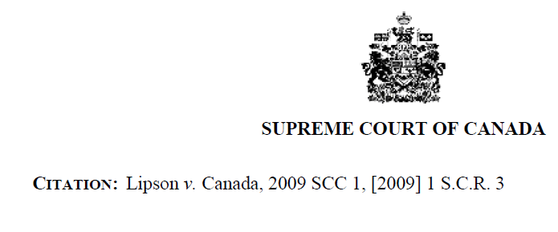
Example:

For some historical SCC cases:
1. Locate the decision.
2. Scroll down on the title page until you locate this: “Indexed As”
3. This is your style of cause.
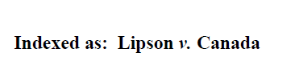
Example:

Note that some commercial reporters provide a style of cause which is different than the “Indexed As” information provided by the SCC for some judicial decisions. This is why it is important to choose the best source available to work with and to cite. A copy of the decision taken from the actual court or tribunal website or their actual reporter will be most reliable for this purpose.
See also the notes provided at page E-45 of the McGill Guide for further details.

The Case Citation – Which Reporter Do I Cite?
a. Choose the Best Source to Work From First
It is very important to remember that you must choose the best source to work from in all circumstances. See this Review Note: “How to Find Judicial Decisions in Print and Online” for a full list of factors to consider when choosing the source that you will work from.
The McGill Guide at page E-43 can be helpful for determining the best source to work from. To summarize, you will choose an official reporter wherever possible. If the decision was not published in an official reporter, you will look to see whether the decision was published in a semi-official reporter. If not published in an official or semi-official reporter, you will choose the Dominion Law Reports or a any other reporter of a national scope. If not in these, you will choose any printed reporter, CanLii or a freely available database. If not in these, you will choose to work with a copy from Westlaw or Quicklaw.
The best source that you’ve chosen to work from is the source that you will copy for the courts, and it is the source that you will use when providing a pinpoint citation.
For example: R v Big M Drug Mart Ltd, [1985] 1 SCR 295 at 297.
R. v Ménard, 2005 SCC 4 ¶ 7.

b. Then, Choose Your Parallel Citation
If a neutral citation is available for your case, you will use the neutral citation as your parallel citation. The history and use of neutral citations is discussed in this document: “Tips and Tricks for Case Citation”.
For historical cases, a neutral citation won’t be available. Thus, you must choose the best source to work from, and then you must provide a parallel citation so that people who are using your footnotes are able to locate the reporter in an alternate location.
One quick way to find out most of the reporters in which a judicial decision has been reported, is to take these steps:
1. Locate the case on Quicklaw (if available).
2. When viewing the full-text of the case, click “Note Up with Quickcite”.
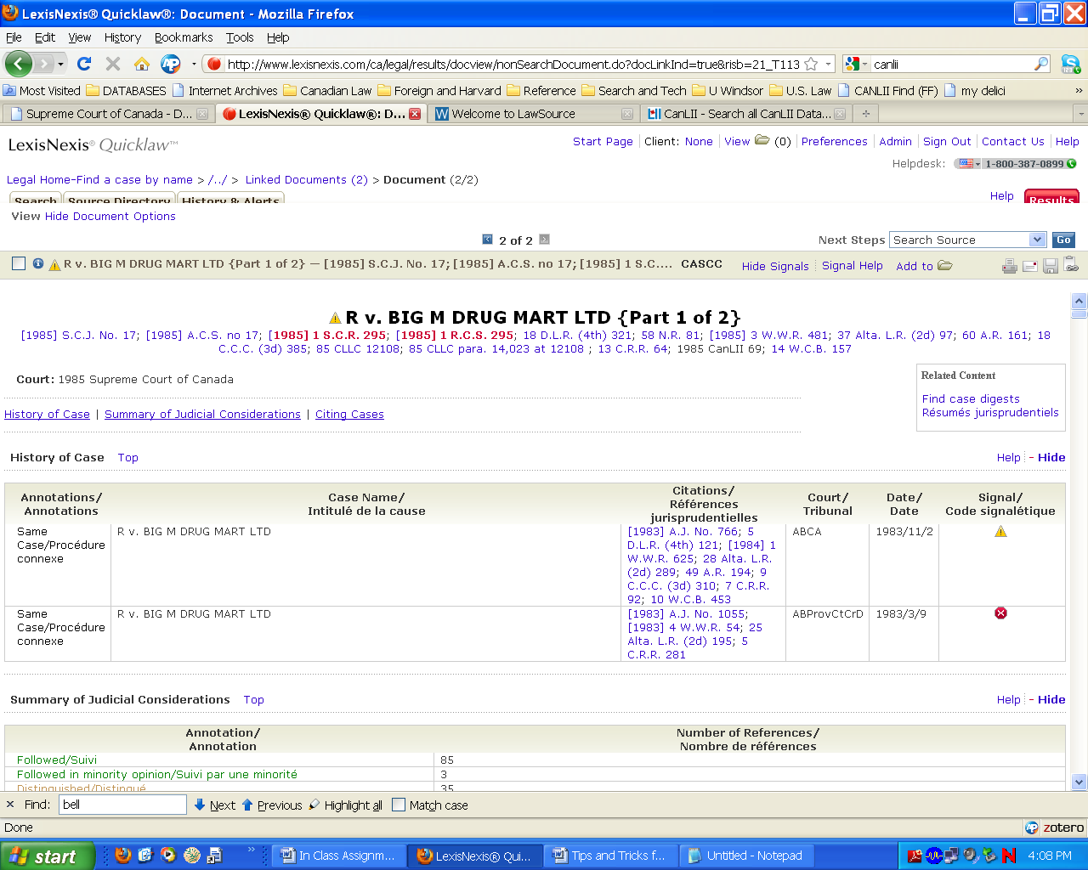
3. A number of reporters will be listed just below the style of cause.
4. Repeat this step using Westlaw (if available) (pull up the case, and, from the left “related information tab, choose “full history”) and/or CanLii based on your time and cost constraints. The purpose of taking these extra steps is to ensure that you have the best possible list of alternate places where this decision was reported.
Westlaw
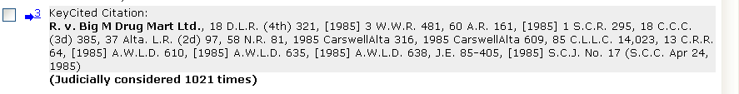
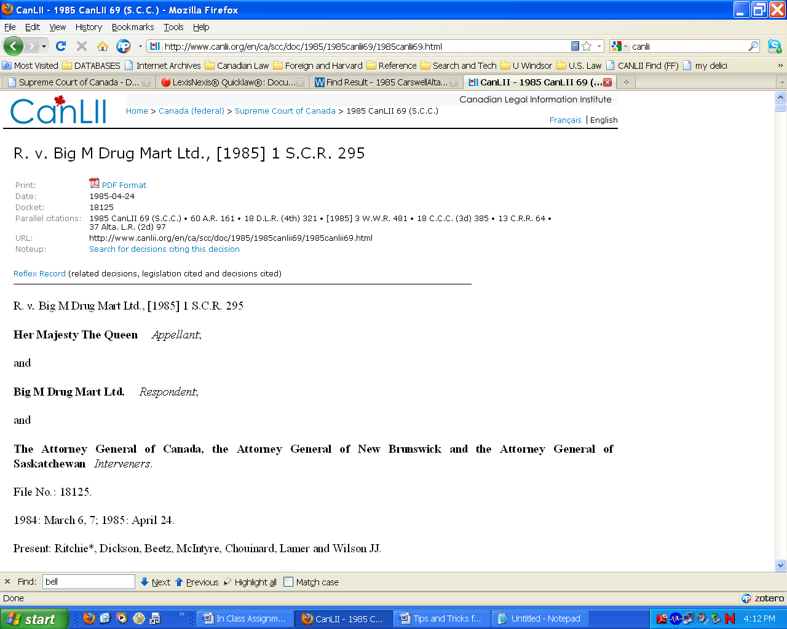
CanLii

Thus, you now have available a good number of parallel places where this decision was published. Choose, in accordance with the rules set out at page E-43 of the McGill Guide, the next best source among them for your parallel citation.

c. Then Place The Parallel Citations in Proper Citation Order
Page E-43 of the McGill Guide tells you what order to place your reporters in when creating your actual citation.
For example, if a neutral citation is available for your case, you will use the neutral citation first, and then the actual source used.
These will become your two parallel citations for many recent cases. Example:
Vaughan v Canada, 2005 SCC 11, [2005] 1 SCR 146.

If using two printed reporters, first place the citation to your actual source used, and then the parallel citation. Example:
R v Big M Drug Mart Ltd, [1985] 1 SCR 295 at 297, 18 DLR (4th) 321.

We will discuss prior and subsequent histories later.

The Case Citation – How Do I Pinpoint?
The purpose of providing a pinpoint citation is to ensure that the court and your opposing counsel are referring to the exact page or the exact paragraph number for the quote upon which you are relying.
For full details, please see these Review Notes: “Understanding How Judicial Decisions are Published”.
Supreme Court of Canada
For SCC decisions which came down between 1876 and 1995, the only way to pinpoint is to provide the page number where the quote appeared in the SCR.
For SCC decisions that came down after 1995, a pinpoint citation to a paragraph number is desirable and possible.
Federal Court of Canada
For FC decisions which came down between 1875 and 1998, the only way to pinpoint is to provide the page number where the quote appeared in the FCR.
For FC decisions that came down after 1998, a pinpoint citation to a paragraph number is desirable and possible.
Other Courts
As a general rule of thumb, for decisions which came down from our earliest reporters until about 1998, the only way to pinpoint is to provide the page number where the quote appeared in the commercial reporter you are using.
Thus, for court decisions that came down after 2002, and disseminated both in a printed commercial reporter, or an online version of the commercial reporter, a pinpoint citation to a paragraph number is desirable and possible.
Where Does the Pinpoint Go?
If Using a Neutral Citation
If you are using a neutral citation, page E-53 of the McGill Guide tells us that the pinpoint belongs after the neutral citation. Example:
R v Proulx, 2000 SCC 5 ¶ 27, [2000] 1 SCR 61.
If there is no neutral citation, your pinpoint belongs with the citation to the source that you are working from. If you have followed the instructions above, then this will usually be the first parallel citation provided, because you are working from the best source available. Example:
R v Big M Drug Mart Ltd, [1985] 1 SCR 295 at 297, 18 DLR (4th) 321.

See Review Notes “Understanding How Judicial Decisions are Published” for details.
From 1875 to 1970, the Federal Court of Canada was called the Exchequer Court of Canada.

