Student Guide





Student Information Guide

The Co-Curricular Record

Overview 3

What is the CCR? 3

Why should you build a CCR? 3

Record Policies 3

Tracking Competencies 4

CCR Organization 5

Adding Activities to the CCR Database 6

Adding Positions to Your CCR 10

FAQ’s 12

**Overview**

**success.uwindsor.ca**

**What is the CCR?**

Students at the University of Windsor are able to document their involvement outside of the classroom on the Co-Curricular Record (CCR). This official document details the students' activities, as well as the corresponding skills that have been gained from each activity. The CCR complements a resume and allows students to showcase their skill development and leadership experiences to potential employers and graduate schools. All information on the CCR is validated by an authorized University of Windsor faculty or staff member.

**Why should you build a CCR?**

 The Co-Curricular Record:

* Complements a resume and academic transcript with a documented list of experiences, validated by a UWindsor faculty/staff member
* Allows you to showcase your skill development and leadership roles
* Shows your progression and participation in co-curricular activities throughout your UWindsor experience
* Encourages reflection on experiences and assists with articulation of related learning

The CCR is a great addition to applications to potential employers and graduate schools!

**Record Policies**

1. Only activities from the current academic year will be recognized on the Co-Curricular Record.
2. In order for an activity to qualify for inclusion on the CCR, the following conditions must be met:
   * Minimum time requirements:
     + Executive positions within student government, clubs, and societies must have held the position for at least one academic semester
     + All other activities must have a minimum of **15 hours per individual activity**
   * All activities must:
     + Occur outside of the classroom
     + Not be for academic credit
     + Be sanctioned by and formally recognized by the University of Windsor
     + Occur on-campus and/or be coordinated on-campus
   * All positions and activities must have a validator who is a long-term **university staff or faculty member**.
   * All positions must have a contact with a UWindsor email that is not tied to a student.
3. Students must add positions to their own individual record which will then be pending until approved by the validator.

**Tracking Competencies**

The online CCR Request Form includes a choice of 15 competencies anticipated to be gained by the activity. When a student adds a position to their own CCR, they will be presented with the same list and asked to reflect and indicate what they actually achieved. **Students can select five competencies to be listed on their record.** The full list of achievements and statements are on the last page of the printed CCR for reference.

The 15 competencies are:

1. Acquisition, Application, and Integration of Knowledge
2. Commitment to Ethics and Integrity
3. Communication
4. Continuous Learning
5. Diversity and Intercultural Understanding
6. Interpersonal Skills
7. Leadership
8. Maintaining Health and Wellness
9. Problem Solving
10. Professionalism
11. Project and task Management
12. Research Skills
13. Responsible Behaviour to Self, Others, and Society
14. Spiritual Awareness
15. Teamwork and Collaboration

**CCR Organization**

* The Position is the role you held in the Activity
* New Positions can be requested by students and/or staff and are approved by the CCR Program Developer.
* Several positions can exist under one activity.
* The Activity is the event or group you participated in.
* New Activities can be requested by students or staff and are reviewed and approved by the CCR Program Developer.
* There are 4 categories of activities on the CCR. They are: Athletics and Recreation, Campus Services, Faculty and Department Activities, and Student Associations.
* Each category is then divided into more specific Units. Example: Faculty of Science.
* The Units are then divided into Departments. Example: Biology.

**Adding Activities to the CCR Database**

Use the CCR Request Form to request a new co-curricular activity be added to the database. This form is only for requesting that a new position be available for students to add to their records. This form is **not** for students to add activities to their individual co-curricular records.

A Request Form must be submitted 30 days prior to the closing date of a particular database. The dates pertaining to each database can be found on the “About the Record” tab of mySuccess under “Important Dates”.

Before submitting a Request Form, please read all of the following information.

**The DOs and DON’Ts of a Successful Request Form**

**Position and Activity Descriptions:** This description will appear on the official record of every student who holds this position.

**The DOs and DON’Ts of Writing a Successful Description:**

* **Do**write about the position in three to four sentences maximum.
* **Do**write in third person (i.e. he/she, they) **paragraph** format, not bullet points.
* **Do**keep your description of duties as clear and concise as possible.
* **Don't**repeat the name of the position in the description.
* **Don't**include any date-specific information.

**Competencies:** Choose anticipated competencies that might come from holding this position. The student who holds the position will later choose their own competencies that best fit what they actually accomplished.

**The DOs and DON’Ts of Selecting Competencies:**

* **Do**select 5 of the 15 available competencies based on what may apply to the position.
* **Don't**limit the competencies based on this semester. Try to choose the best 5 competencies that could come from this position in any term.

**Position Contact Information:** This is the contact information students can use to reach the club/organization/employer/etc. for more information about the position.

**The DOs and DON’Ts of a Successful Contact:**

* **Do**include a contact with a uwindsor email for the club/organization/employer/etc.
* **Do**use an email that will continue to be used long-term.
* **Do**inform us at ccr@uwindsor.ca if the contact information changes. ​
* **Don't**use a student email. For example, the contact for ABC club should have abc@uwindsor.ca as the email address, **not**johnsmith@uwindsor.ca (the current student president).

**Validator Information:** This is the contact information for the faculty or staff member who will be approving or declining position involvement on individual records.

**The DOs and DON’Ts of a Successful Validator:**

* **Do**use a long-term faculty or staff member for the validator. If the position you are adding is a club, the validator is the Student Clubs Coordinator (studentgroups@uwindsor.ca).
* **Do**ensure you have permission from the proposed validator and the complete contact information before submitting the form.
* **Do**inform us at ccr@uwindsor.ca if the validator information changes. ​
* **Don't** submit without a validator, positions without a validator will be immediately declined.

**Approved/Declined E-mail:** You will receive an e-mail regarding the status of your application from the CCR Program Developer. Please note, the approval process will take longer if information is incomplete.

*The Co-Curricular Record Program Developer reserves the right to edit positions and their descriptions, as well as request changes before approval.*

Please follow the steps below to utilize the Request Form on mySuccess.

1. Go to success.uwindsor.ca and select **“Student/Alumni”**.

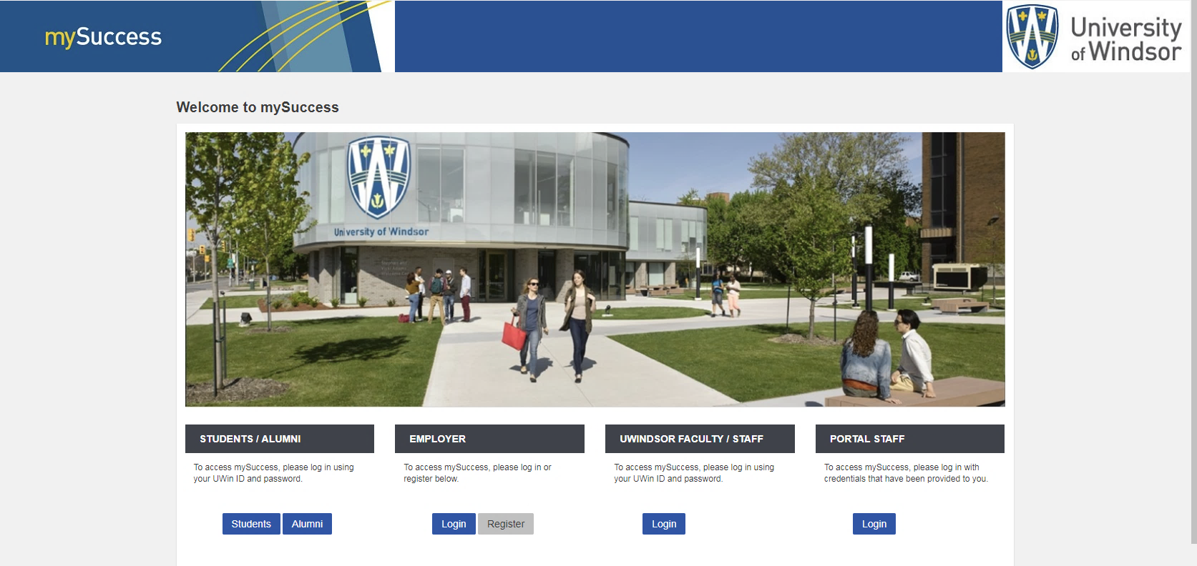

1. Select **“Co-Curricular Record”** from the left-hand taskbar. From the homepage, select the **“New Position Requests”** tab.

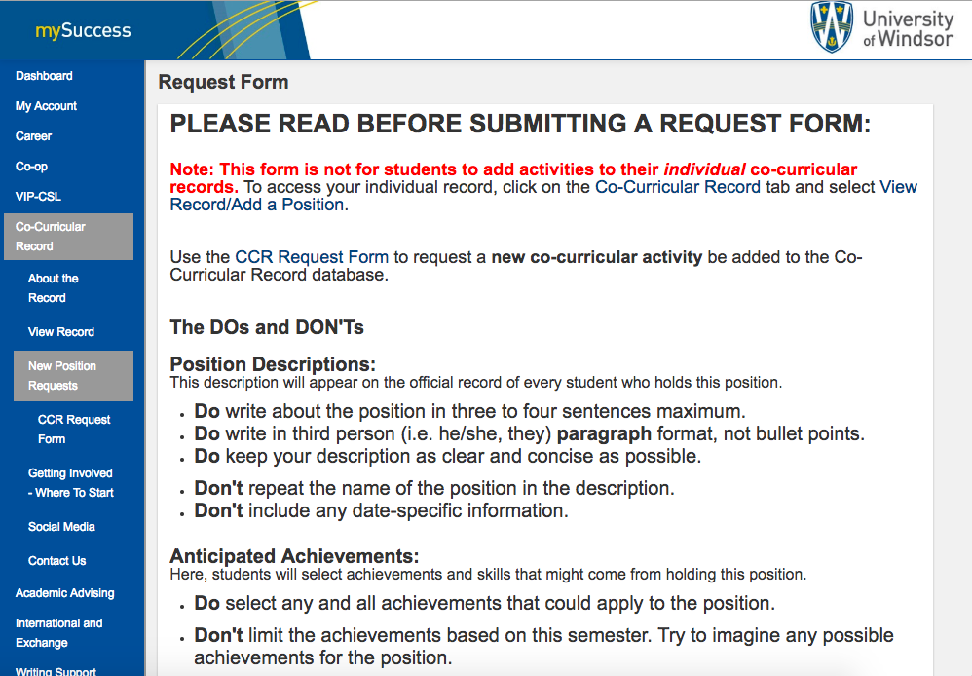

1. Once you have read all of the information on the Request Form page, select **“CCR Request Form”** and then “**Add New Position to New or Existing Activity”**.

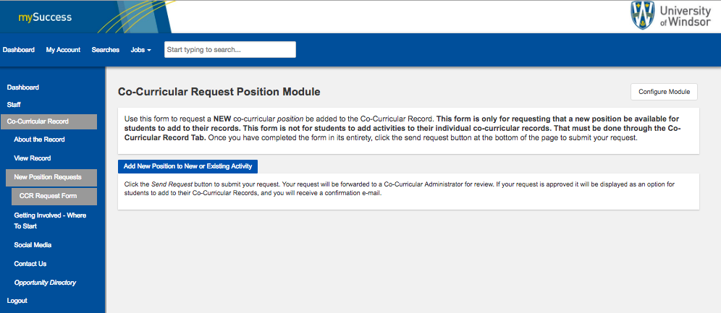

1. Input the information for each field and click “**Submit**” when complete. Please Note: No new categories will be accepted.

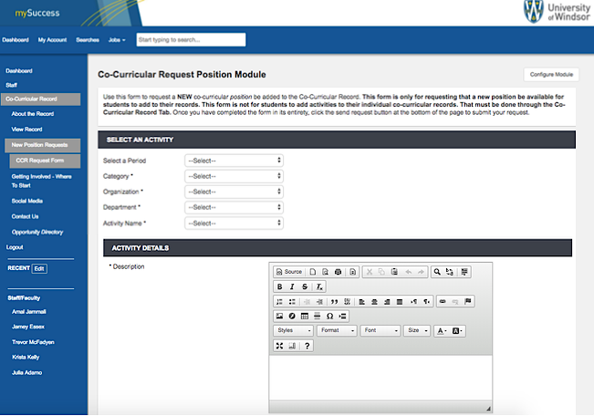

**Adding Positions to Your CCR**

Each student is responsible for their own CCR and must document their involvement themselves.

NOTE: The CCR is not retroactive. Once a database closes, involvement for that time period cannot be documented. Students must consult with the Important Dates found on mySuccess. You will always have the whole term following the term in which you held the position to add it to your CCR, unless otherwise posted.

To add a position to your individual CCR follow the steps below.

1. Once you login to mySuccess and are on the Co-Curricular Record homepage, select the “**View Your Record/Add a Position**”.

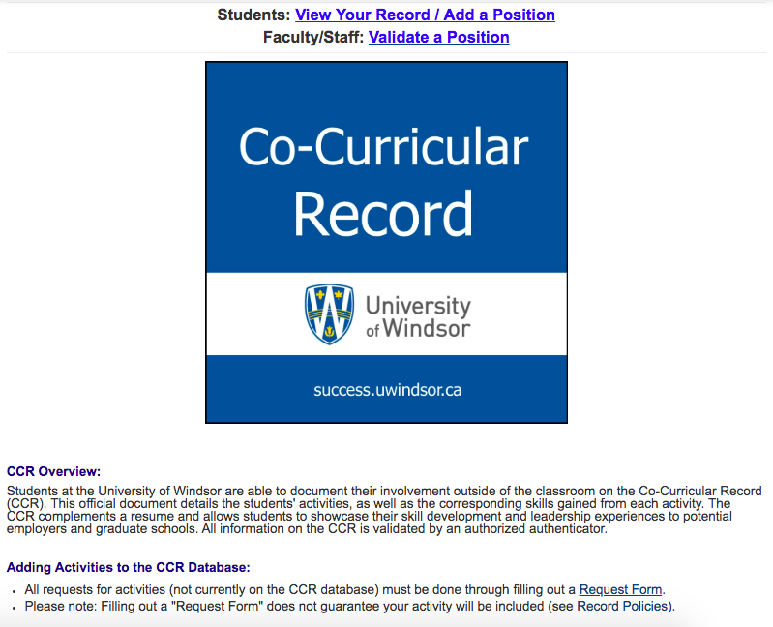

1. Type the name of the position you are looking to add and select it from the drop down list. If your position does not appear, you will need to submit a Request Form using the process outlined beginning on page 6.

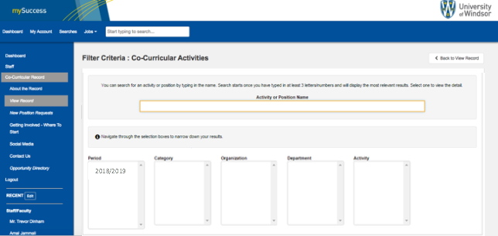

1. A list of Competencies will be displayed for you to select the top 5 that are applicable to your experience. Take some time to reflect upon your experience and what you have achieved, and refer to the anticipated competencies. For a full list of competencies, see page 4. Once you have selected competencies, select “**Save**”.

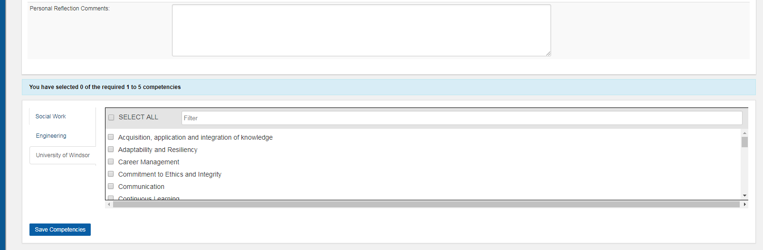

**NOTE: Your request will be sent to the validator associated with that activity and will remain in “Pending” status until processed.**

**FAQs**

|  |  |
| --- | --- |
|  |  |

**1. What is the Co-Curricular Record (CCR)?**

* This official document details student activities, as well as the corresponding skills that have been gained from each activity. The CCR complements a resume and allows students to showcase their skill development and leadership experiences to potential employers and graduate schools.

**2. Why should I build my CCR?**

* The CCR is a great addition to applications to potential employers and graduate schools.
* It complements a resume and academic transcript with a documented and **validated** list of experiences to showcase your skill development and leadership roles.
* It shows your progression and participation in co-curricular activities throughout your UWindsor experience, encourages reflection on experiences, and assists with the articulation of related learning.

**3. How do I get a position on my CCR?**

* Log in to mySuccess and click on [Co-Curricular Record](https://success.uwindsor.ca/myAccount/ccr/overview.htm) on the drop-down menu. Then select [View my Record/Add a Position](https://success.uwindsor.ca/myAccount/ccr/mytranscript.htm)and search for the position you would like to add.
* Note: it is **your** responsibility to add a position to your record (not the validator or the University). This must be done before the deadline, for more information on upcoming deadlines, please see [Important Dates](https://success.uwindsor.ca/myAccount/ccr/overview/importantdates.htm).

**4. How do I add a new position that doesn't currently exist?**

* Use a [Request Form](http://success.uwindsor.ca/myAccount/ccr/requestform/ccrRequest.htm) to add a **new**position or activity to the CCR database. Refer to the Dos and Don'ts on submitting Request Forms and ensure the information is **complete** and accurate before submitting.
* Once the position has been approved, you must sign back in to mySuccess and add the activity to your individual record. Please note: Request Forms are subject to approval and will be denied if the CCR criteria is not met.
* A Request Form can be submitted by students or faculty/staff. Please refer to the [Important Dates](http://success.uwindsor.ca/myAccount/ccr/overview/importantdates.htm) for information on deadlines.
* Note: The Request Form is only to add a position to the CCR database. To add a position to your individual record, please refer to Question 3.

**5. Can I add an activity from a previous year?**

* No, a student can only add a position from the current academic year. See [Important Dates](http://success.uwindsor.ca/myAccount/ccr/overview/importantdates.htm) for deadlines.

**6. What is a validator and how do I become one?**

* A validator is a faculty or staff member that sees your pending request for an activity to be included on your CCR and approves or declines it.
* All positions must have a faculty or staff validator.
  + Exception: Clubs that do not have a faculty or staff member to validate can use the Clubs Coordinator as an alternative form of validation. This method is only available to UWSA ratified clubs.
* ​To become a validator, you must log on to mySuccess with your faculty or staff member login information. Then email the CCR Program Developer at [ccr@uwindsor.ca](mailto:ccr@uwindsor.ca) and request validator status.

**7. What is the time commitment for each activity?**

* The minimum time requirement for student government, clubs, societies, and executive positions must be at least one academic semester. All other activities must meet a minimum of **15** hours of commitment per individual activity. The number of required hours may vary per activity.

**8. Do the activities need to be directly related to the University?**

* Yes, the CCR is an official document of the University of Windsor, therefore, all activities must be sanctioned by the University.
* For the CCR to recognize an activity, a faculty/staff member of the university must be able to validate participation.
* Paid work can qualify for inclusion on the CCR, but it must not be for academic credit. For example, GA/TA positions will count recognition if the student is paid, but not if they will be receiving academic credit.

**9. Can I delete an activity if I add it incorrectly?**

* Students cannot remove new position requests once submitted. If the activity or position has incorrect information, please contact the CCR Program Developer at [ccr@uwindsor.ca](mailto:ccr@uwindsor.ca).
* Students cannot remove individual positions from their record once they have been approved or declined (only while still pending). If the position has been approved or declined already, with incomplete information, please contact the CCR Program Developer at[ccr@uwindsor.ca](mailto:ccr@uwindsor.ca)[.](http://ccr@uwindsor.ca/)

**10. Can I appeal a declined activity?**

* Yes, first please contact the validator of your activity for their reasoning. Permission from the validator to the CCR Program Developer is required to overturn any declined decision.
* It is at the discretion of the validators whether or not the position status should be overturned.

Further questions can be directed to the CCR Program Developer at [ccr@uwindsor.ca](mailto:ccr@uwindsor.ca).