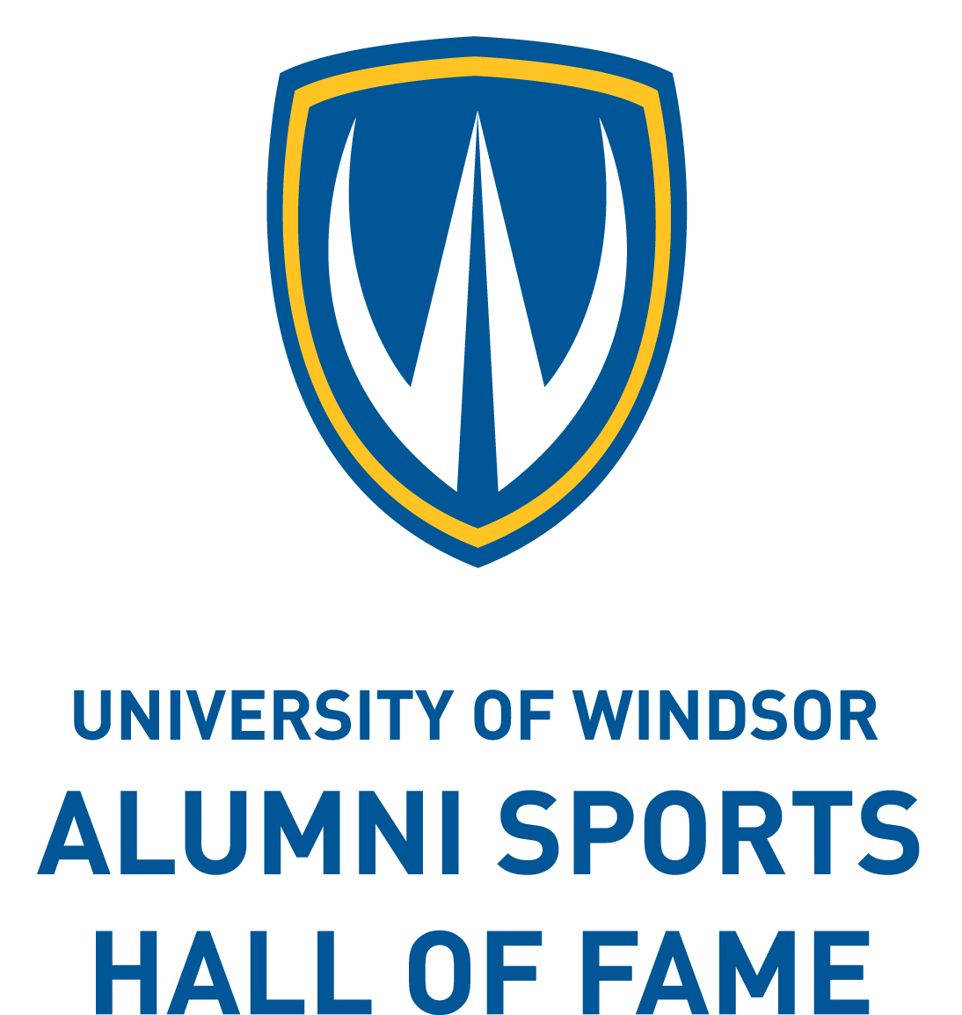

**ALUMNI SPORTS HALL OF FAME**

**SPORT ACHIEVEMENT AWARD**

**NOMINATION FORM**

**SUBMISSION DEADLINE: February 14, 2022**

**Instructions**

**1. Please TYPE OR PRINT all information on this form in the space provided.**

**2. List information only once. Please do not duplicate.**

**3. See Rules and Regulations for eligibility requirements.**

Name of Honouree: E-Mail:

Address: City/Prov:

Postal Code: Phone:

**ELIGIBILITY**

**Sport Achievement Award:** a graduate recognized for outstanding contribution to sport beyond their University of Windsor experience, ie. Conference, Provincial, National, International, Olympic; duration; awards, medals, records, etc.

Sports participation **while** in attendance at the University of Windsor (if applicable):

Athlete-specify sport:

Non-Athlete ie. coach, manager-specify:

Year(s) of participation:

***Please note sport involvement post-university on reverse.***

In order for this nomination to be eligible for consideration, the **signature of the nominee** is required. Supporting documentation must be submitted using the following pages as guidelines. A maximum of 2 pages of additional information may be appended to this application.

Honouree Signature: Date:

I hereby affirm that the nomination information is accurate. I recognize that providing false or misleading information may jeopardize this nomination.

Nominated by (please print): Phone:

E-Mail:

Nominated by (signature):

***Please forward completed Nomination Form to:***

Office of Alumni Affairs

by E-Mail: alumni@uwindsor.ca

Mail: University of Windsor, Windsor, Ontario, N9B 3P4

or Fax: (519) 973-7063

**on or before February 14, 2022**

Office Use Only: Last attendance at U of W_______ Year of Graduation, Faculty/Program _________

**Sports involvement post-University (specify):**

A) Sport(s)

B) Level(s)

C) Location(s)

D) Year(s) of Involvement

E) Special Awards and/or Citations

*Revised: December 2021*