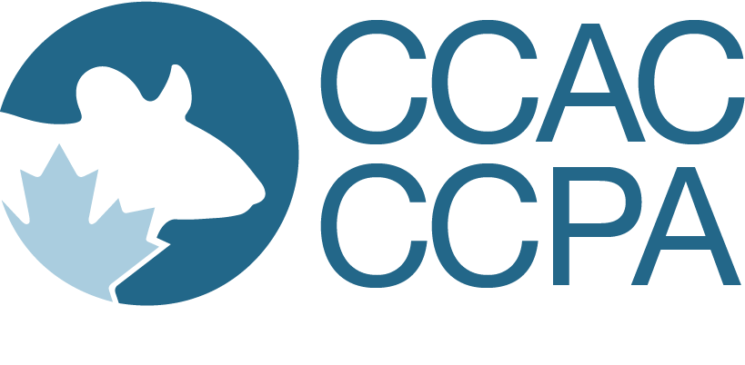
OVERSIGHT OF ANIMAL-BASED COMMUNITY OUTREACH ACTIVITIES FORM
DATE OF PUBLICATION: May 2020
Animal-based community outreach activities are non-invasive activities meant to informally educate the public and for which there is no assessment of understanding or retention of knowledge obtained from the involvement of animals.
Projects that involve institutional research or teaching animals in outreach activities do not require a full Teaching Animal Use Protocol and an independent pedagogical merit review. However, institutions should have proper safeguards in place, including an Oversight of Animal-Based Community Outreach Activities Form and standard operating procedures that clearly outline the institutional animal care committee’s expectations with regard to animal welfare.
This form can be approved by the animal care committee chair or the veterinarian. Post-approval oversight of these projects by the animal care committee should be proportional to risk.

SECTION 1: GENERAL INFORMATION
Instructor or person responsible:
Position:
Department:
Phone:
E-mail:

Title of Outreach Activity

Duration of Activity
Proposed start date: | Date
Proposed completion date: | Date

Explain Why Live Animals Are Involved in This Activity

Section 2: Demonstration staff
(e.g., instructor, teaching assistants, students)
Please provide the name(s) of all demonstration staff directly involved in this animal-based activity.
NAME | DEPARTMENT/  AFFILIATION | POSITION | PHONE

Section 3: Description of activities involving animals
Using simple language, briefly describe the proposed activities, providing overall context and background. Provide details as to what will happen to the animal from start to finish, including how animals will be monitored. Identify who will perform each activity, and how they are qualified to do so. If animals do not all undergo the same activities, be sure to clarify the number of animals undergoing each activity, and the sequence of events.

Section 4: Animals involvement
Please provide details of animals involved in the activities.
Species  (common name) | Age or weight | Numbers required | Source of animals

Where Are the Activities Being Carried Out?
☐ Institution
Location:
☐ Field
Location:
☐ Other
Location:

Section 5: Safeguards
List all relevant standard operating procedures and other institutional practices that guarantee proper safeguards are in place to ensure animal welfare (including limiting repeated uses).
standard operating procedure Title / Institutional Practice description

Section 6: Declaration
Your signature below indicates that:
all animal activities will be in accordance with standard operating procedures or procedures approved by the animal care committee;
you have considered alternative procedures that do not involve live animals;
you are confident that an alternative to the proposed live animal activity is not feasible; and
you will notify the animal care committee of any revisions to this form.
Name: Name
Date: Date

FOR ADMINISTRATIVE USE ONLY
ACC chair or veterinarian name: Name
Date received: Date | Date reviewed: Date
☐ Approved | ☐ Not Approved
☐ Conditionally approved
Conditions:

Canadian Council on Animal Care • ccac@ccac.ca • www.ccac.ca

