Add a TA or support staff to a course
- On the navbar, select Course Tools > Classlist.
- Select Add Participants > Add existing users.
- Type in the TA’s or support staff name in the text field and click on the search icon to start searching.
- Scroll down to see the search results table. Select the user you want to add by clicking in the check box to the left of the name.
- Click in the Select a Role field to select the role to the right of the name and select the appropriate role.
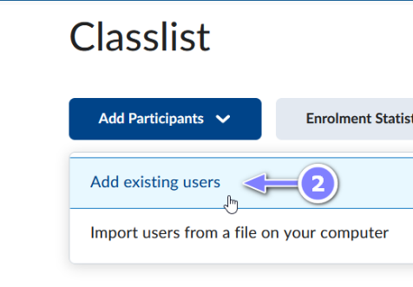
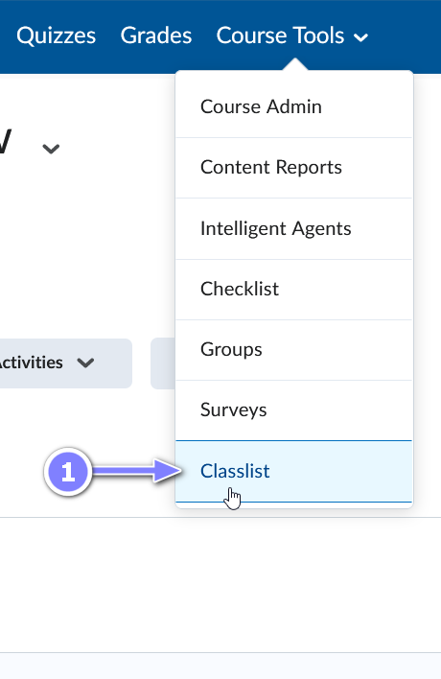
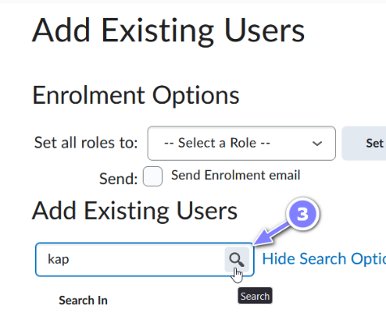
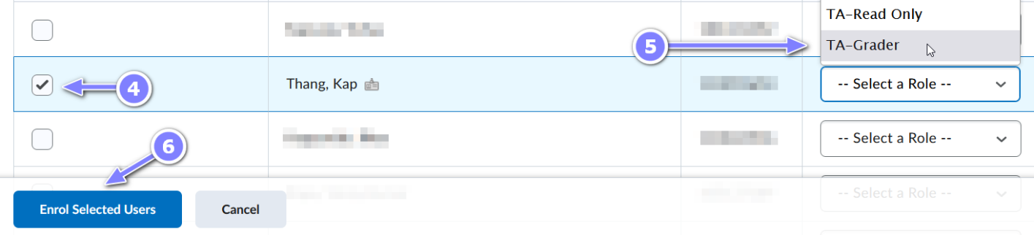
- Select Enrol selected users.

