Adjusting Final Grades
The Final Calculated Grade column of the Gradebook is where Brightspace calculates the final grade for each student in your course. You cannot manually adjust any grades in this column. If you want to manually adjust a grade for one or several of your students, you need to use the Adjusted Final Grades column.
WARNING: You must include final grades for ALL students in the Adjusted Final Grades column, whether you are adjusting one or all of the students’ grades. The most efficient way to do this is to ask the system to transfer all the grades from the Final Calculated Grade column to the Adjusted Final Grade column by the steps below. Once that is done, you can adjust the final grades for whichever student(s) you want.

Adjust final grades
- In the Grades tool, select the Enter Grades tab.
- Click the drop-down arrow beside Final Calculated Grade.
- Select Enter Grades.
- At the top of that page, beside the Final Grades title, click on the drop-down arrow.
- Select Transfer All to transfer all grades from the Final Grades column to the Final Adjusted Grade column of your Grade Book.
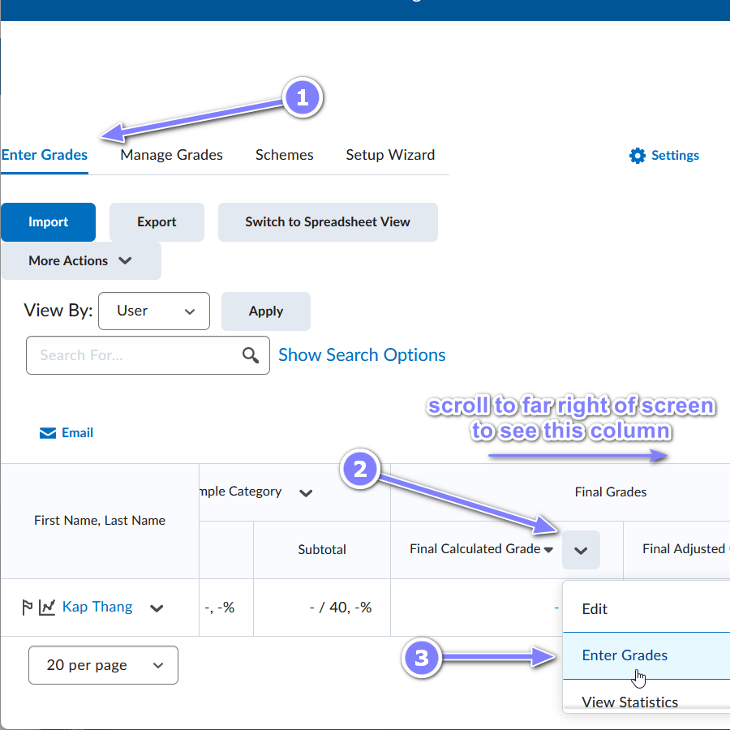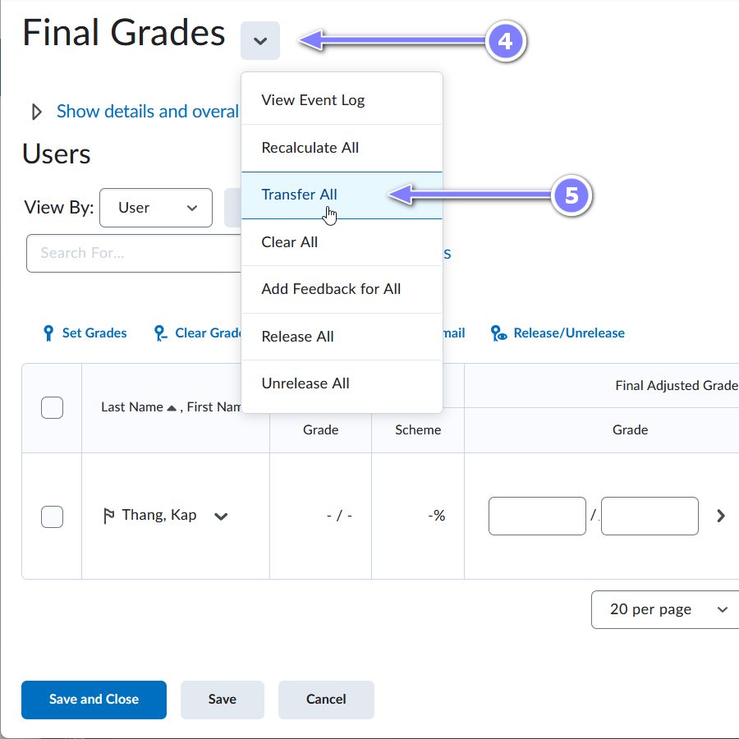
- A confirmation dialogue box will appear. (Note: transferring grades will override any grades previously entered in the Final Adjusted Grades column). Click Yes.
- Make changes to any of the grades in the Final Adjusted Grade column.
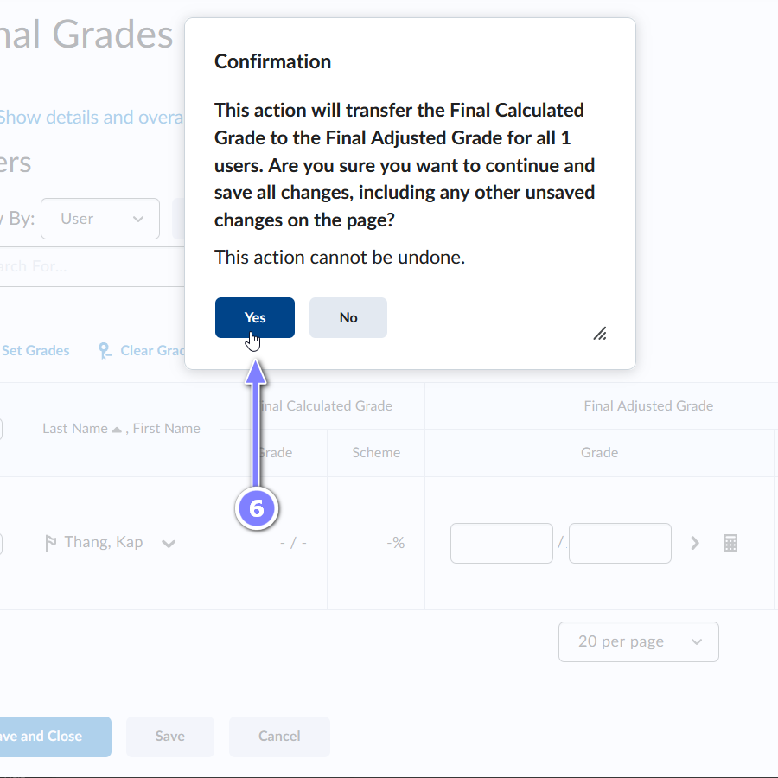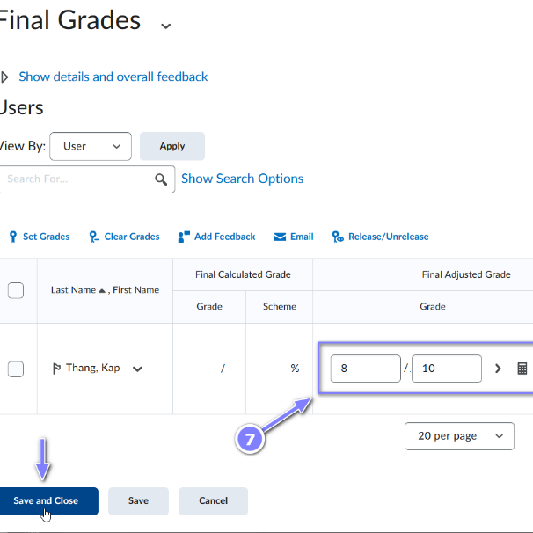

Release Adjusted Final Grades to your students

- Check that the Adjusted Final Grade is selected as the grade for release.
  - Click the Enter Grades tab.
  - Click on the Settings gear icon in the top right.
  - Select the Calculation Options tab.
  - Under Final Grade Released, ensure Adjusted Final Grade is selected.
  - Select the Save button at the bottom of the page.
  - Select Yes in the dialogue box that pops up.
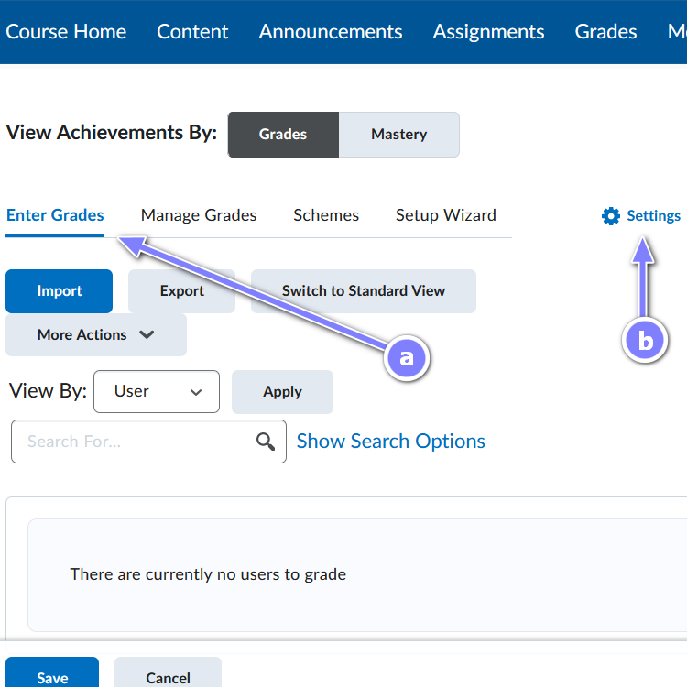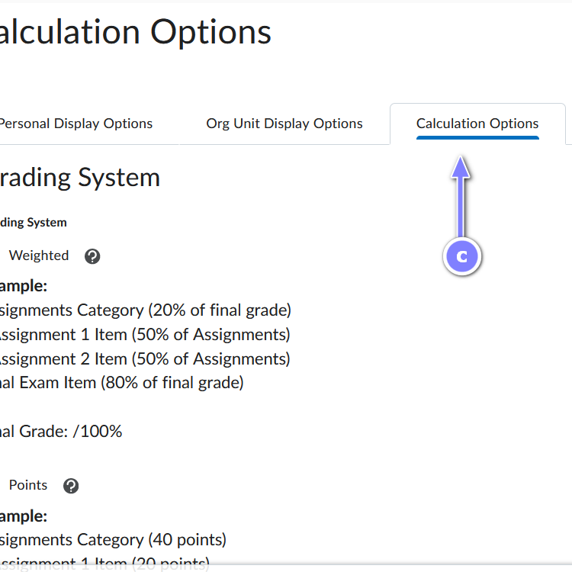
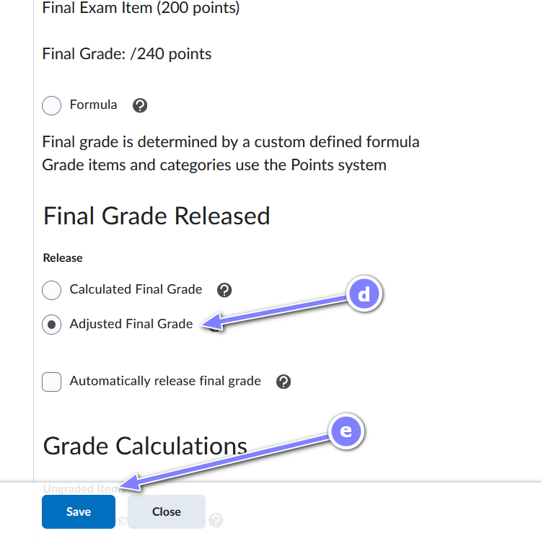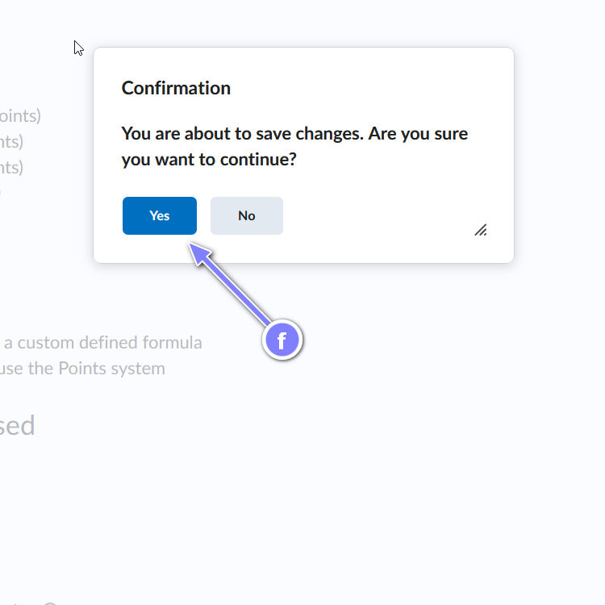
- Select the Close button.
- Select Enter Grades.
- Click on the drop-down arrow beside Adjusted Final Grade.
- Select Enter Grades, once more.
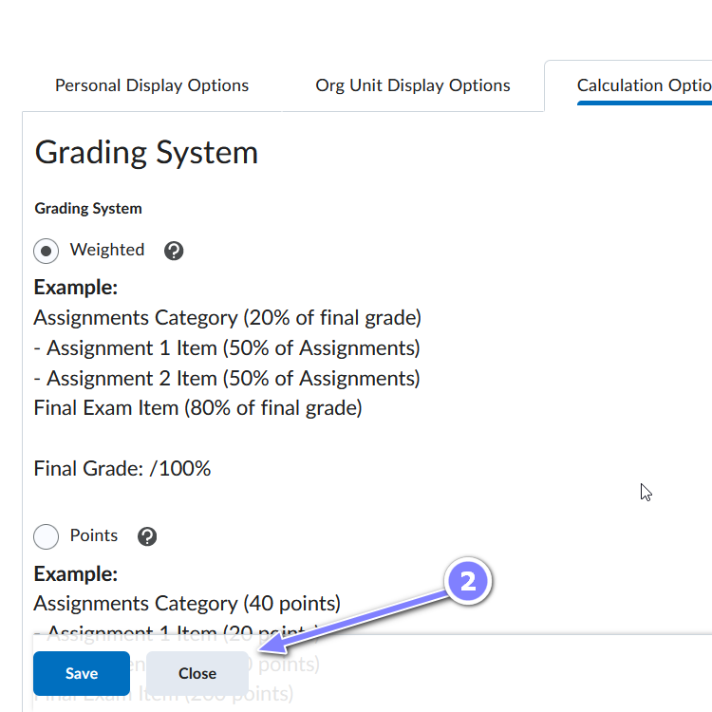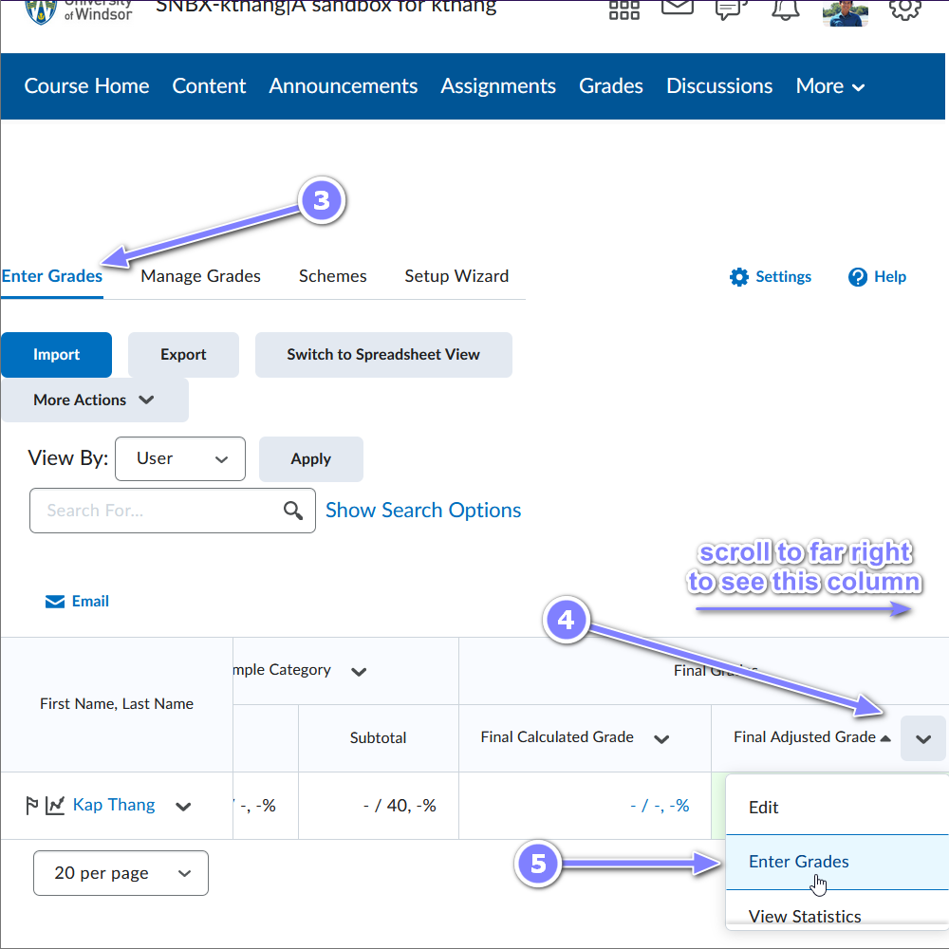
- Place a check in the box to the left of the Last Name column title to select all the students’ names. (If not all the students in your class appear on the screen, you will need to repeat steps 6 & 7 for each page of students.)
- Select Release/Unrelease. All the boxes under the Release column will now have checkmarks in them.
- Select Save and Close and then Yes in the pop-up box. Each student will now have a grade and an open eye icon in the Final Adjusted Grade column in the Grade Book.
