Changing Student Quiz Grades After Submissions Received
You can change your student’s grades even after they submit an assignment or a quiz. Let us first take you through an example scenario that we will work with.

Changing Grades Scenario:
You created a quiz consisting of 10 questions, each worth 10 points for a total of 100 points. However, students email you after receiving their grades, saying that one of your questions is incorrect. You look at that question and agree with the students. So how would you go about updating each student’s grade?
Editing the content of the quiz will not affect attempts completed or in progress. Previous quiz attempts reflect the quiz content and scoring as it appeared to each learner at the exact time, they started their attempt. Edits will only apply to future uses of this quiz. There are several ways to edit the grades. The simplest method is to change the grade assigned to students for this faulty question.

Correct the score given to students using “Update all attempts”
To correct the question error presented in our scenario, isolate the question and use the Update all attempts option.
- In Manage Quizzes, click the contextual arrow (the down arrow) beside the name of the quiz and select Grade.
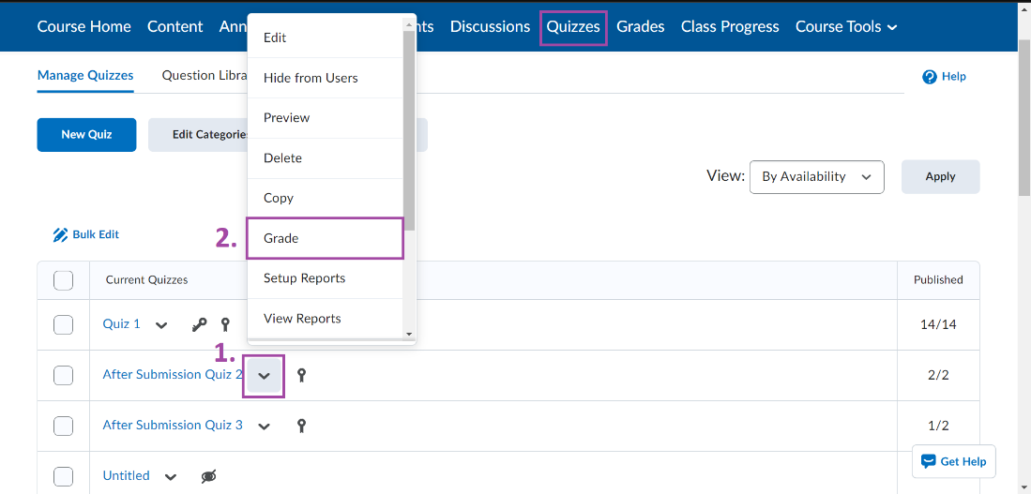
- Click the Questions tab.
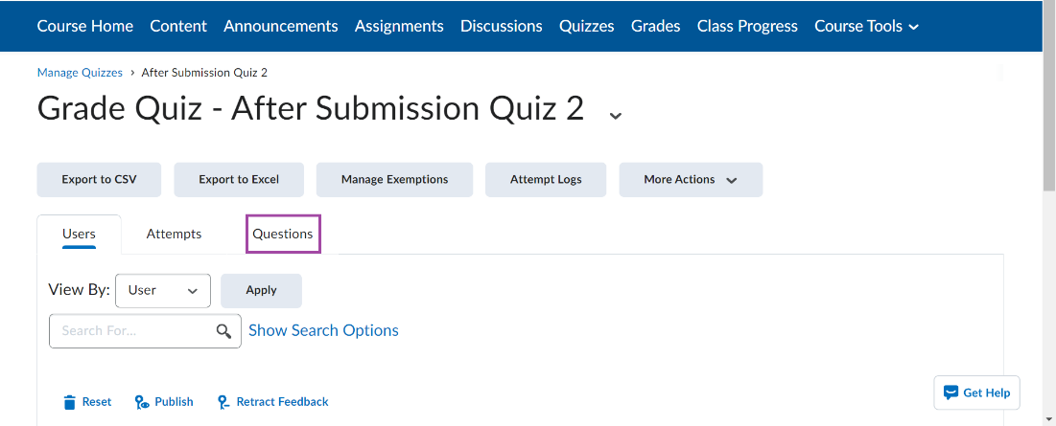
- Select Update all attempts.
- Click on the question that is incorrect.
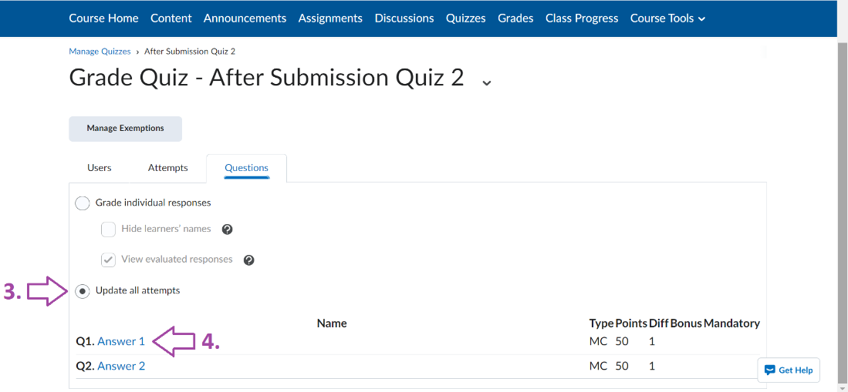
- Under Grading type, you can either select
  - Give to all attempts ___ points: Assigns the same point value to all students for the specific question.
  - Give to attempts with answer ___ _____ points: Assigns a point value for students who have a specific answer for the question.
- (Optional) You can also provide a reason for the grade change in the Comment text box which will be seen by students when they view their submission attempts.
- Click Save.
- On the confirmation pop-up, click Yes. Your change will apply to all submitted quizzes.
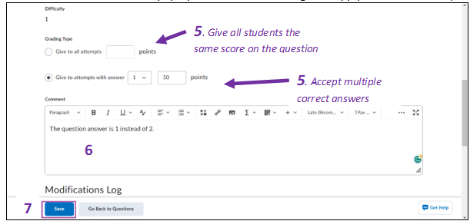

View Modification Log
You can access the quiz modification log by scrolling to the very bottom of the page of the question that you are editing. The quiz question modification log should look something like this:
This is what a student would see on their quiz attempt for the question that was changed:
Change Student Grades in the Gradebook
Another method to edit student grades is to manually change them in the gradebook. Use this method if you want to change the overall grade of a quiz, rather than change the score of one question.
- Click Grades in your course Nav bar.
- Select the Switch to Spreadsheet View button. This setting will enable you to input student grades for any assessments.
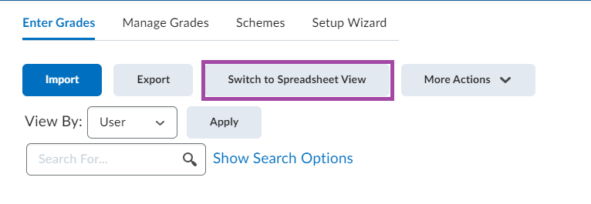
- Then, simply input the changed grades into the preferred student’s grade box. 