Copy material from another Brightspace course
- In the course that you want to populate (copy material into), click Course Tools on the Nav bar and select Course Admin.
- Select Import / Export / Copy Components.
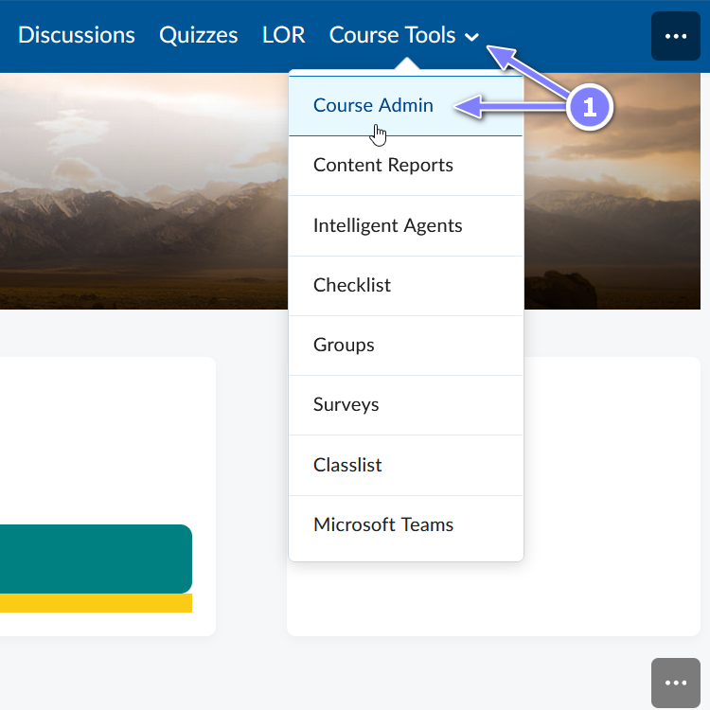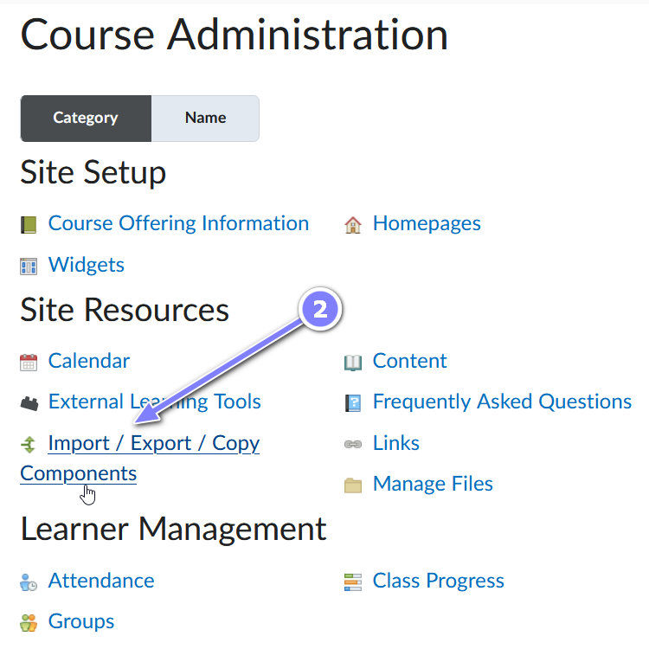

- Ensure Copy Components from another Org Unit is selected. (Org Unit means Course site)
- Click into the Search for offering button. A pop-up will appear.
- Type part of the name of the course you want to copy from and select the Search button.
- Select the radio button to the left of the course you want to copy from and click the Add Selected button.
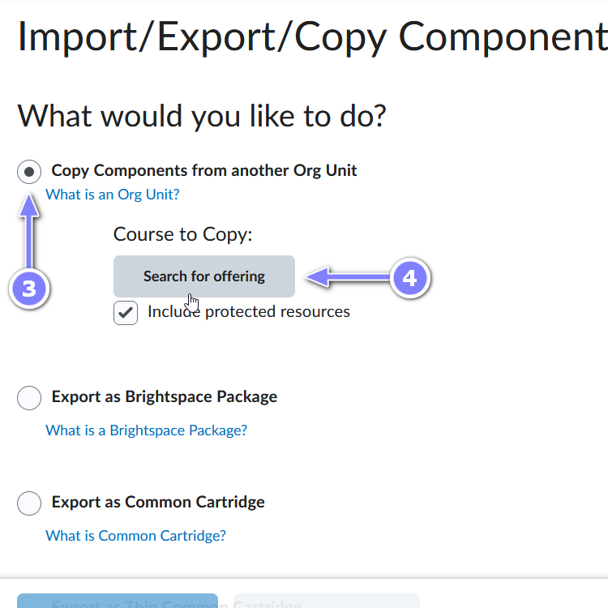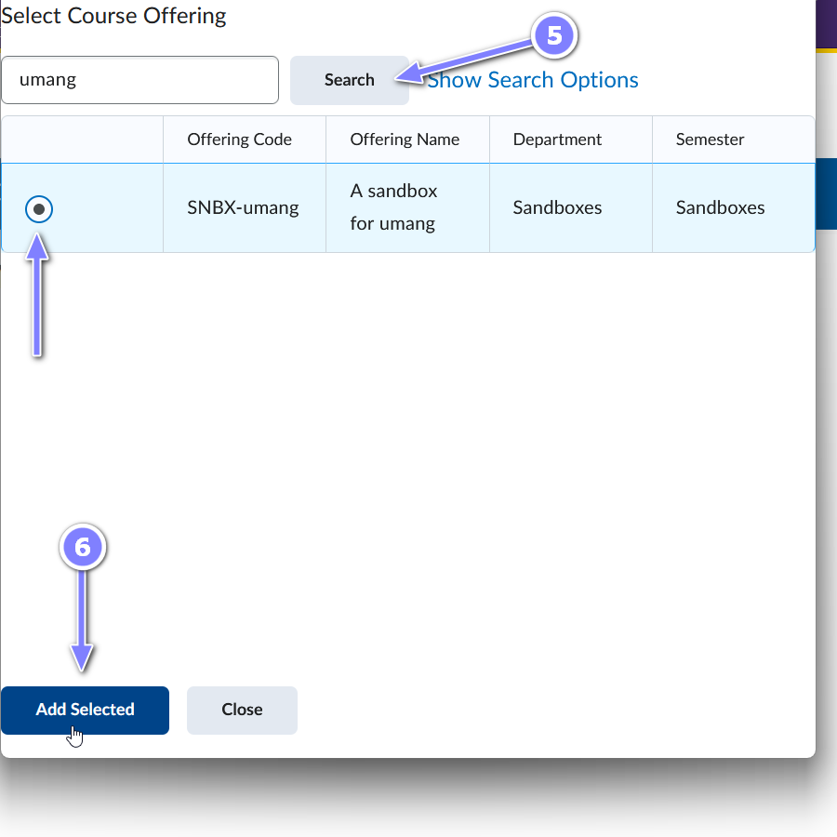
- Once the pop-up closes and the Import/Export/Copy Components page refreshes to include the Course to Copy you have selected, select either the Copy All Components if you want everything of the course to be copied or Select Components if you want to copy only select components.
  - If you select Select components: in the page that appears click beside the components you would like to copy and click Continue.
  - On the Confirm Components to Copy, select Finish. (If you want your start, due and end dates to be offset to match the current term’s dates, you can select the Offset all dates of copied components and select the Days before selecting Finish.)

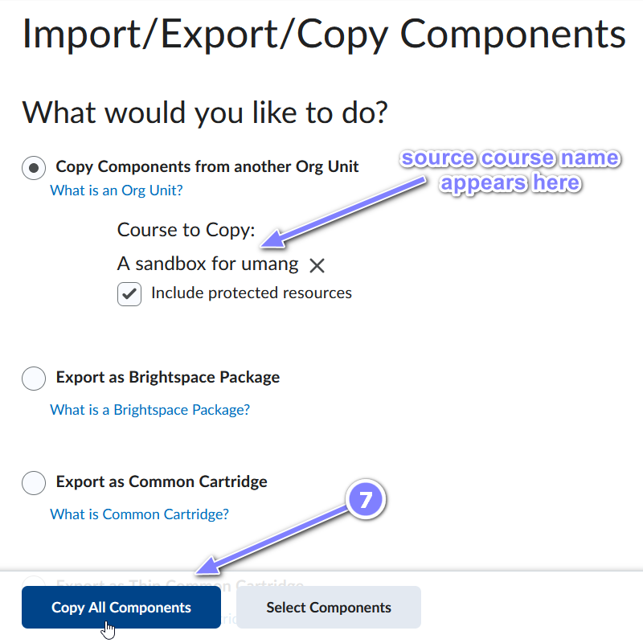
- A progress bar will appear to show the copying process.

