Exporting Videos from a Blackboard Site into YuJa,

then Adding Video to Brightspace Site

Exporting videos from your Blackboard site and then adding them to your new Brightspace site is straightforward if you follow the few steps below.

Step 1: Retrieving Videos from Blackboard
- Access the Blackboard site with the videos you wish to move
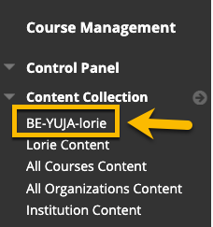
- Click the Content Collection and locate your course in the options and click the course name.
- Locate the video(s) in the list and check the box beside the video to download. (Note, you may have several pages of content that you can use the Show All option at the bottom of the page to display all content).
- Click the checkbox beside the video(s) you wish to download, then click the Download Package button to receive a compressed .zip file of the videos.
- Save the file to a location on your computer that you can locate and retrieve the files in the next step. By default, a lot of browsers will save files into a Download folder unless you have specified another location for saving files. 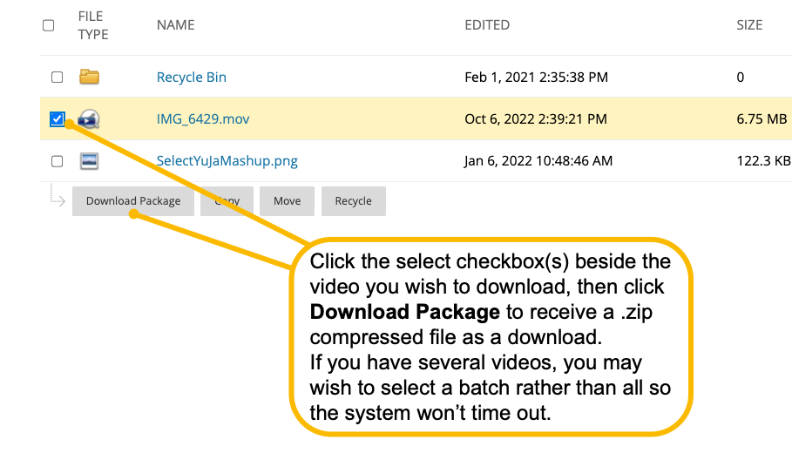

Stage 2: Upload files to YuJa
Once you have downloaded the files from Blackboard, you will want to double click on the .zip file so the videos will expand into a folder. You can upload multiple files simultaneously if they are the same type.

- Log into YuJa at http://uwindsor.yuja.com
- If you haven’t used YuJa before this will initiate your account. You will upload your videos into the My Media section of YuJa. You can also make folders to help organize your materials. To upload, click the Manage Media button at the top of the screen.
- Locate the .zip folder you have downloaded with videos. Double Click the .zip file to expand the files into a folder if you haven’t already done that.
- (Optional) Create a new folder in YuJa for the videos if desired by clicking the New Folder option. Select that folder if created.
- Click the Upload option and select the video(s) on your computer after you have uncompressed the .zip file (or multiple select for more videos if files are the same type). Browse or drag and drop the files to import to YuJa.
- Once in YuJa, you can get the Direct Link to the newly uploaded video to share as a web link in your course, or email, or other location by hovering over the video and selecting the More option. Click More, then click the Links option, then copy the link to paste where needed. Alternatively, you can use the YuJa Media Chooser (detailed below).

Step3: Inserting the YuJa Video into your Brightspace Course using the YuJa Media Chooser
Anywhere you find the text editor in Brightspace, you can add YuJa Videos through the Insert Stuff icon and selecting the YuJa Media Chooser to access and inserting the video.

Below, we will provide an example of adding a video through a Content item, (Create File) then using the icon in the editor to access the YuJa Media Chooser to insert the video and player into your site.
- Log into Brightspace at http://brightspace.uwindsor.ca and access the course you wish to import the new YuJa video from the Course Selector .
- Under the Content option on the Nav Bar, select Upload / Create (See image below)
- Choose Create a File and provide a fitting title
- Click the Insert Stuff icon
- Select the YuJa Media Chooser. You will be brought to your Media section where you can locate the video through scroll bars, or the Search field near the top.
- Select your video (will outline selected video with a blue border), then click Insert Content (see image below)
- You will be brought to a preview screen. If you are satisfied with the choice, click Insert. Optional, add descriptive text of make any final adjustments in the content editor.
- Click Save and Close to complete.

