How to Grade Discussion Posts in Brightspace
- Navigate to your course Discussions.
- Click on the down arrow beside the topic to grade.
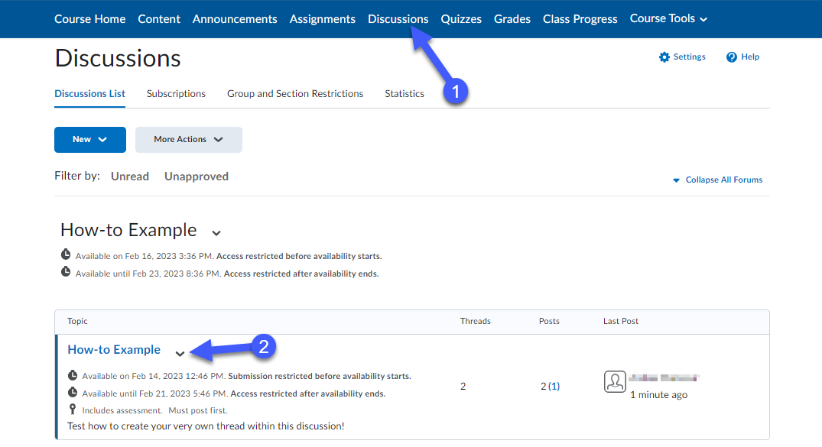
- Select the Assess Topic option. (This will only show if the topic thread is linked to the grade book).
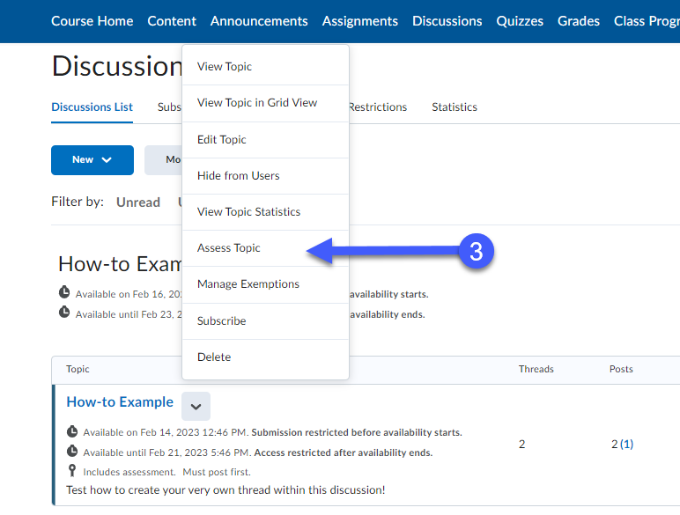

- Navigate to the student you want to evaluate and click on Topic Score.
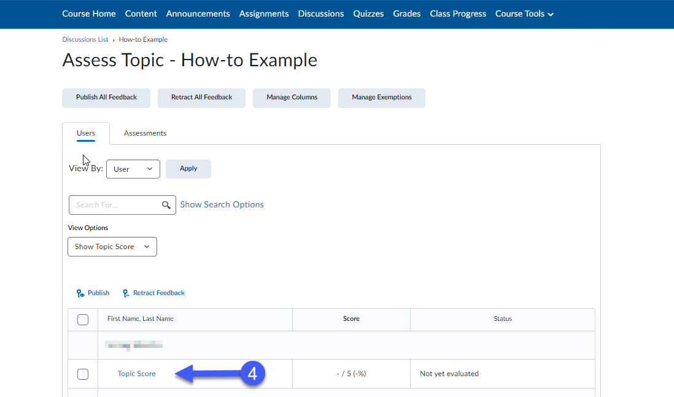
- If a rubric is attached to this discussion, click on the arrow on the rubric and mark accordingly.
- If there is no rubric, the points can be placed manually into the topic Score box.
- Use the Overall Feedback text box for adding overall feedback.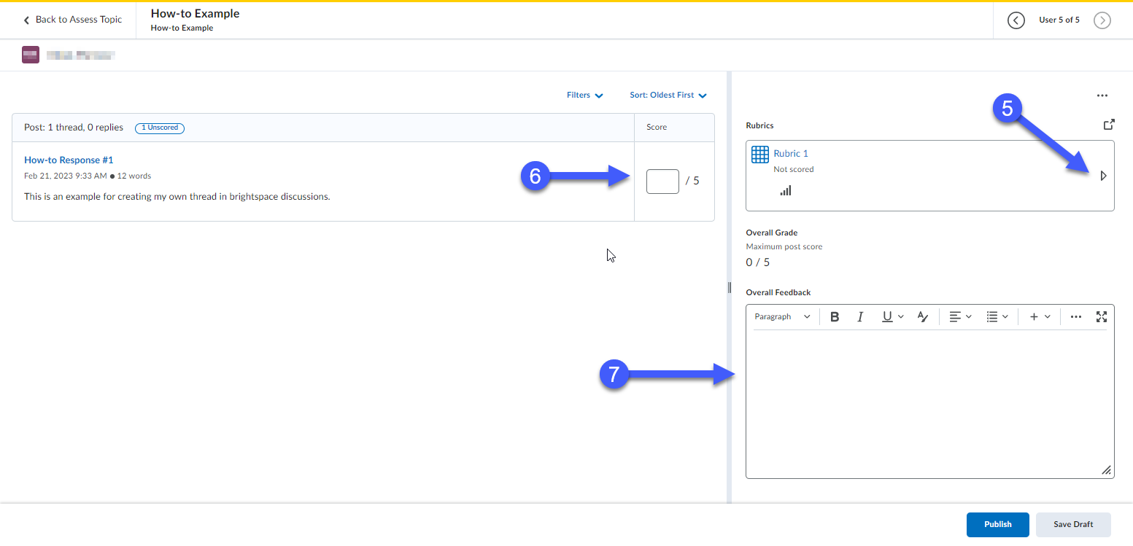

- Once finished grading, click Save Draft. This will save your work but will not release your grades to the student so you can publish grades to all students at once. If you want to release grades to each student as you grade them, select Publish.
- Click on the right arrow on the top right of the page to bring you to the next student to grade.
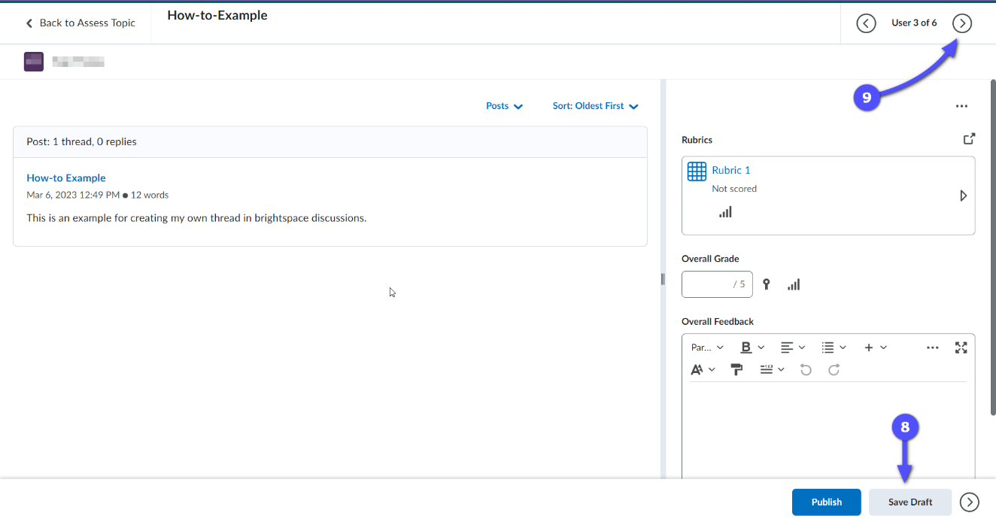
- When you are ready to publish, go back to the assess topic page (as shown in step 3 above), select the check box in the column heading so that all students’ check boxes are selected and select Publish. (Note: if you have more students than appear on the first page, you will need to go to the next page, select all the check boxes and Publish until all the students’ names have been selected.)
