How to add a meeting link to the Brightspace navbar

Retrieve the meeting link in Teams
(If using a different platform, you will need to copy the meeting link you will be using in that platform)

  - In Teams, click on the Calendar icon in the left menu rail, then find and double click on the meeting you’ve created (see Create a recurring Teams meeting) to view the meeting details.
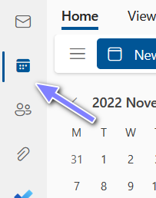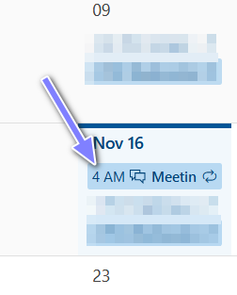
- Scroll down to see the Click here to join the meeting link. Right mouse-click on it and select Copy Link (desktop version) or Copy Link Address (or something similar, depending on the browser). 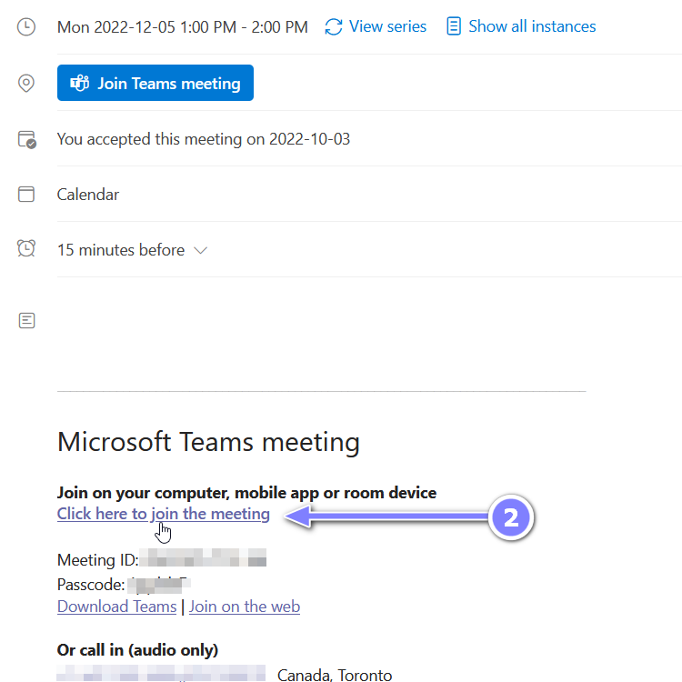

Add the meeting link to the Brightspace navbar

  - Login to https://brightspace.uwindsor.ca and go to your course. Click the three dots (…) on the far right in the navbar then click on Customize This Navbar (or Edit This Navbar if you already created a copy). In the popup window asking if you want to create a copy and edit that instead, select Yes.
  - Click on Add Links.
  - Click on Create Custom Link.
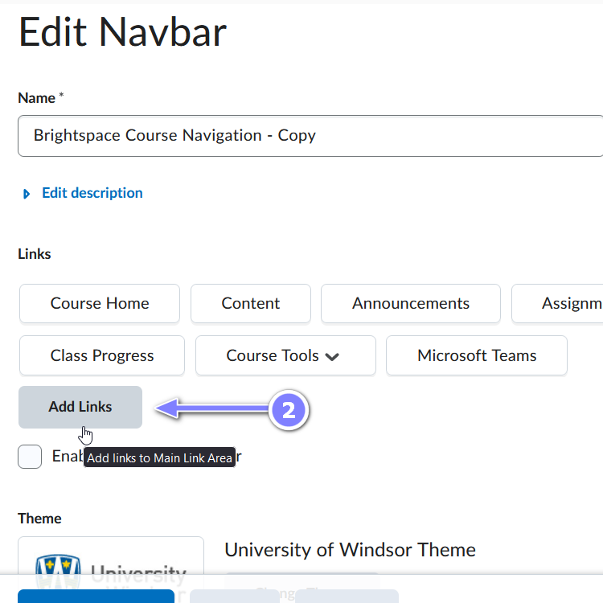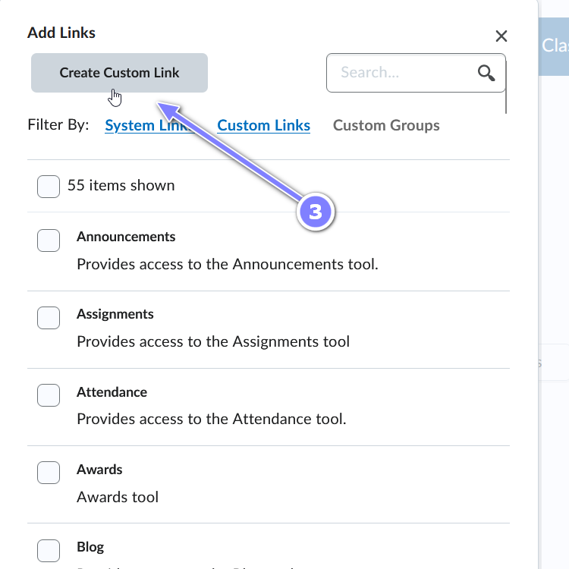
- Enter a name for the link.
- Paste the link you saved in step 1.3) above. If you have another meeting link such as Zoom meeting link, you can paste that as well.
- Click Create.
- With the newly created link selected, click Add.
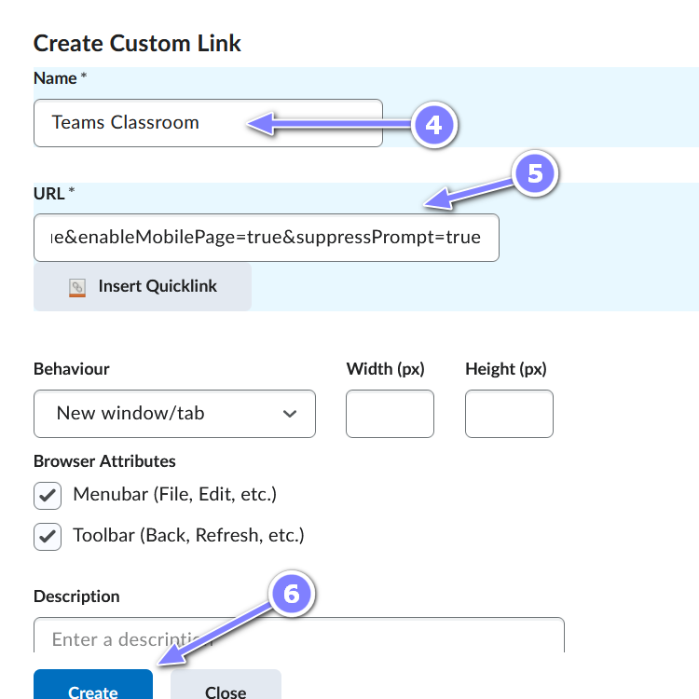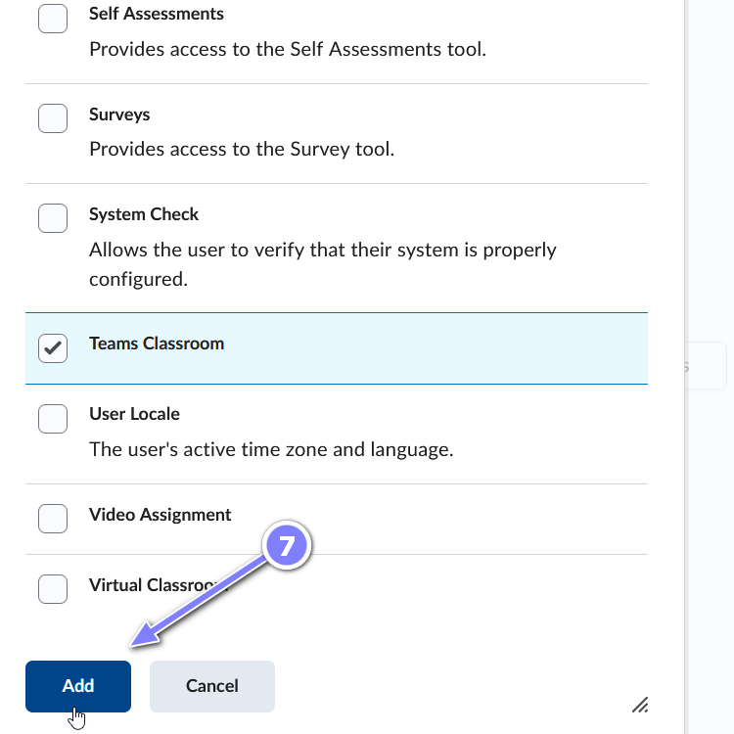
- Click Save and Close (notice the custom link is added to the Links list).
- The custom link is now visible in the navbar for this course for students to see.
