How to copy a link from a Teams recording and add to the Content area in Brightspace
- Navigate to your Microsoft Teams application and select the course lecture you have recorded.
- Once the recording has finished, this will show under the course chat in Microsoft teams.
- Click on the three dots in the top right corner of the recording icon and click Get Link and click Copy.
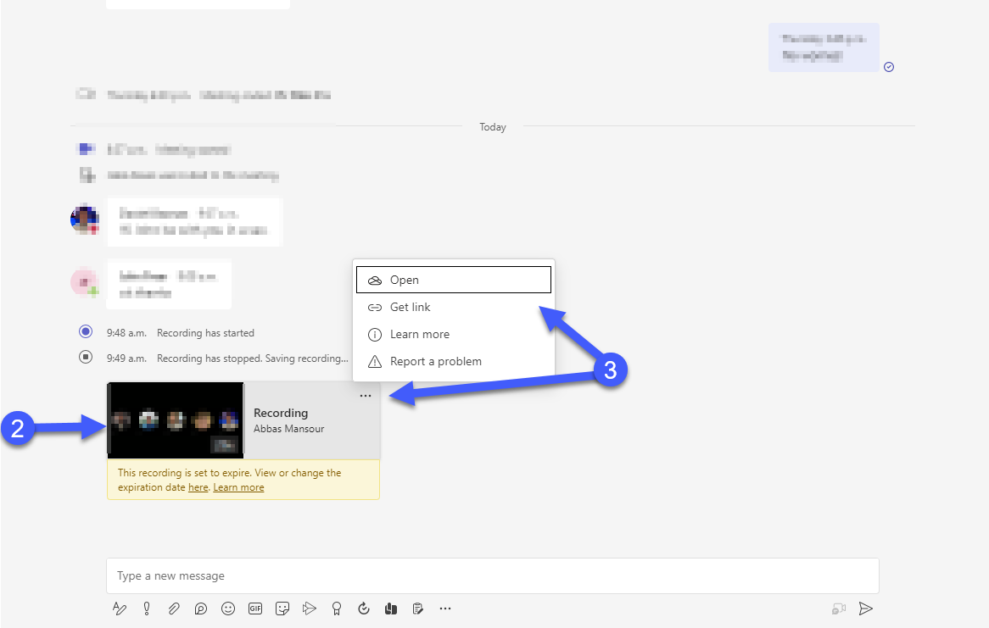
- Log into https://brightspace.uwindsor.ca/ and go to your selected course.
- On the navigation bar within the course, click Content.
- If you have not already done so, create a Module where the recordings will be placed in a section for the student’s view.
- Click on the Upload/Create button within the module and click Create a Link in the drop-down menu.
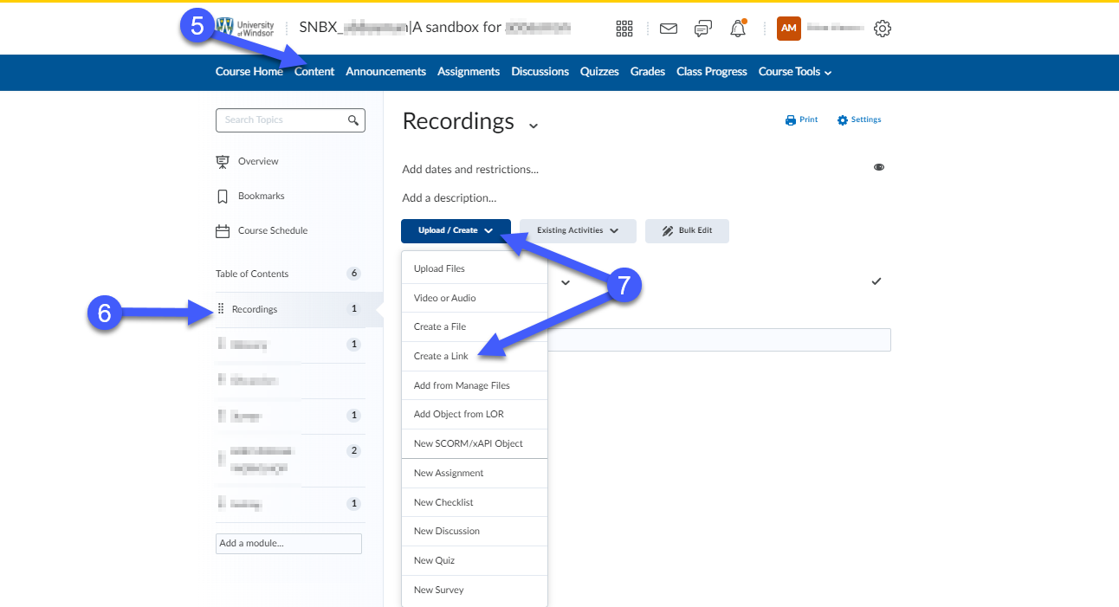
- Give the recording a title to distinguish between different recordings and paste the link that you copied from Microsoft Teams (in step 3 above) into the URL box.
- Click Create. The link will now be visible within the module for you and your students to see.
