How to create a video assignment on Brightspace

Note: a video assignment grade item does not appear in the Grades page until the first published submission

- Navigate to your course site on Brightspace then click Content in the Navbar.
- Select a module of your choice for where you would like to post the video assignment. In this example, we have chosen to place it in the module called Video Assignments. Click on the module name in the Table of Contents to open its editing screen on the left. Then click Existing Activities, scroll down and select Video Assignment.
- In the pop-up that appears, click Individual project option, which appears as a individual person icon. (The other three options are not available.)
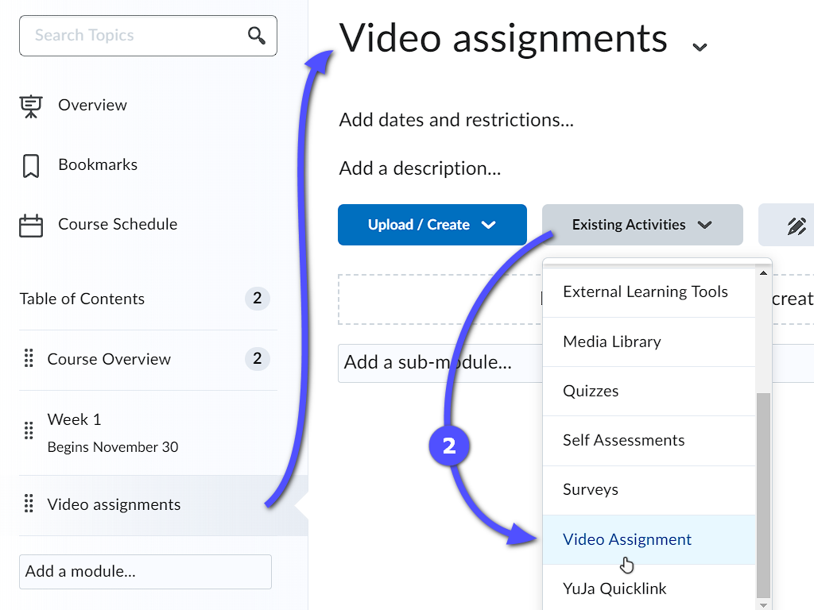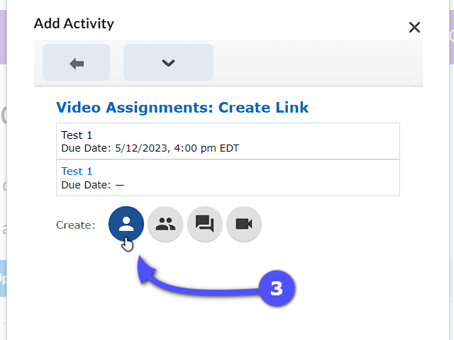
- On General page, provide an Assignment Name for this video assignment, as well as a Due Date and Due Time, if desired.
- Leave the Evaluation Type as Percentage unless a different type is required.
    - All Evaluation Types will be graded out of one hundred
    - If your gradebook is on a Weighted system, make sure to adjust the weight of this assignment after the first published assignment. You do this in the Manage Grades page.
- Type or paste in the Instructions. The limit is 5000 characters. Record or upload a video of your instructions, if you choose, by clicking on camera icon.
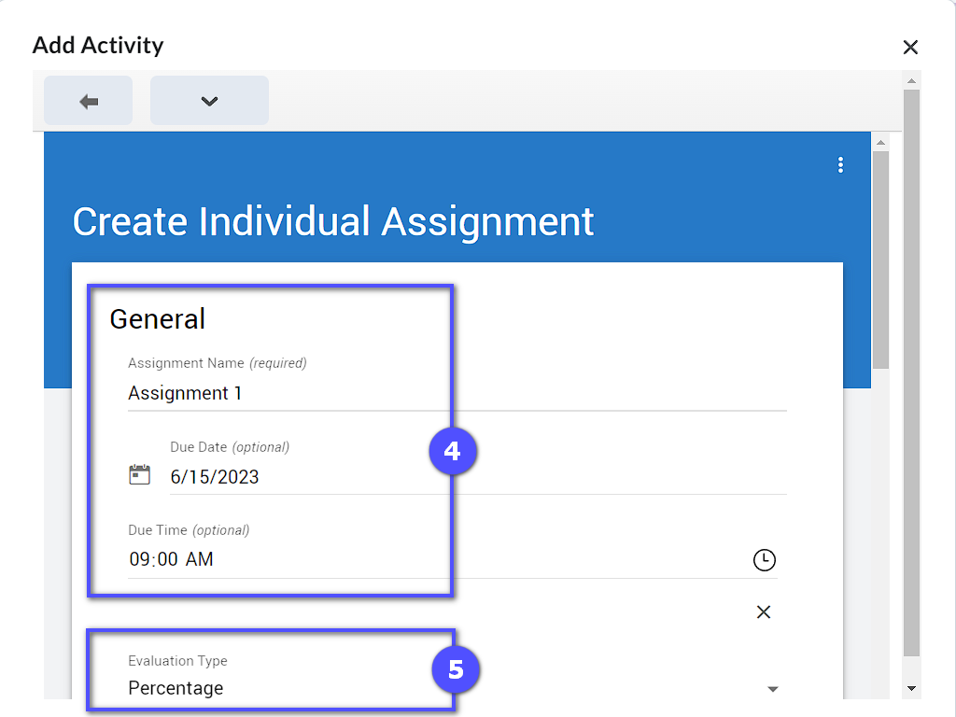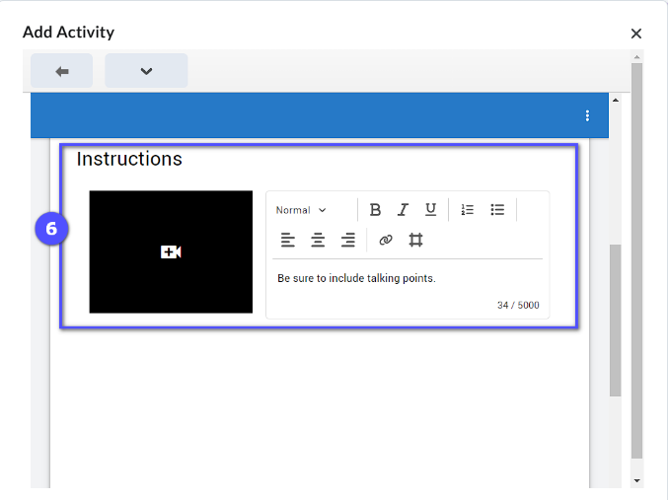
- Auto Analysis is not available.
- Peer Review. If you want your students to review each others’ video assignments, click the Peer Review toggle so it is on the right and red. Enter the number of students to provide a peer review in the Number of Required Reviews field.
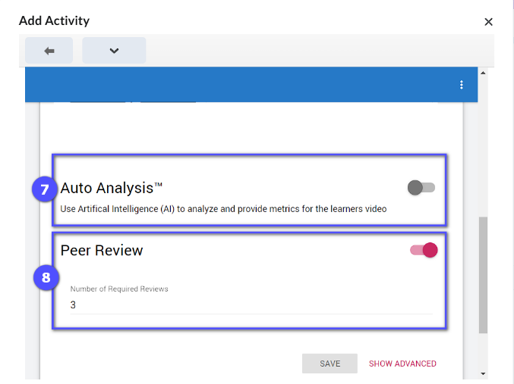

- Click Show Advanced, if you want to include Post-Submission Instructions, in text or video and/or a due date and time for peer reviews. All other Advanced option are not available.
- Click Save to finalize the assignment setup.
- You will be brought back to the Video Assignments: Create Link page. Select the assignment you just created. A link to it will be added to your Content.
