How to Create Groups

- Open your course site in Brightspace.
- From the Navbar, go to Course Tools > Groups.
- Click on New Category. A category is a way to organize these groups. I.e., if you would like to switch group members between different assignments, you can create a category named Assignment 1 and another Assignment 2 so that the groups are different for each assignment. If you do not different groups for different assessments or learning activities, simply create only one category.
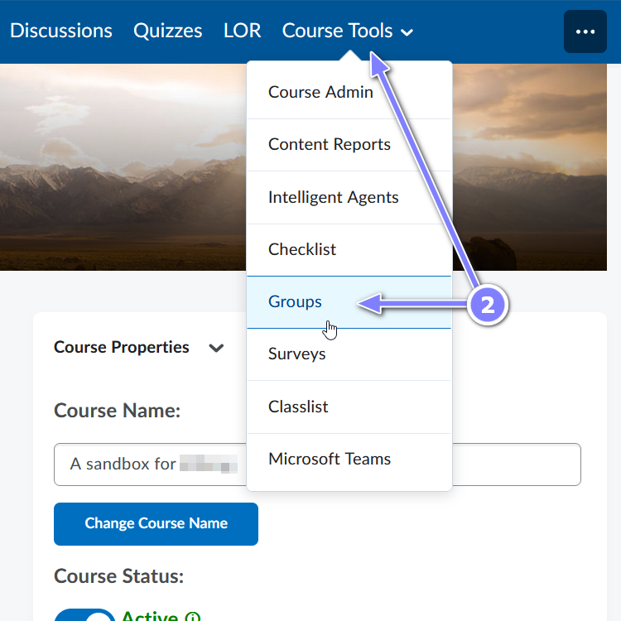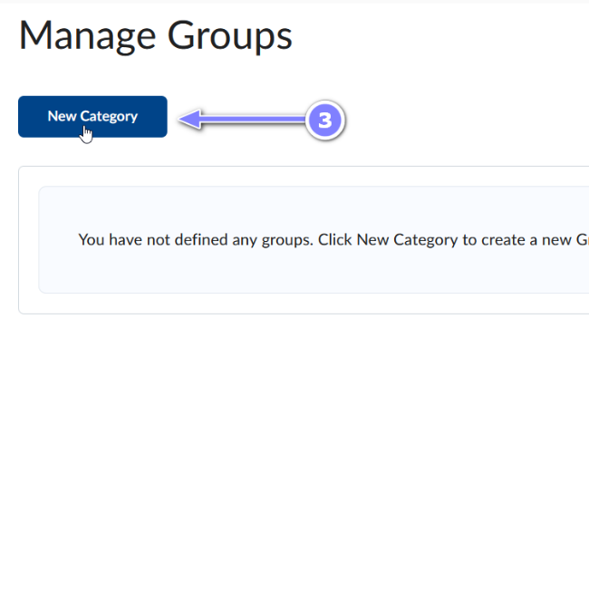
- Fill in the Category Name and, if you would like, the Description.
- Select the desired Enrolment Type.
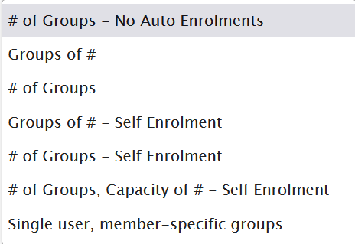

# of Groups–No Auto Enrollments:
This option creates a specified number of groups, for which you can add any number of users
Groups of #:

This option creates a minimum number of groups needed to place users in groups of a specified maximum size. User can be auto enrolled or manually enrolled.
# of Groups
This option creates a specified number of groups. Learners can be auto enrolled or manually enrolled.

Groups of # – Self Enrollment
Similar to second group type however learners can enroll themselves into groups.

# of Groups – Self Enrollment
Similar to third group type however learners can enroll themselves into groups.
# of Groups, Capacity of #
– Self Enrollment
This option creates a specified number of groups with a specified number of enrollments per group. Learners can enroll themselves.

Single user, member-specific groups

This option creates a group with a single user where the first name and last name of the learner is the name of the group. This is mostly used to create a journal type groups with a single member

- Depending on the enrolment type selected, you may need to enter the number of users and/or groups.
- Restrict Enrollments To*: Use this option to create subgroups within an existing group

- Group Prefix: Use this option to modify group names (i.e., write “Team” to use Team 1, instead of Group 1)
- Create Workspace: You can choose to create group-specific assignments (a different assignment for each group), provide lockers for the group members to share documents, and group discussion areas.
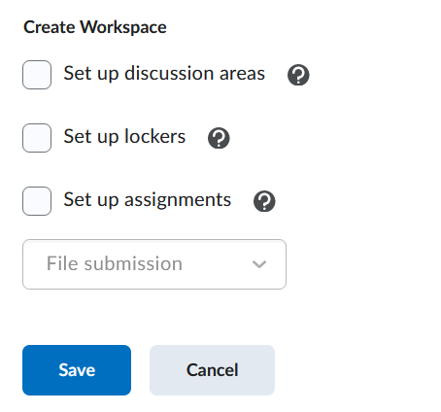

- Click the Save button to finalize all the selected options. Now when you create an assignment you will see the Group Assignment option in the Submission & Completion area.

Managing Groups:
If you have created multiple categories of groups, select the one you’d like to manage in the View Categories drop-down menu, then click on the chevron next to the name of the category to view the pop-up. Select the appropriate action from the pop-up.
