How to Create Groups

- Open your course site in Brightspace.
- From the Navbar, go to Course Tools > Groups.
- Click on New Category. A category is a way to organize these groups. I.e., if you would like to switch group members between different assignments, you can create a category named Assignment 1 and another Assignment 2 so that the groups are different for each assignment. If you do not different groups for different assessments or learning activities, simply create only one category.
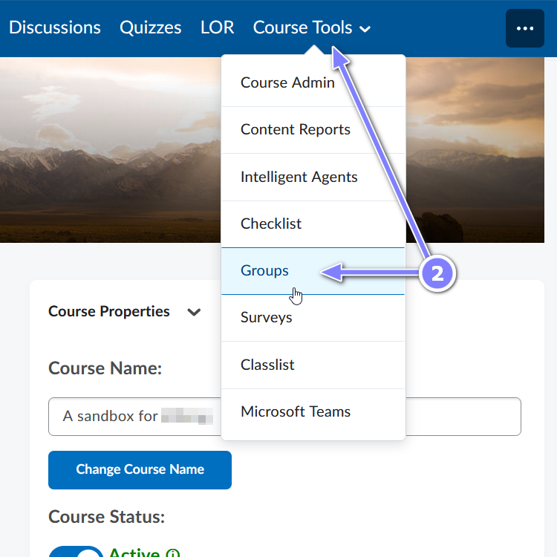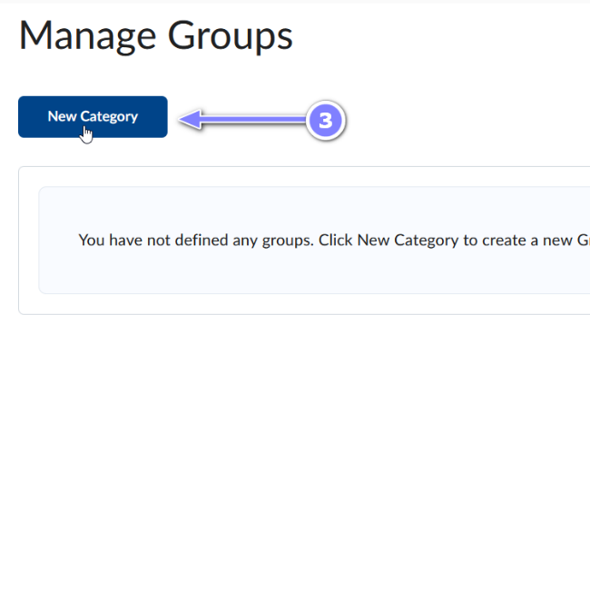
- Fill in the Category Name and, if you would like, the Description.
- Select the desired Enrolment Type.
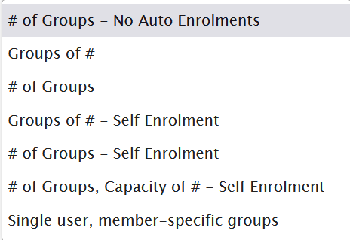

# of Groups–No Auto Enrollments
This option creates a specified number of groups, for which you can add any number of users manually
Groups of #

This option creates a minimum number of groups needed to place users in groups of a specified maximum size. User can be auto enrolled or manually enrolled.
# of Groups
This option creates a specified number of groups. Learners can be auto enrolled or manually enrolled.

Groups of # – Self Enrollment
Similar to second group type however learners can enroll themselves into groups.

# of Groups – Self Enrollment
Similar to third group type however learners can enroll themselves into groups.
# of Groups, Capacity of #
– Self Enrollment
This option creates a specified number of groups with a specified number of enrollments per group. Learners can enroll themselves.

Single user, member-specific groups

This option creates a group with a single user where the first name and last name of the learner is the name of the group. This is mostly used to create a journal type groups with a single member.

- Depending on the enrolment type selected, you may need to enter the number of users and/or groups.
- Restrict Enrollments To*: Use this option to create subgroups within an existing group.
- Group Prefix: Use this option to modify group names (i.e., write “Team” to use Team 1, instead of Group 1)
- Advanced Group Options: What appears here will depend on what was selected in step 5.
  - Auto-Enrol New Users: When new users are enrolled in the course after groups are set up, they are automatically added to the group with the fewest users.
  - Randomize users in groups: Selecting this option enrolls users in a random order. Clearing this option enrolls users based on their order in the classlist.
Example of students enrolled into 3 groups by classlist order:
Student A -> Group 1
Student B -> Group 2
Student G -> Group 3
Student J -> Group 1
Student T -> Group 2
Student Z -> Group 3
  - Make category and group descriptions visible to group members: Students will be able to see the Category Name and whatever you entered into the Description text box.
  - Set Self Enrollment Start Date: Users will be able to see the available groups, but unable to self-enroll prior to the start date, or after the expiry date. Manual enrollment by the instructor can occur at any time. Not choosing a date means the group is available for enrollment at any time after creation.
  - Set Self Enrollment Expiry Date: Users will be able to see the available groups, but unable to self-enroll prior to the start date, or after the expiry date. Manual enrollment by the instructor can occur at any time. Not choosing a date means the group is available for enrollment at any time after creation.
  - Allocate unenrolled users after Self Enrollment Expiry Date: This control will automatically and randomly assign students to a group if they are not already assigned by the expiry date provided. Capacity will be ignored.
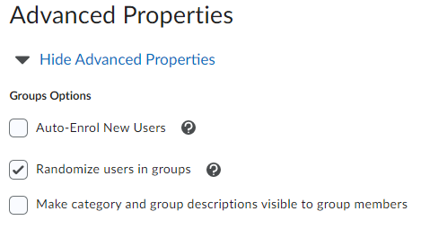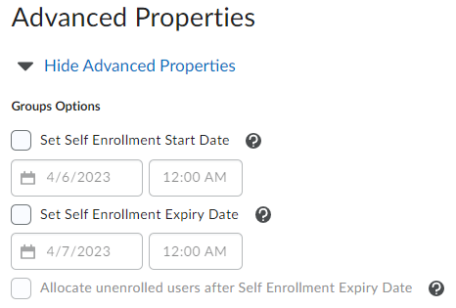
- Additional Options - Create Workspace: You can choose to create group-specific assignments (a different assignment for each group), provide lockers for the group members to share documents, and group discussion areas.
  - Discussion Areas provide a discussion space for each group using a new or already created forum. Users in the group can create new topics to discuss with their group.
  - Lockers provide a place to store all the group’s files and documents.
  - Assignments allows for assignments to be assigned to either all users of a group, or to individual users.
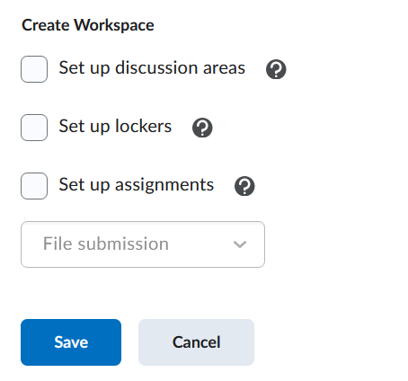
- Click the Save button to finalize all the selected options. You will see a chart of your groups and the selections made.
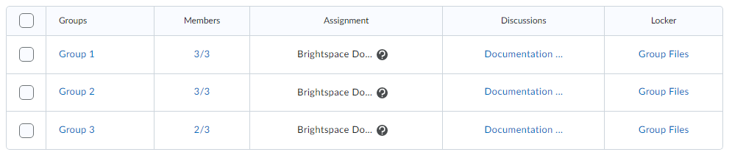
When you create an assignment you will now see the Group Assignment option in the Submission & Completion area.

Managing Groups:
If you have created multiple categories of groups, select the one you’d like to manage in the View Categories drop-down menu, then click on the chevron next to the name of the category to view the pop-up. Select the appropriate action from the pop-up.
