How to download a classlist

- Navigate to Grades > Enter Grades.
- Click on Export.
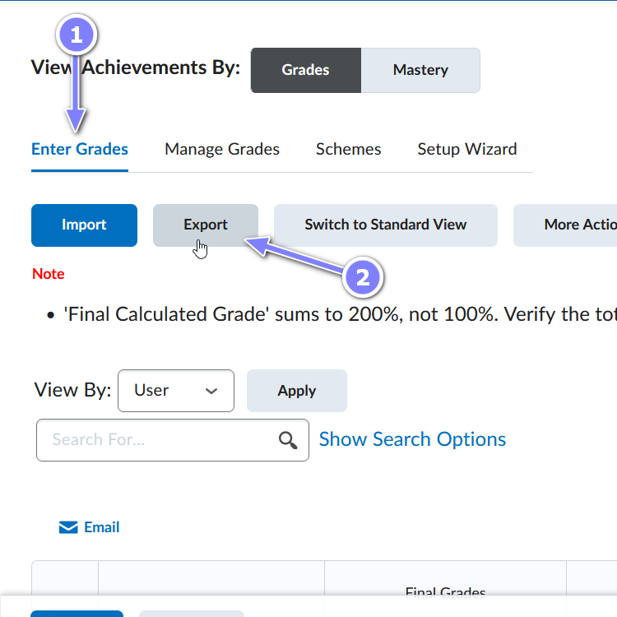
- Select the items to include in the exported spreadsheet. Notice there’s an option to select the order of sorting the list.
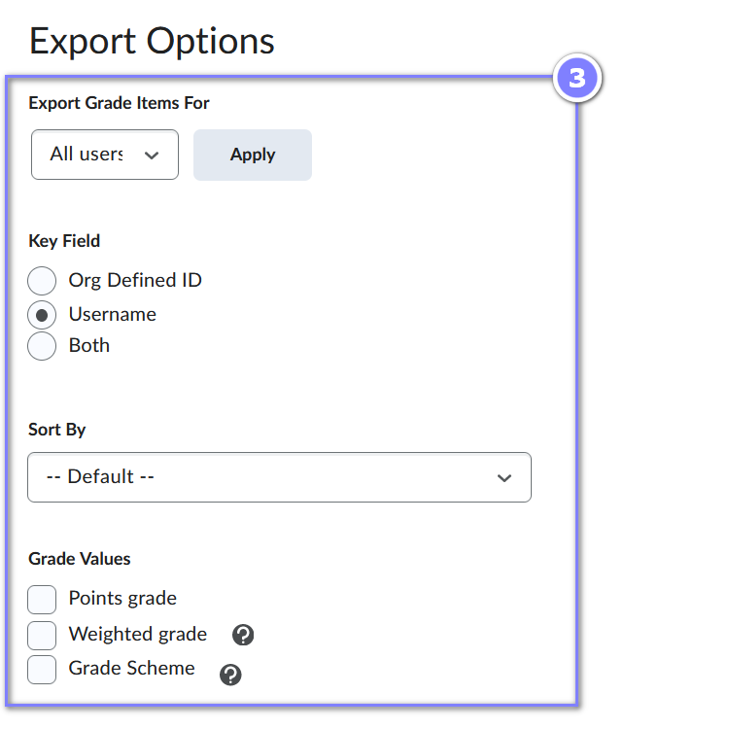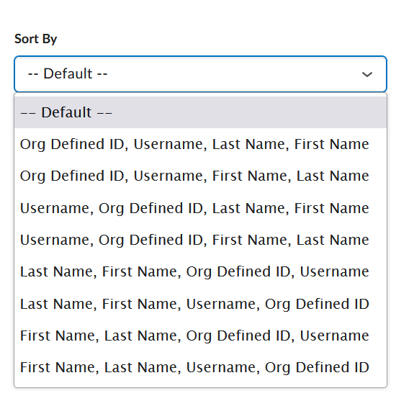
- Scroll down and select any grade items to be included in the spreadsheet then click on either Export to CSV or Export to Excel. Both will output in spreadsheet format.
