Upload Scantron results to Brightspace Grade Book
- In your Brightspace course select Grades in the Nav bar.
- In the Enter Grades tab select the Import button.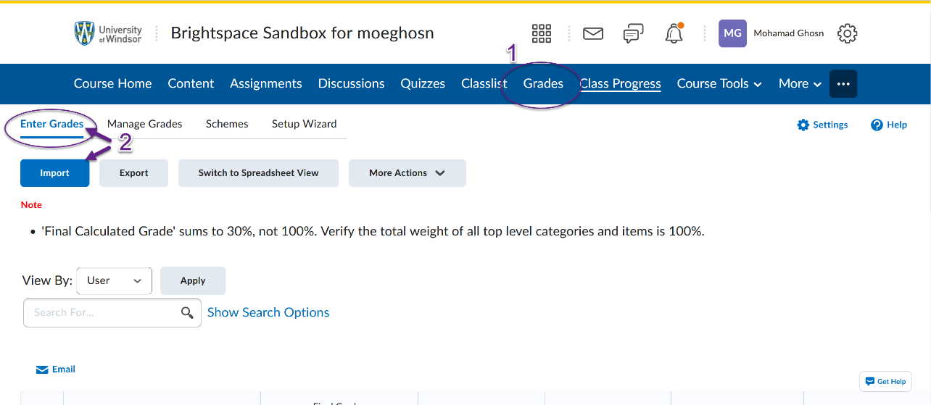
- Under Import File click Choose File (Chrome) or Browse (Firefox), find the .TXT file that you were given and select it.
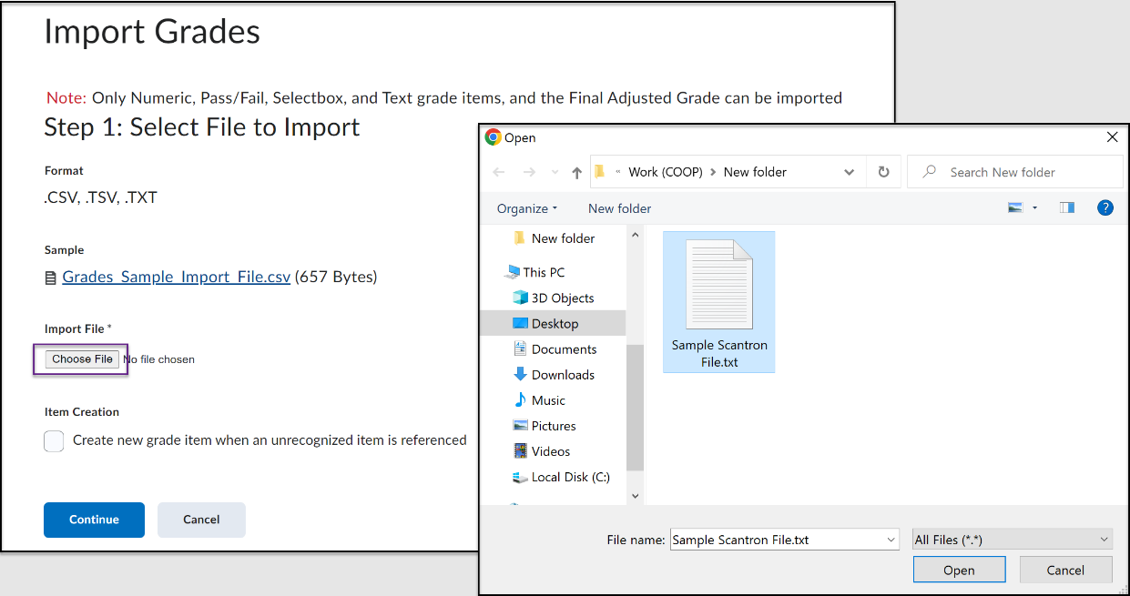

- If you would like to create a new column in your Grade book while importing the Scantron report, check off the Item Creation option. If the desired column is already created, then leave this option NOT selected.
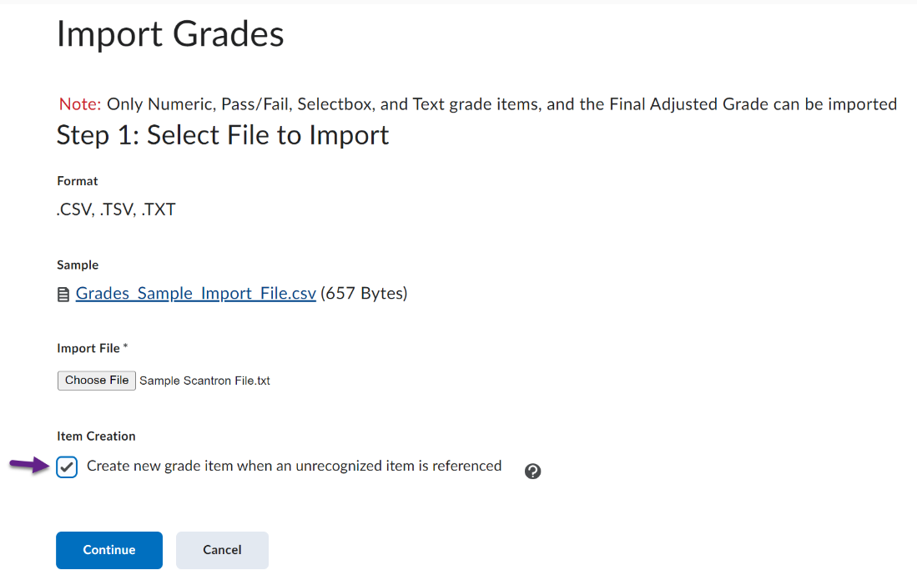
  - If you choose to create a new grade item, ensure the proper type has been selected (numeric or a pass/fail assignment) and fill out the proper settings for Maximum Points and Weight have been set. (Note: The Maximum Point set cannot be smaller than a Points Grade set within the Scantron i.e., setting the maximum points to 10 when, in the scantron above, there are grades given up to 42 points.)
- Once all settings are set, a screen showing errors and warnings will appear. If no errors or warnings are found, then click continue to import the grades.
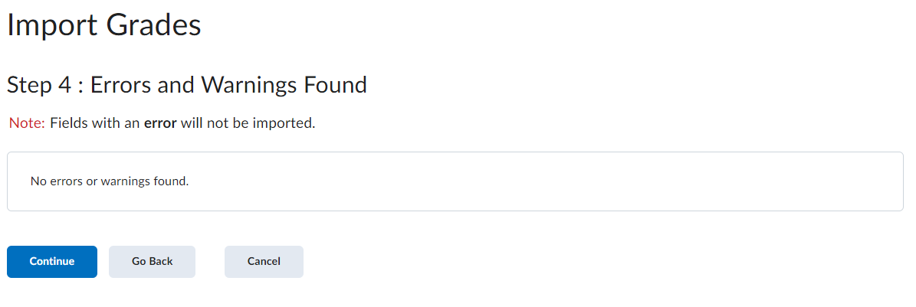
- Preview of Import will be shown with all the student’s names and grades. Click Import to finalize the Scantron import.

