How to import grades to Brightspace
In order to import grades to Brightspace, you must have a file of the grades in an acceptable format. See three options in steps 2, 3, and 4.
- Navigate to your course site on Brightspace and click Grades in the Nav bar.
- Select the Enter Grades tab. (Here you can Export the existing Gradebook to make adjustments offline, if you want.)
- Click Import. (Here you can download the Grades_Sample_Import_File to use as a template to create your own file, if you want.)
- Click Choose File and browse and select the file to import. (Here you can select a file created from an export or from the sample file, or a file exported from Blackboard.)
- Check the Item Creation checkbox to create new columns that are not automatically recognized by Brightspace.
- Click Continue.
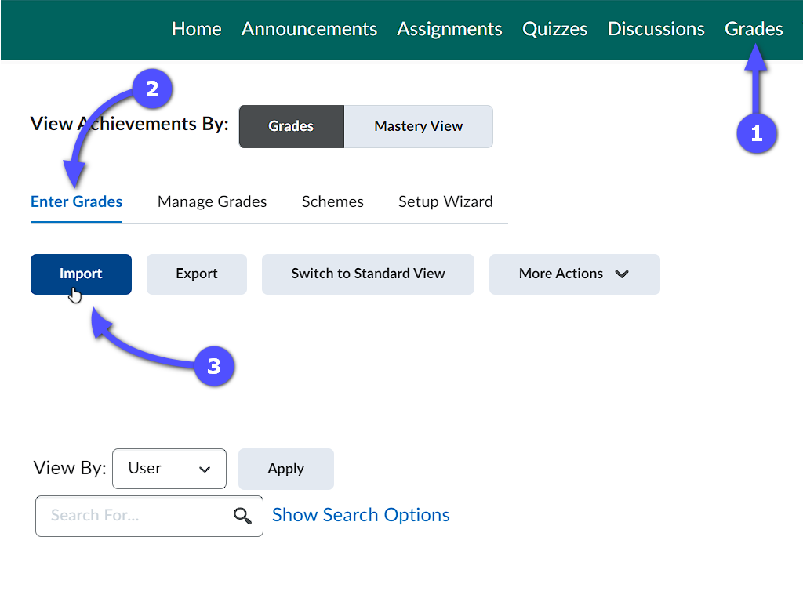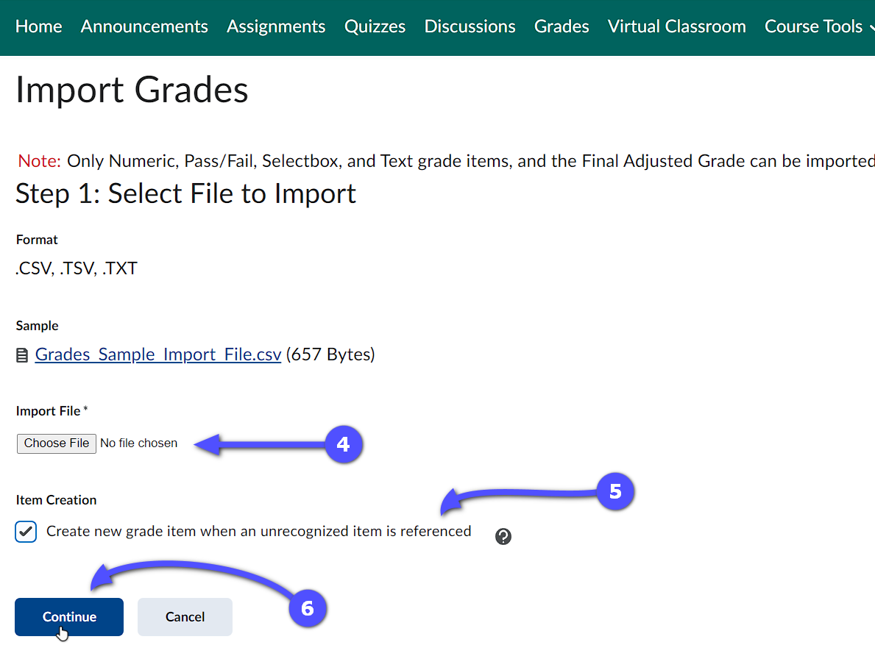
- If there are no errors, click Continue again.
- Review the import preview to ensure there are no errors and then click Import to finalize the process. The grades should now be visible on the Enter Grades page.
