How to import grades to Brightspace
To import grades to Brightspace, you must have a file of the grades in an accepted format, typically in CSV, TSV or TXT format. See three options in steps 2, 3, and 4.
- Navigate to your course site on Brightspace and click Grades in the Nav bar.
- Select the Enter Grades tab. (Here you can Export the existing Gradebook to make adjustments offline, if you want.)
- Click Import. (Here you can download the Grades_Sample_Import_File to use as a template to create your own file if you want.). See page two in this document for more information on the required keywords for columns.
- Click Choose File and browse and select the file to import. (Here you can select a file created from an export or from the sample file, or a file exported from Blackboard.)
- Check the Item Creation checkbox to create new columns that are not automatically recognized by Brightspace.
- Click Continue.
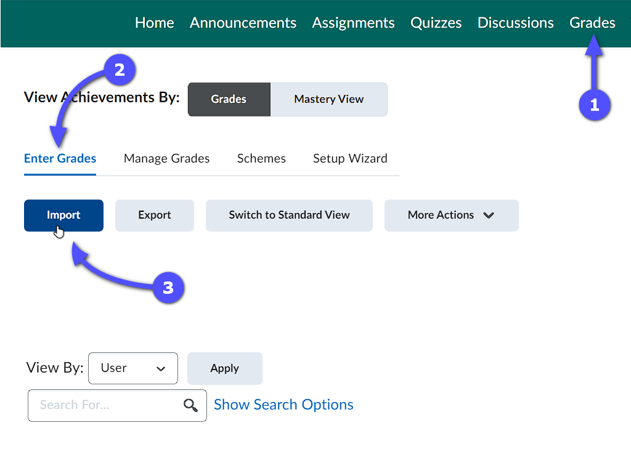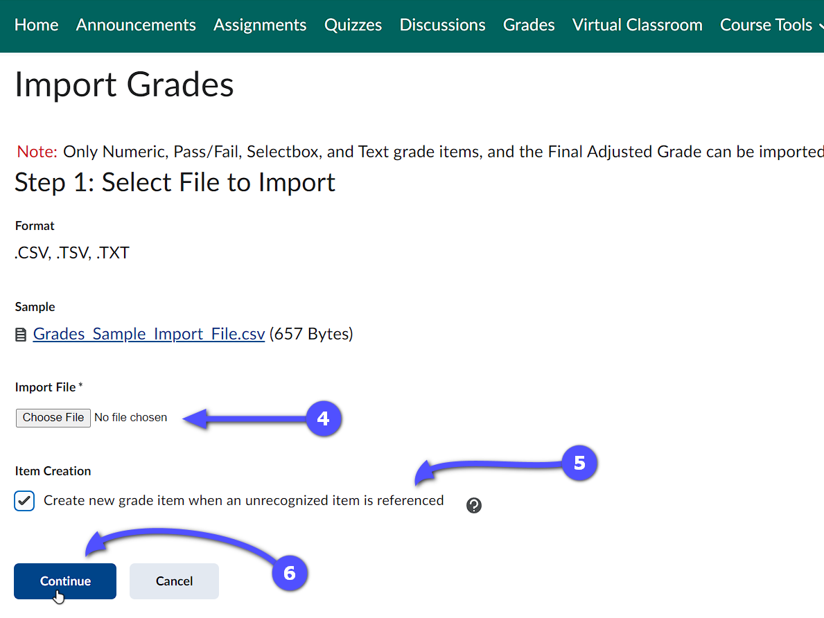
- If there are no errors, click Continue again.
- Review the import preview to ensure there are no errors and then click Import to finalize the process. The grades should now be visible on the Enter Grades page.
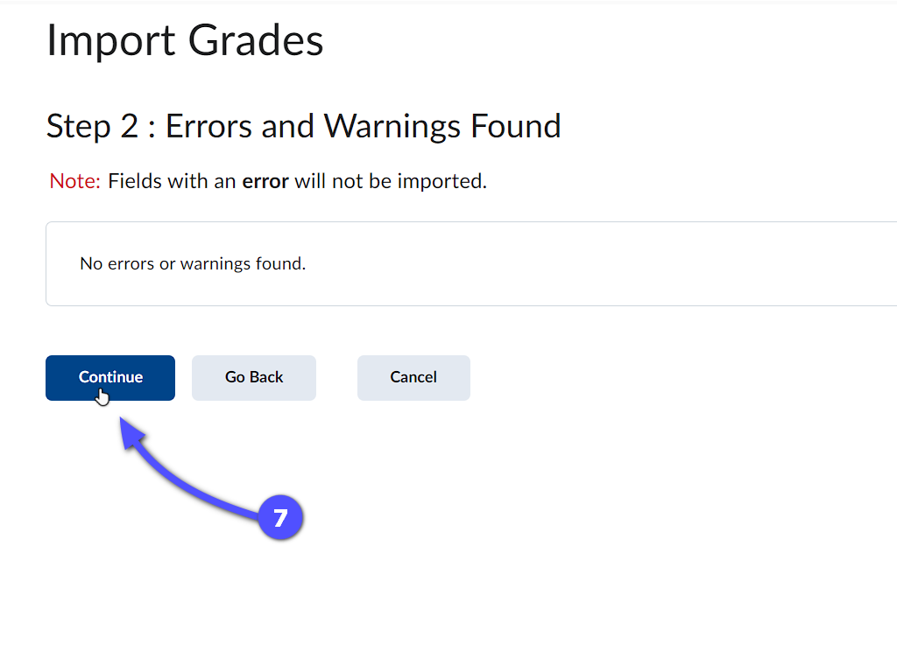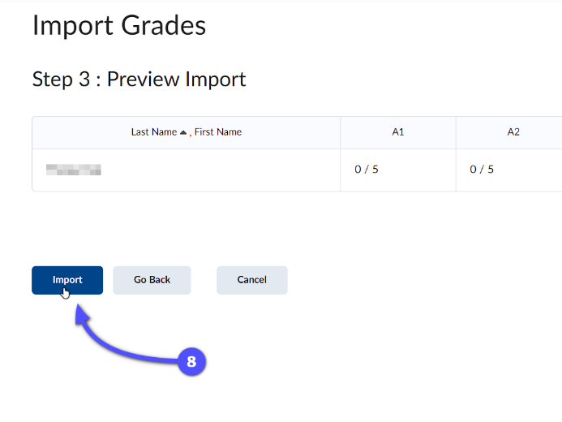

Explanations of the Gradebook import fields:
Field | Description | Example
Username | A unique name for identifying a user in the Learning Environment.  You must provide a Username or Org Defined ID (or both). | Frank.Catcher
Org Defined ID | A unique number for identifying a user in the Learning Environment.  You must provide a Username or Org Defined ID (or both). | 20067930
Points Grade | Numeric and Pass/Fail grade items should be labelled with the grade item name followed by “Points Grade”.  Users’ grades should be the Points Grade they received.  E.g., 44 points out of a possible 50 points. | 44
Grade Symbol | Select box grade items should be labelled with the grade item name followed by “Grade Symbol”.  Users’ grades should be a pre-existing grade scheme symbol.  E.g., “Very Good”, “Merit”, or “3.5”. | Very Good
Text Grade | Text grade items should be labelled with the grade item name followed by “Text Grade”.  Users’ grades can be any text value. Text grade items do not count towards users’ final grades. | Perfect Attendance!
Adjusted Final Grade Numerator | The total points a user achieved in a course. You can enter a user’s percentage grade (without the % sign) if you enter the denominator as 100.  E.g., 84 points out of 100 points or 230 points out of 285 points. | 84
Adjusted Final Grade Denominator | The total possible points are available in a course. Enter 100 if you want to record users’ percentage grades.  E.g., _ / 100 points available or _ / 285 points available. | 100
End-of-Line Indicator | Line-Leading Character | The last column must be labelled “End-of-Line Indicator” so the system knows when the next set of data begins.  The end of each user’s line should be indicated with the pound key “#”.  When exporting a CSV file in Excel, the pound key "#" appears as a line-leading character. | #

