How to import questions to Brightspace Question Library from Blackboard archive

Before proceeding with this guide, make sure to have an archive copy of your Blackboard site.
Once you have your course archive zip file ready,
- Navigate to your course site and click on the gear icon next to your name at the top right and click Import/Export/Copy Components.
- Scroll down and make sure to select both Import Components and from a course package.
- Click Start.
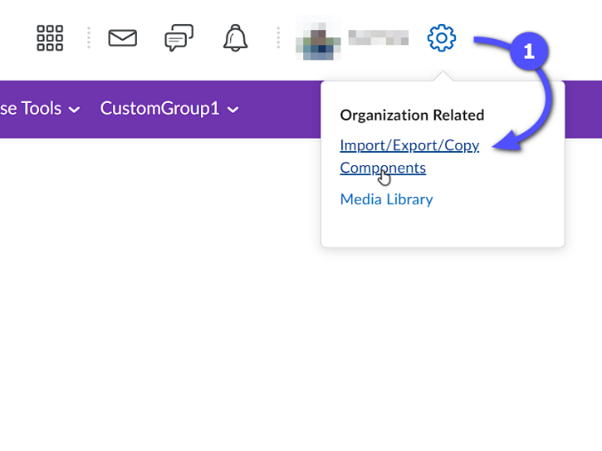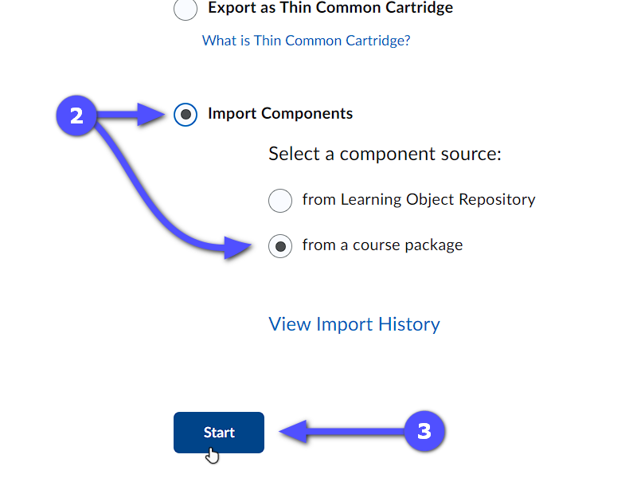
- On the file upload popup, select your archive copy by clicking on Upload.
- Click Advanced Options… to select only the materials to be imported into Question Library. (This may take a few minutes, depending on the size of your archived course.)
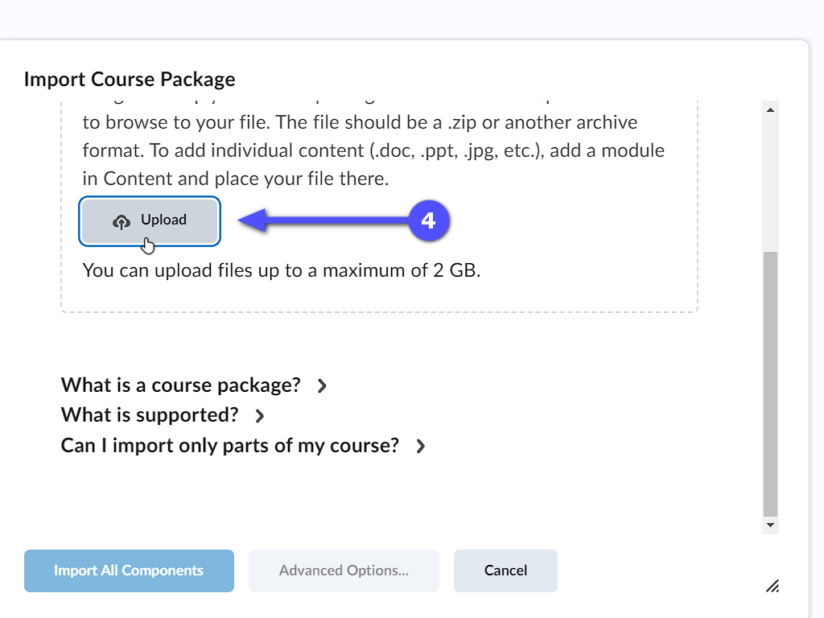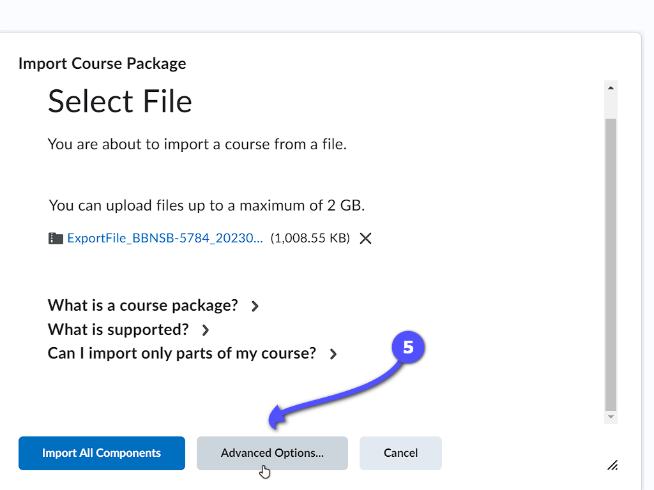

- Click Continue and click Continue again in Step 2.
- Scroll down and tick the Question Library option and select Import all items.
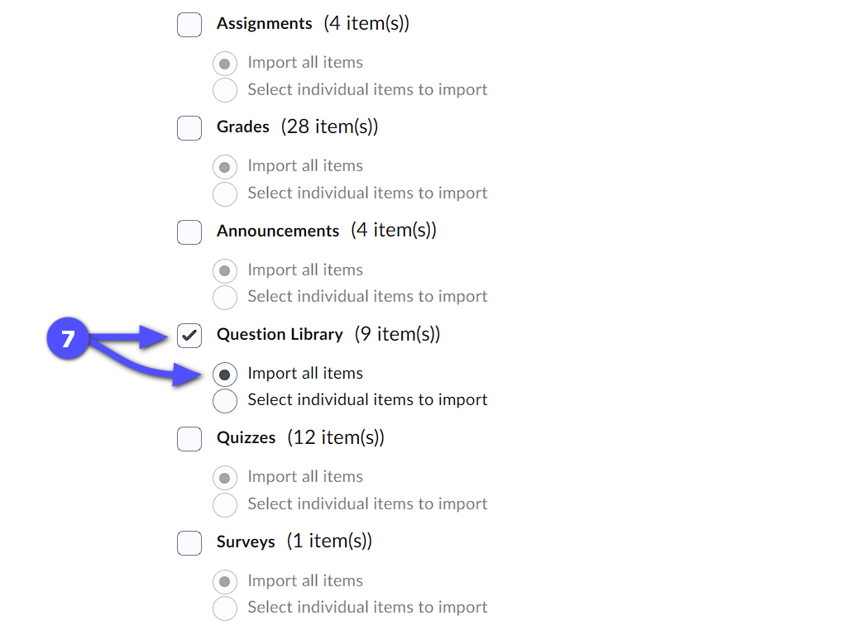
- Click Continue and click Continue again for Steps 3 and 4. Wait until the process finishes.
- Once the process finishes, click View Content or simply navigate to Quizzes > Question Library to view the imported materials from the archive.
