How to set an accommodation for all quizzes
Instead of setting up an accommodation for a student every time you create a quiz, you can create an accommodate for the student that will be applied to every quiz.
- Click Course Tools in the Nav bar and select Classlist.
- Scroll down to the student list table and select the down arrow beside the name of the student for whom you want to create an accommodation.
- Select Edit Accommodations.
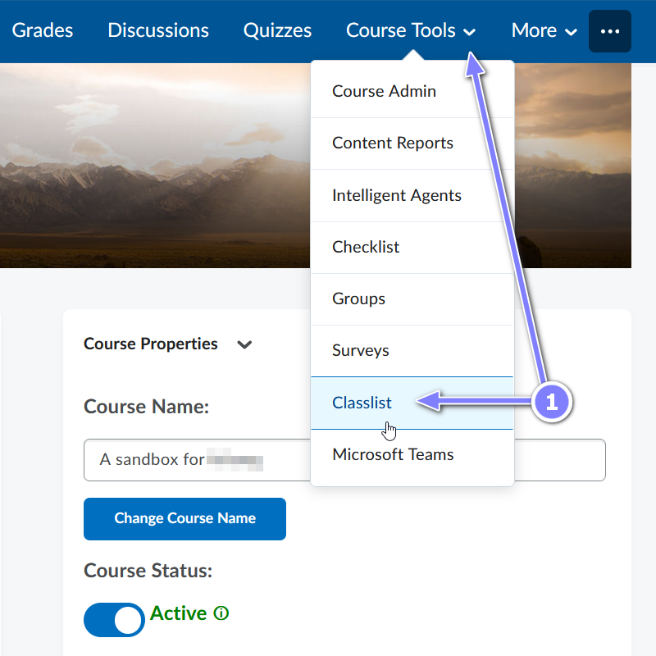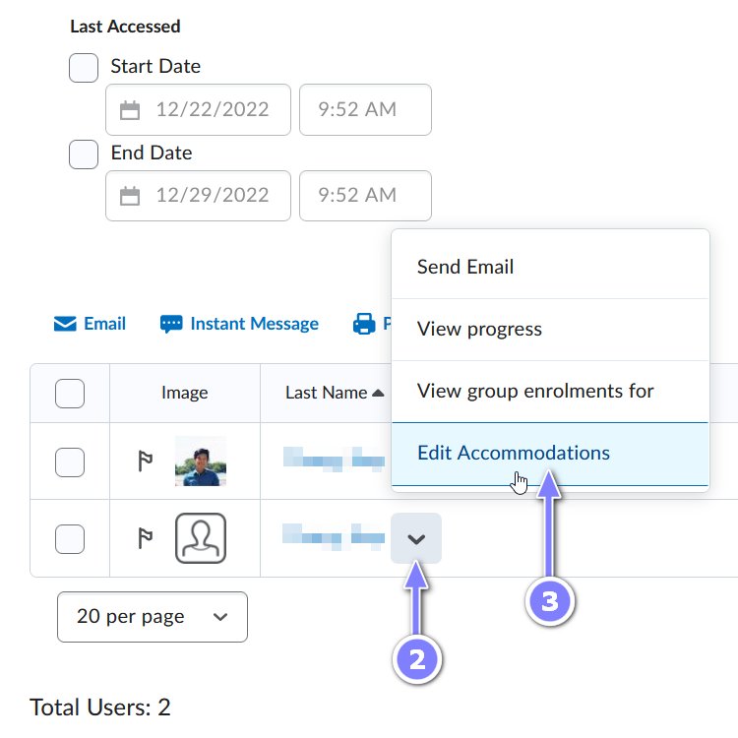
- Set the desired accommodations and click Save. This accommodation will apply to this student for all quizzes.
  - To grant a learner additional time on a quiz, under Quizzes > Timing, select the Modify Time Limit check box and then grant the time either in terms of quiz time multipliers or minutes:
    - To grant the additional time in terms of quiz time multipliers, select the Multiplier of original quiz time radio button and specify the number of times. For example, 1.5 times more than the original time on the quiz.
    - To grant the additional time in terms of minutes, select the Extra time radio button and specify the number of extra minutes.
