How to share YouTube video in Brightspace and have it start at a chosen point in the video

# **To add a link**

1. Find the YouTube video you want to share and advance it to the spot you would like it to start and pause it.
2. Click the S**hare** button.

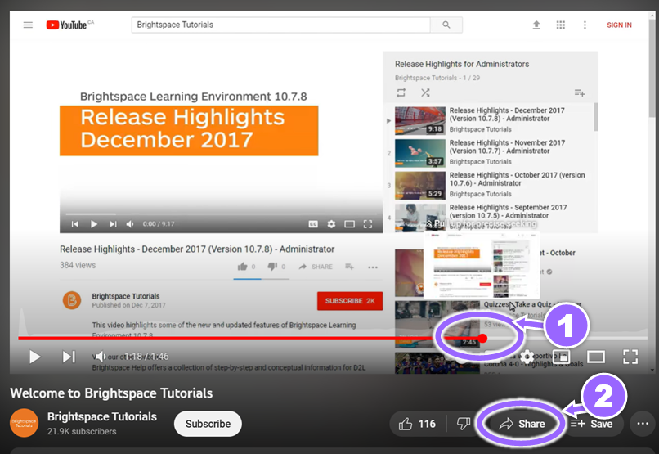

1. Place a check mark in the **Start at** box.
2. Click **Copy** found to the right of the URL.

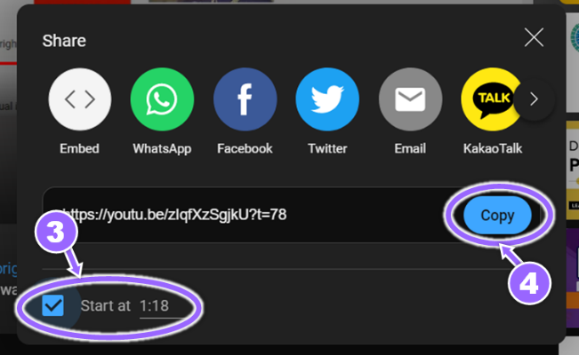

1. You can now paste this code into the Brightspace editor using **Insert Stuff > Insert Link** or in a module using **Upload/Create > Video or Audio**.

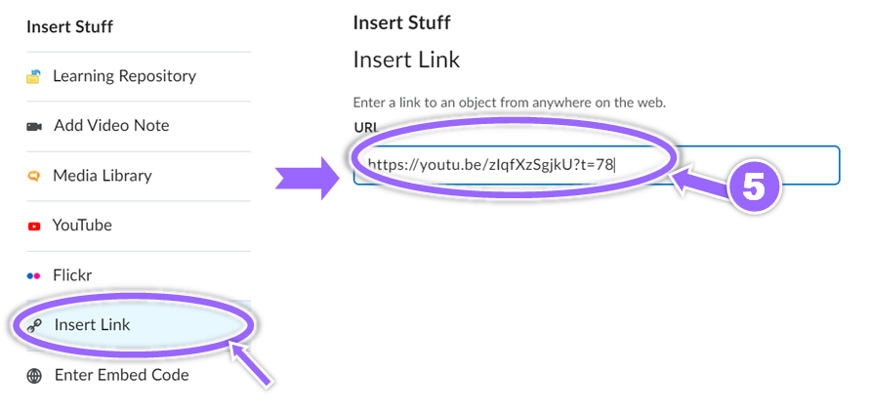

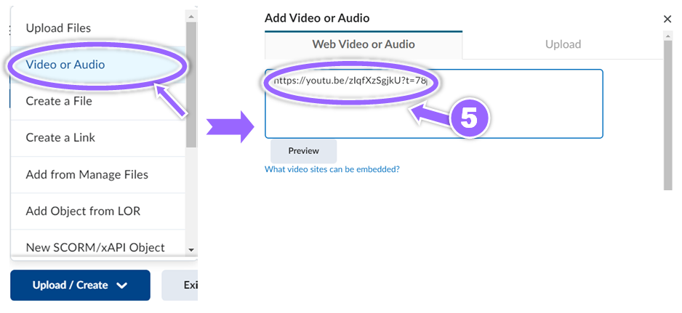

# **To embed a video**

1. Find the YouTube video you want to share and advance it to the spot you would like it to start and pause it.
2. Click the S**hare** button.

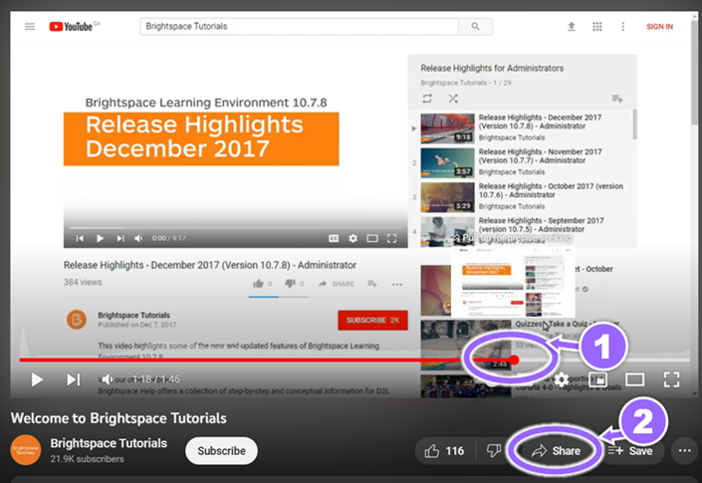

1. Select **Embed**.

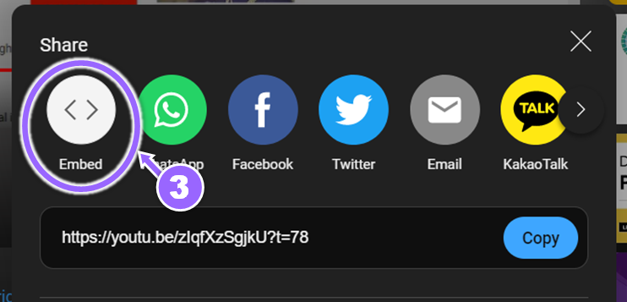

1. Place a check mark in the **Start at** box.
2. Click **Copy** on the bottom right to copy the embedded code.

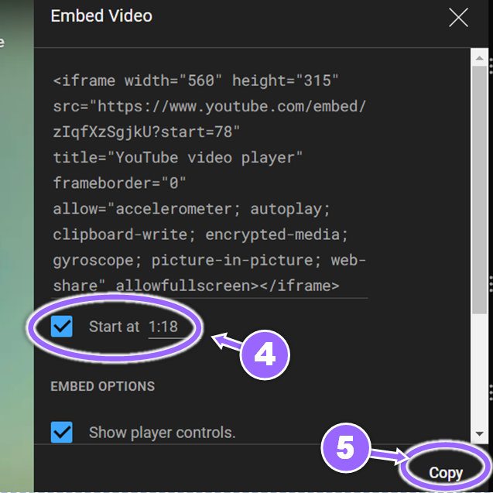

1. You can now paste this code into the Brightspace editor using **Insert Stuff > Embed code** or in a module using **Upload/Create > Video or Audio**.

