Show Grades Running Total to Students
This document includes instructions for configuring a Brightspace grade book to display an automatically updated or running total in the Calculated Final Grade column. It is intended for instructors.
Brightspace grade book is used to provide students with access to their scores on individual quizzes, exams, and assignments. It can also be helpful to provide cumulative feedback as the course progresses by configuring the existing Calculated Final Grade column to display an automatically-updated running total across all graded items. Follow the below steps to create a running total:
- In your course site, select Grades in the Nav bar and click Settings on the right side of the screen.
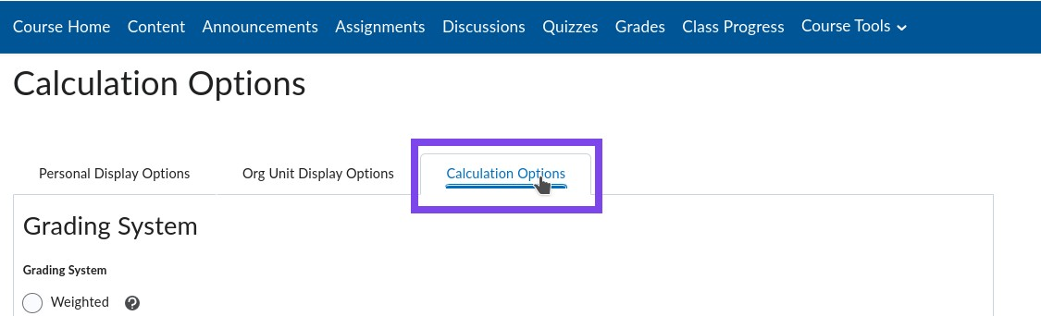
- Click Calculation Options.
- Scroll down to Final Grade Released options.
- Select Calculated Final Grade instead of Adjusted Final Grade. You can change this at the end of the semester, but if you select Adjusted Final Grade, students will not see a running total of their grades as the semester goes on.
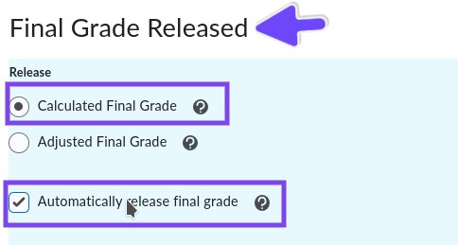
- Select Automatically release final grade.
- Click Save.
- Click Yes to confirm the changes.
Note: You can create running total while running Setup Wizard as well. From Step 2 of the Setup Wizard, select Calculated Final Grade and check Automatically release final grade option. Then, click continue to go to the next step of the Setup Wizard.
