How to use Microsoft Forms

Microsoft Forms can be used for:
- General surveying purposes
- Collecting feedback of peer assessments

Some of the key features of Microsoft Forms include:
- Ability to restrict access to a form based on organizational membership (i.e., course-based restriction)
- Live update of responses
- Multiple analytical tools available for the data, as well as export to excel function
- A lot of form styling and question types available to use
- Forms are available in both desktop and mobile layouts
- The forms can be turn into quizzes and assign points to the questions
- Easy to setup, manage and deploy to users

To start using Microsoft Forms:
- Go to https://forms.microsoft.com and login with UWin ID email and password.
- Click New Form to start.
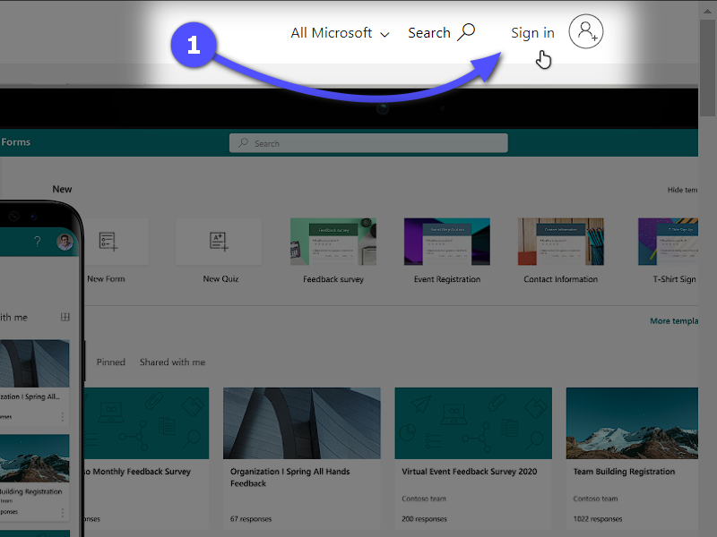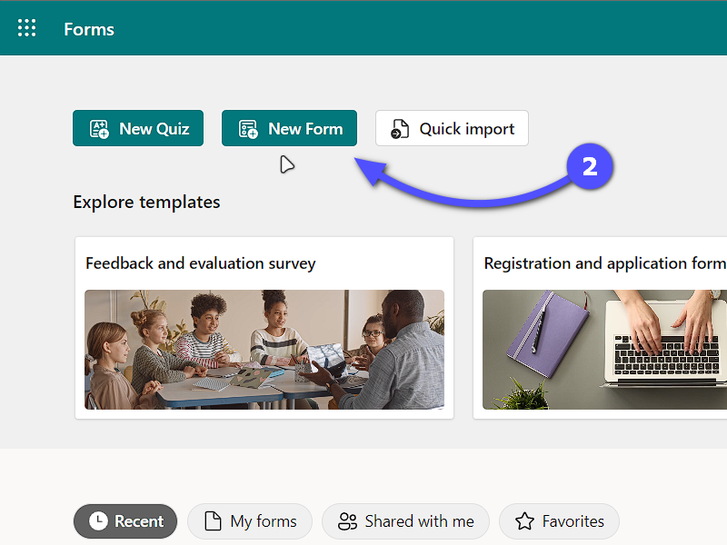

- Click on the words Untitled form and provide a title.
- Click Add new, click the type of question you want to create, (i.e., Multiple Choice, Text, Rating, etc.) and complete the required fields to create your question to add to the form.
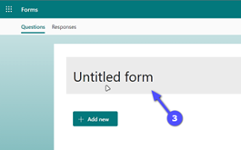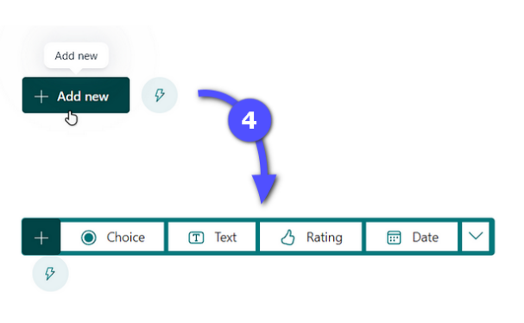
- Click on anywhere outside the question to save the changes.
- Click Collect responses at the top right to set the deployment settings.
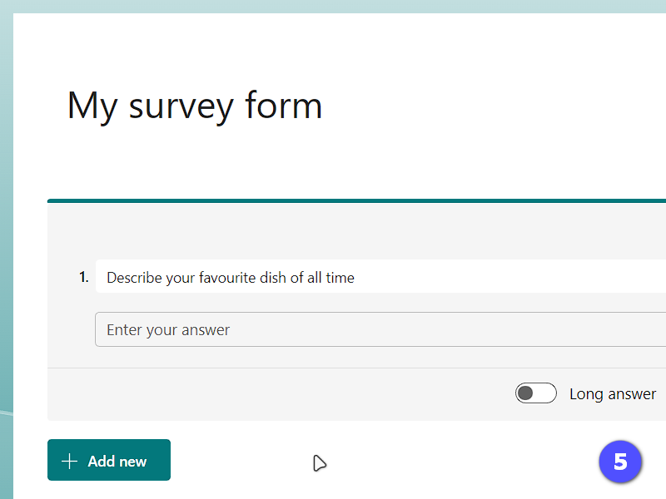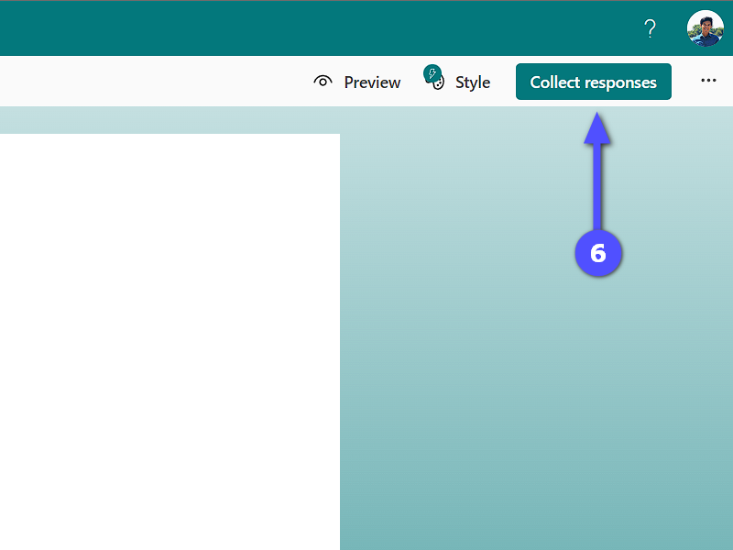
- If using for a course, select the third radio option, Specific people in my organization can respond, and in the Enter a name, group, or email address box enter the full course code, including the section, of the course that you want to give access to this form (i.e., start typing “comp2707” and options should appear below to select the right course).
- Select the sharing mode using the icons (from left to right):
  - Share via a link
  - Share via an invitation to email
  - Share via a QR code
  - Share via an embed code
- Check Shorten URL checkbox if you prefer a shorter link.

- Click Copy link and share to users. Click X button at the top right to close this window.
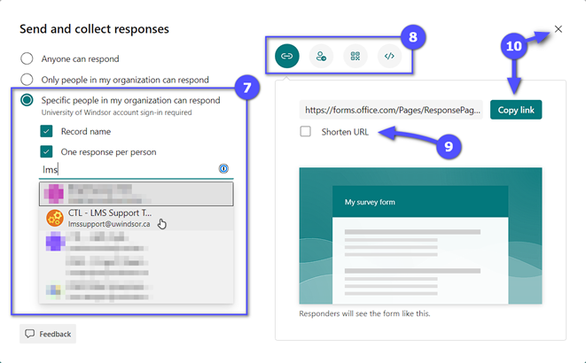

- Example view of the form as a user
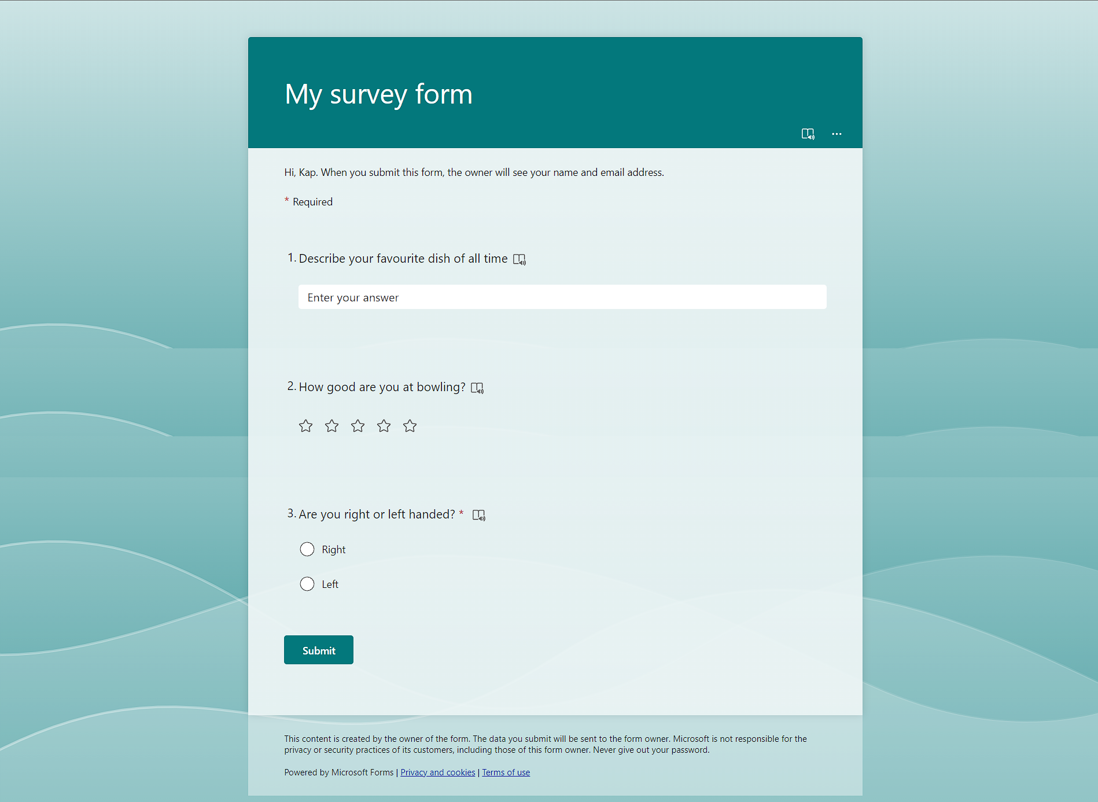

- Click Responses to view the analytics board for the form. 