How to view ungraded quizzes

- Click Quizzes in the nav bar.
- Click on the chevron (downward arrow) next to the quiz for which you want to view the ungraded list and select Grade.
- Click Show Search Option.
- Select Users who have completed an attempt under the Restrict To drop-down.
- Select Pending evaluations under Status.
- Click on the magnifying icon to perform the search. You’ll now see a list of submissions that needs to be graded.
  - Written-Response type questions usually get zero by default until it’s manually graded, these will appear here under this search.
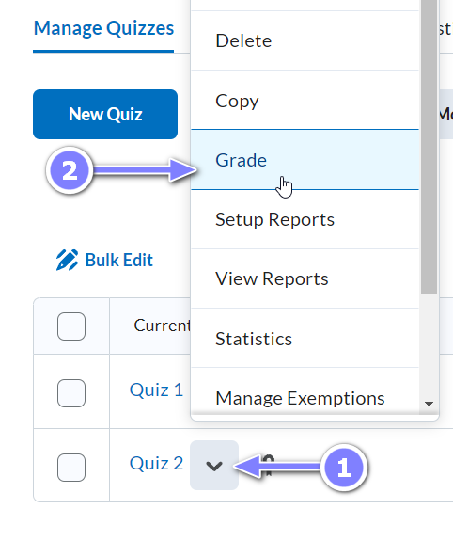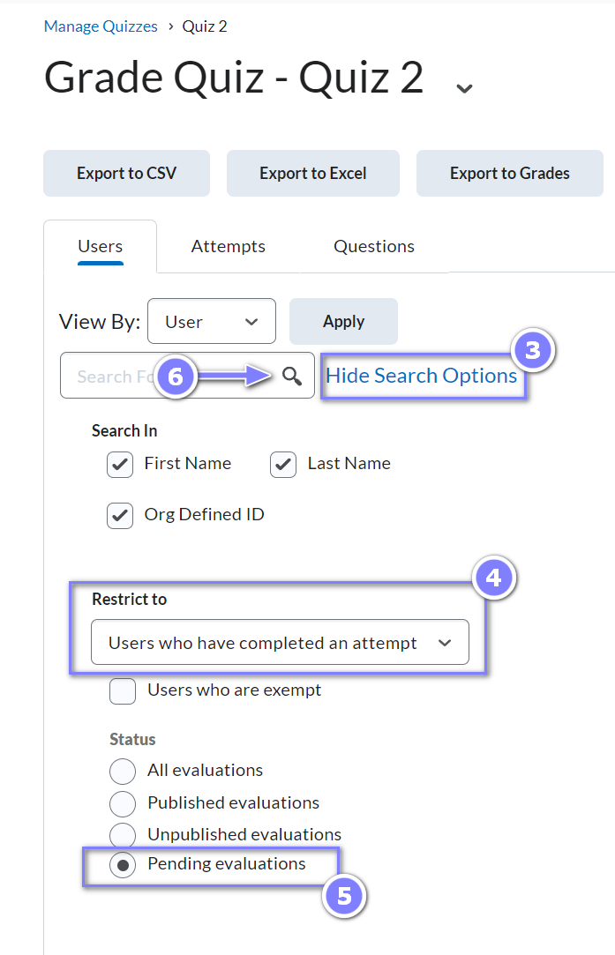
- You can also do the same search via the Attempts tab, which provides a more compact view with each student’s attempt on one line. Under the Restrict to drop-down, select Attempts that have been completed.

