Make your course site active / available to students.

Method 1 (from the Course Home page of a course)
- Navigate to the Course Home of a course. One of the widgets near the top of the page is Course Properties. This widget allows you to activate and deactivate this course by clicking (not dragging) on the Course Status slider.

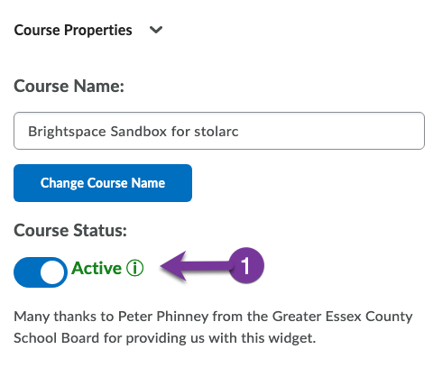

Method 2 (from the Brightspace landing page)
- From the Brightspace Landing page, find the course that you would like to make available to students. If it is hidden from students, it will have an Inactive icon on the course card.
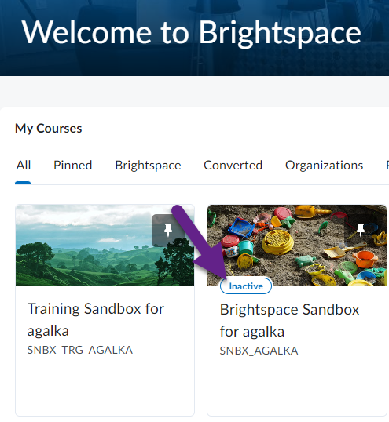

- Hover your mouse over the card’s top right corner (if there is a pin, hover just to the left of the pin) until three dots appear. Click on the three dots and select Course Offering information.
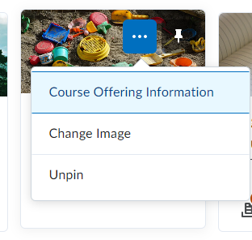
- On the Course Offering Information page, scroll halfway down until you see Active. Place a check mark in the box next to Course is active and click Save. It may take a few minutes before the Inactive icon disappears from the course card.
