Trouble shoot using Quiz Attempt Logs
If you would like to know when a student entered and completed a quiz or when certain questions have been answered, view the Attempt Logs of the quiz.
- Click Quizzes in the Nav bar of your course and locate the quiz.
- Select the down arrow next to the quiz and select Attempt Logs from the drop-down menu.
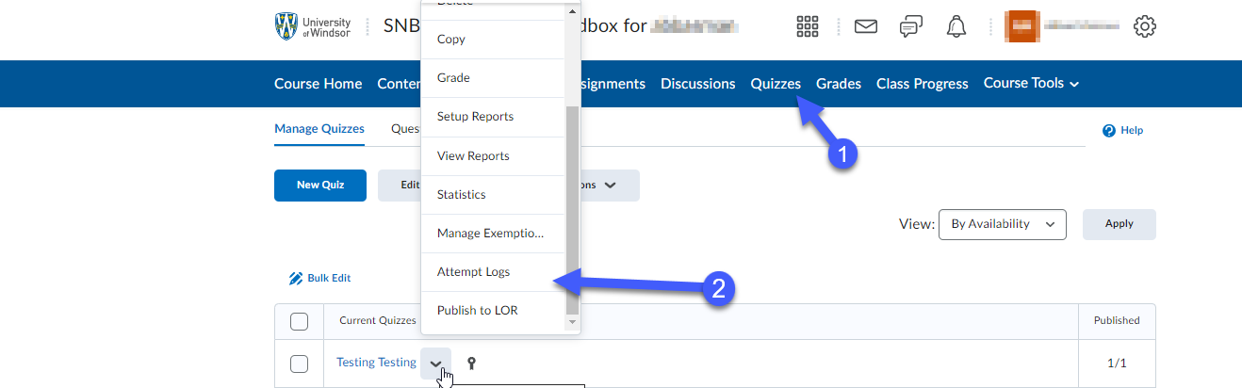
- You will see an Overview tab showing when students entered/completed a quiz, and a Detailed tab detailing when each question was saved for each student. 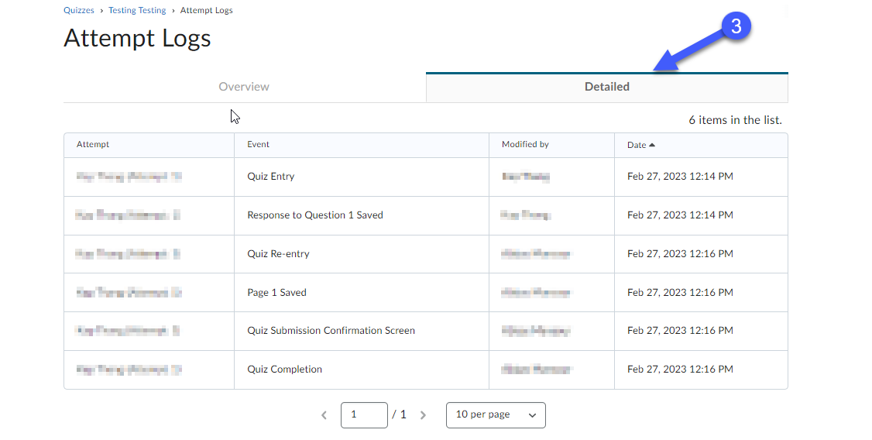
- Note: In the Overview tab, there are four sub-tabs that distinguish between different sections in a quiz: (Quiz Entry, Quiz Completion, Quiz Attempt Deleted, and Quiz Attempt Restored.) 