Best Test Practices for Instructors

Things to Consider:
- Determine the purpose and objectives of the quiz: Before creating the quiz, think about what you want to achieve and what kind of questions you need to ask to meet your goals.
- Plan the structure of the quiz: Decide on the number of questions, the type of questions (multiple choice, true/false, short answer, etc.), and the overall length of the quiz.
- Write clear and concise questions: Make sure each question is well-written and easy to understand. Avoid using complex language and double-check for spelling and grammar errors.
- Use images and multimedia elements: Adding images and multimedia elements, such as videos, images, or audio files, can make the quiz more engaging and easier to understand.
- Set up appropriate feedback: Provide clear and helpful feedback for each question, including both correct and incorrect answers.
- Use randomization and question pools: Consider using question pools to randomly select questions from a larger set and randomize the order of questions and answers to prevent cheating.
- Time the quiz appropriately: Set a time limit for the quiz that is appropriate for material covered and the complexity of the questions.
- Use accessibility best practices: Make sure the quiz is accessible to all students, including those with disabilities. Consider adding alternative text descriptions for images and using clear and concise language.
- Test the quiz before deploying: Before releasing the quiz to students, test it thoroughly to make sure it works as intended and there are no technical issues. This can be done with the Preview button within the quiz editor, or by Viewing as Learner.
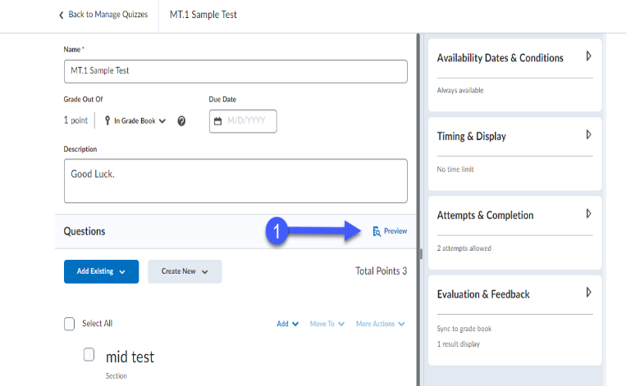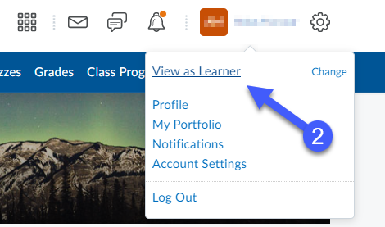
- Ensure students can pick up where they left off if they get disconnected. This means the availability of the quiz or exam should be the length of the exam period. If you want to avoid students ending the test after the End time by providing a shorter availability window, you must be available to your student and students will be able to contact you during the exam so you can manually provide access to any student who lost connection. (You will be able to extend individual student’s access through the Manage Special Access option of the quiz.)
- Monitor and analyze quiz results: After the quiz has been completed, review the results to see how well students performed and identify areas where they struggled. Use this information to improve future quizzes.

Prepare your students:

Provide clear instructions for:
- Where to find the test in your Brightspace course site, how long the timer will be set for, and the consequences for submitting the test late.
- How to be in contact with you in case of any issues/emergencies.
- How many attempts students have for the test. If more than one, be sure to note which attempt will be counted. (E.g., First attempt/ Last attempt/ Best attempt)
- What students should do if they need any test exceptions (students requiring extra time, another date to write, or extra attempts). Provide students special access in Brightspace (in the quiz-> Availability Dates & Conditions-> Manage Special Access).
- Provide students with the Test Best Practices for Students document.

Advise students to:
- Take the test with a secured internet connection and device, and if possible, to use a wired internet connection rather than wi-fi.
- Use a common browser such as Chrome, Microsoft Edge, Safari, or Firefox. Ensure it is up to date prior to the test date. Older versions may not display all Brightspace material properly.
- Not use the Pulse app as some questions may not work well in the app. Using a computer/laptop is best for assessments.
- Use only arrows within the exam window and not use the browser’s forward or back button.
- Ensure that questions are showing as saved as they progress throughout the test.
- Double check answers before submitting as the scroll wheel on the mouse or clicking on the screen of the selections can change answers. Double check!
- Type answers to essay questions in Notepad (or TextEdit on a Mac) then copy and paste the answers into the text fields provided for each essay question. This ensures students have a copy of their answers just in case they lose Internet connection.
- Not navigate away from the browser window as it may kick them out of the exam.
- Refresh the page if kicked out of the test. If the availability window for the text has not closed, quickly enter the test again. If they cannot access Brightspace or the test, contact you/GA immediately by whatever method you indicate, to assist you and/or set up accommodations for any lost time. If you/GA cannot solve the issue, have the student create a Brightspace ticket with as much detail as possible https://www.uwindsor.ca/brightspace/ticket.
- Click the Save and Submit button twice when done the test to ensure the quiz is submitted. They should reach a confirmation page and receive a confirmation email when submitted properly.

