
CALL FOR INSTRUCTORS FALL 2026
The Odette School of Business invites internal and external applications from qualified individuals who are interested in teaching during the Fall 2026 semester. The following course(s) are intended to be offered during the Fall 2026 term:
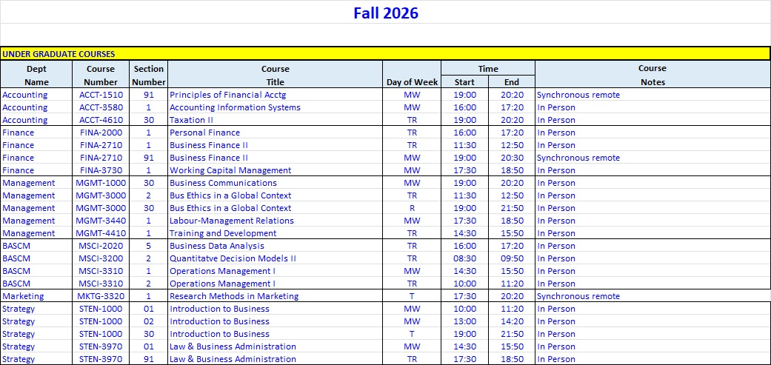

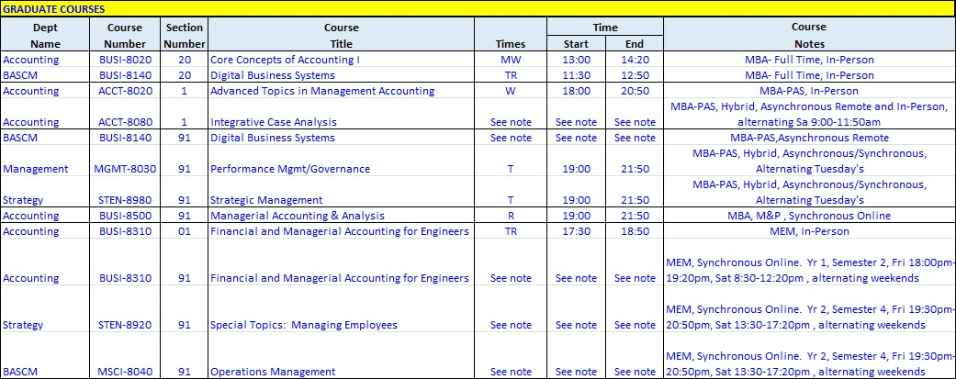
To view the full course descriptions, visit the online Undergraduate and Graduate Calendars.
Classes are generally delivered two times per week between 8:00 AM and 9:50 PM. The Fall 2026 academic term runs from September 10, 2026 to December 23, 2026. Other important dates for this term can be found at https://www.uwindsor.ca/registrar/events-listing.
For more information on how to apply, please see Appendix 1. The deadline for receipt of applications is Monday, June 8, 2026 at 4:00pm. In accordance with Article 54 of the Collective Agreement (2021-27) between the Faculty Association and the University of Windsor, the assignment of each course section will be based on a thorough review of every applicant’s teaching competence and academic credentials, and no candidate shall be considered for appointment without having completed the Application Form and providing the supporting academic documents outlined in Appendix 1. Incomplete or late applications will not be considered by the Appointments Committee.
Courses offered are subject to budgetary approval and sufficient enrolment and listings are subject to change or cancellation.
Appendix 1: Application Procedure
Interested applicants must complete the online application and provide:
- An up-to-date CV (Required for all applicants).
- A Cover Letter (Required for new applicants only).
- A Teaching Dossier (Required for all applicants). Please provide evidence of teaching effectiveness in the form of a teaching dossier, beginning with a cover letter that summarizes your teaching competence with respect to the courses you are applying to teach. In addition to the teaching dossier cover letter, your teaching dossier should include materials such as lists of courses taught and teaching experience, student testimonials, awards, lists of teaching professional development and/or teaching workshops, student performance, peer evaluations, and/or other forms of evidence of teaching effectiveness. We strongly encourage providing as much evidence of teaching effectiveness as possible.

- A Statement on Commitment to Equity, Diversity, Inclusion and to Indigenization (Required for all applicants).
- Reference letters (first-time Instructors only).
- Frist-time Instructors will be asked to also provide the following information and documentation:
  - Teaching Experience. Please provide teaching experience for teaching the exact course or same subject material for which you are applying. If not applicable, please provide general teaching experience, training, or teaching potential.
  - Teaching Evaluations. Please provide any teaching evaluations for the past five years at the University of Windsor or elsewhere, if available.
  - Education Information. Please list your highest or most relevant degree earned and the name of the degree-granting institution. Please list any other academic credentials in progress or professional designations and/or professional experience appropriate to the area of instruction.
  - A List of Relevant Research, Publications, and/or Creative Work.
  - Three Current Letters of Reference.
Please note the maximum a sessional can teach per semester is three course sections, but applicants are encouraged to apply for any courses they are qualified to teach.

Interested applicants are to submit applications directly to the Odette School of Business online at: Sessional Appointments

Successful applicants must attend an instructor orientation session prior to the start of the academic term. This session covers administrative details and other matters such as marking criteria, course content coordination, and course syllabus requirements.
We thank all applicants in advance for their interest. However, only successful applicants will be contacted.

