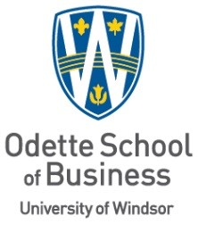

MAJOR RESEARCH PAPER DEFENSE

To be held Virtually

Siraat Mustafa

Will present his

MAJOR RESEARCH PAPER

“A Glimmer of Hope: Environmental Change and Strategy Adaptation at World Wrestling Entertainment (WWE) “

Wednesday May 18, 2022
Time: 2:00pm.
G. Kerr
Advisor

D. Bussiere
Internal Reader

April 22, 2022

