WHMIS 2015 Safety Data Sheet (SDS)
A Safety Data Sheet (SDS) (formerly known as Material Safety Data Sheet or MSDS) is a document, specific to each individual product or material. SDS provides important information and data about any hazards associated with the product so users of the product understand the hazards and precautions necessary for its safe handling’. Also know how to recognize symptoms of exposure, and what to do if emergencies occur. Every material (hazardous product) that is controlled by Workplace Hazardous Materials Information System (WHMIS) must have an accompanying SDS.
SDSs are prepared and provided by the chemical manufacturers or supplier to purchaser of the hazardous product at the time of first order and, thereafter, any time the SDS is revised. An employer may be required to prepare an SDS e.g., when the product is produced and used exclusively in that workplace. An SDS from different manufactures may differ dramatically in appearance yet still present the required data in organized format of sections. To help bring order to the SDS format, an internationally harmonized 16-headings and sections SDS format has been adapted in WHMIS 2015 (Table 1). SDSs are required to be accurate at the time of sale. An SDS will be required to be updated when the supplier becomes aware of any "significant new data".
Table 1: The 16-header format of a Safety Data Sheet (SDS)
SDS Section and Heading
Section 1 | Identification
Section 2 | Hazard identification
Section 3 | Composition/Information on ingredients
Section 4 | First Aid Measures
Section 5 | Fire-Fighting Measures
Section 6 | Accidental Release Measures
Section 7 | Handling and Storage
Section 8 | Exposure controls/Personal protection
Section 9 | Physical and Chemical Properties
Section 10 | Stability and Reactivity
Section 11 | Toxicological Information
Section 12 | Ecological Information
Section 13 | Disposal Considerations
Section 14 | Transport Information
Section 15 | Regulatory Information
Section 16 | Other Information

Note: Sections 12 to 15 require the headings to be present, but under Canadian regulations, the supplier has the option to not provide information in these sections.

Supervisor Responsibilities:

All WHMIS hazardous products in your work area must have an associated SDS readily available to students, staff, faculty, visitors, and members of the University of Windsor’s Joint Health and Safety Committee (JHSC). SDSs cannot be kept in locked desks, cabinets, or locked rooms. They must be easily accessible by all employees and students that work with, or near the hazardous products.

Worker Responsibilities:
Workers are strongly encouraged to inspect SDSs before they begin work with hazardous materials. It is important to remember that the product name and supplier on the SDS much match the material in use. For most researchers who work with hazardous products, you should always:
- read the name of the chemical (Section 1),
- know the hazards (Section 2),
- understand safe handling and storage instructions (Section 7), and
- understand what to do in an emergency (Sections 4, 5 and 6).

Formats:
- Electronic format:
SDSs for all chemicals/hazardous product acquired by the Chemical Control Centre (CCC) are available online (www.uwindsor.ca/msds).
For items not acquired by the CCC, electronic copies can be scanned or downloaded from suppliers and provided electronically through a computer to employees and students in the area where the hazardous products are used or stored. All individuals must be trained to access these files.
- Paper format:
Paper copies must always be visible, and accessible in the labs that do not have a computer.

Accessing UWindsor SDSs:

Go to www.uwindsor.ca/msds , click MSDS Access and login to the Hazardous Material Information System (HMIS). Contact the CCC (ccc@uwindsor.ca) if you need a password.

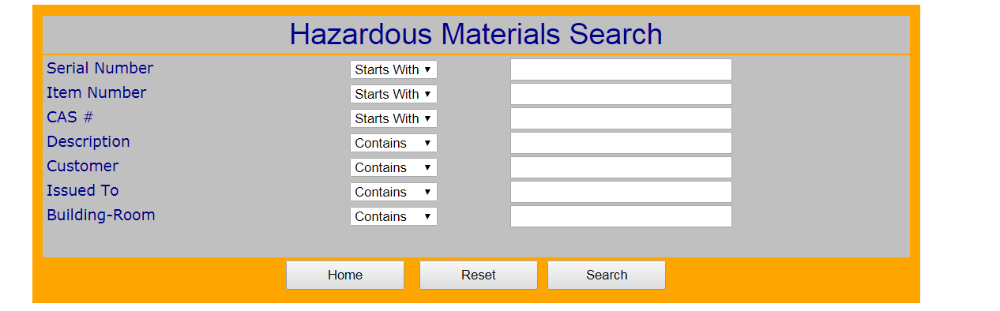
- Search for the specific item of interest by: (a) serial number; (b) item number; (c) CAS #; or (d) description.
  - Search parameters must match exactly. When searching by description, it is recommended that you start using a general search term before searching for specifics.
- From search results, select “View MSDS” to open a new window with .pdf version of the supplier specific SDS
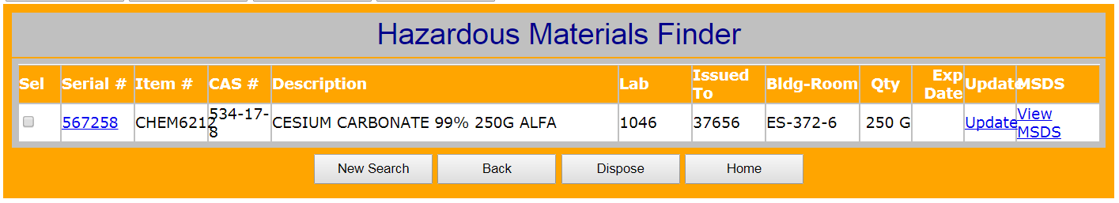

Limitations
Laboratory workers should recognize the limitations of SDSs as applied to laboratory operations:
- SDSs must describe control measures and precautions for work on a variety of scales, ranging from microscale laboratory experiments to large manufacturing operations. Some procedures outlined in an SDS may therefore be unnecessary or inappropriate for laboratory-scale work.
- Section 2 SDS summarizes the hazards related to the product, precautions to take, and what to do in an emergency. Understand that the SDS covers information about the potential hazards but may not be specific about the required safe work procedures needed for your workplace (e.g., the SDS may not specify what type of respirator must be used, just that a respirator is needed). More information can be found by asking your supervisor. These decisions may require the help of a safety professional or someone with chemical safety knowledge.
For more information on SDSs, please contact:
Chemical Control Centre, Laboratory Safety
P: 519.253.3000 ext. 3523 F: 519.973.7013
E: ccc@uwindsor.ca www.uwindsor.ca/ccc

LSB-2017-2

