Use of Freight Elevator in the Essex Hall
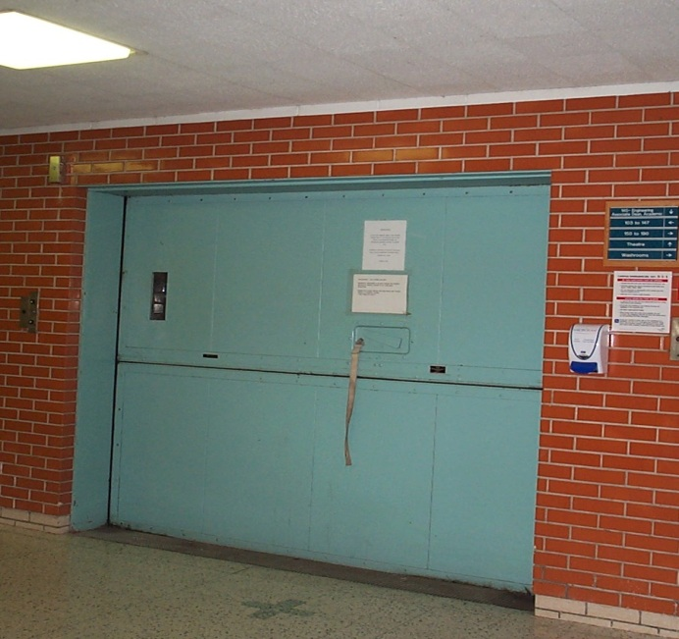
A freight elevator is an elevator designed to carry goods, rather than passengers. The one in the Essex Hall operates between a basement and third floor. This freight elevator is larger and capable of carrying heavier loads than a passenger elevator. All chemicals, gas cylinders and cryogenic materials must be transported from one floor to another using the freight elevator. The passenger elevator is not approved to be used for that purpose. The freight elevator has manually operated doors and the operation requires that users control it. The following information and directions must be understood and followed to ensure reliability and safety use of the freight elevator. The user is responsible for proper use of the freight elevator.
Freight Elevator, Essex Hall, First Floor
Calling the Elevator
- To ‘call’ the elevator to your floor, press and hold the call button located on the wall by the elevator. IF THE ELEVATOR FAILS TO MOVE, a bell should sound when the call button is pressed. Both indicate that one or more of the access doors are open and imply that the elevator is being used. Wait a while and try again or check each floor to see who may be using it and coordinate your need with theirs.
- IF THE ELEVATOR FAILS TO MOVE when ‘called’ and it is not being used by others, it generally means that one of the doors has been left open or ajar by a previous user. The first best step is to search the floors, locate the cab, and close the doors properly. It is theoretically possible, though not likely, that someone or something may have slightly moved a door on another floor enough to open the interlock switch. In such a case, each floor’s door will need to be checked, pushing down on the door to make sure it is in contact with the floor.
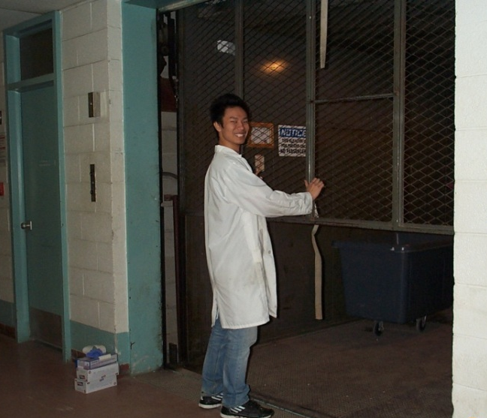
Operating the Doors
- The doors require manual—lift to open—operation by the individual user/operator. There is an outer door at each floor, and an inner door which is a part of the cab.
- Open and close the doors carefully as follows: Lift the doors at their centers (lifting off-center damages bearings and may cause them to jam). Opening them too forcefully can cause the doors to come off their tracks. Slamming them closed too hard may result in a malfunction.
- A mechanical interlock prevents an outer door from being opened if the elevator cab is not directly opposite the door. You need to look and confirm the cab’s presence before attempting to open this door.
Opening the Inner Door of Freight Elevator, Essex Hall, Basement
- Open the outside, quite heavy door by separating horizontally two panels, followed by opening of the inside, wire mesh door, by pulling it up.
- You might need to align/level the elevator floor to ground level. To do so, use the buttons located on the control panel inside the elevator.
Loading the Elevator
- Load the cab with your shipment. Be aware that load weight limit is a maximum 6000 pounds. If your load approaches the maximum, center it in the cab to balance the load evenly.
- No personnel should accompany a transport of chemicals, gas cylinders and cryogen liquid container or larger Dewar in the freight elevator. The transportation of these items must be carried out without any people inside the cab.
Operation
- Leave the elevator if transporting the hazardous goods, close manually the inside doors by pulling it down, followed by closing the outside doors by pulling together two panels using the fabric belt and …watching your hands, fingers.
- To bring the elevator to the desire destination/floor press and hold the call button on that floor. IF THE ELEVATOR FAILS TO MOVE, go back to the starting floor, reopen the doors and close them again to get the interlock switches to make the necessary contact.
- Contact the CCC if you are unsure of the proper operation of the freight elevator.
- In case of freight elevator malfunction call the Facility Services, ext. 2850

LSB-2013-02

