Labels must be used on all containers of hazardous products at the
University of Windsor

What You need to know  Workplace labelling of the hazardous products is a basic requirement of the Workplace Hazardous Materials System (WHMIS).Labelling requirements differ depending on whether the containers are supplier or workplace containers.  Hazardous products from individual supplier must contain a WHMIS supplier label. Supplier labels must be written in English and French and must include the following information:  - Product identifier – the brand name, chemical name, common name, generic name or trade name of the hazardous product.  - Supplier identifier – the name, address and telephone number of either the Canadian manufacturer or the Canadian importer.  - Pictogram(s) – hazard symbol within a red "square set on one of its points".  - Signal word – a word used to alert the reader to a potential hazard and to indicate the severity of the hazard.  - Hazard statement(s) – standardized phrases which describe the nature of the hazard posed by a hazardous product.  - Precautionary statement(s) – standardized phrases that describe measures to be taken to minimize or prevent adverse effects resulting from exposure to a hazardous product or resulting from improper handling or storage of a hazardous product.  - Supplemental label information  Labels are the first alert to the user about the major hazards associated with a product, and outline the basic precautions or safety steps that should be taken.  Workplace labels are required on all portable containers which contain hazardous products in the workplace.  A workplace label is required when:  - a hazardous product is produced (made) at the workplace and used in that workplace,  - a hazardous product is decanted (e.g., transferred or poured) into another container ( e.g. wash bottle), or  - a supplier label becomes lost or illegible (unreadable).  Workplace labels require the following information:  - Product name matching the Safety Data Sheet (SDS) product name.  - Safe handling precautions, may include pictograms or other supplier label information.  - A reference to the SDS (if available). | The University of Windsor labels come in two sizes to accommodate different containers sizes. The labels also advise University personnel that a SDS is available from the CCC through the Hazardous Materials Information System (HMIS) at www.uwindsor.ca/ccc.  University of Windsor Labels  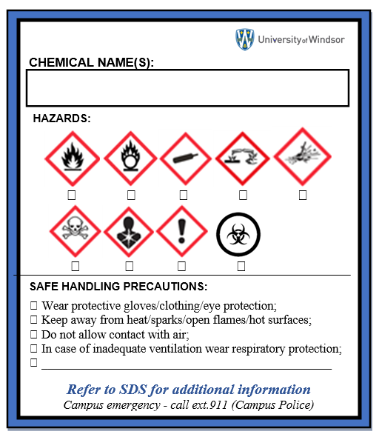  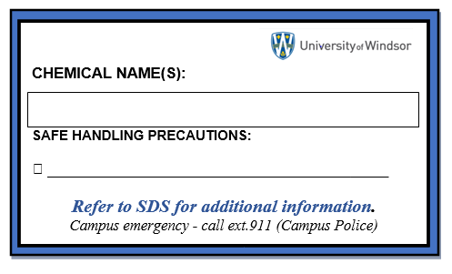  Where to get Labels  The workplace labels are available free-of-charge from the Chemical Control Centre (CCC). For more information or to request labels contact the CCC ext.3523 or email ccc@uwindsor.ca

