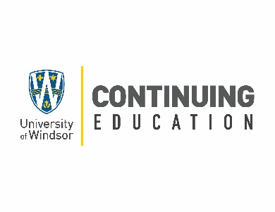

Call for Course Developer and Instructor
Summer and Fall 2021

The University of Windsor’s Continuing Education department offers lifelong learning for personal and professional development. Open to a diverse range of students within our community and beyond, our programs are designed to be relevant, accessible and of high quality. We are currently seeking a course developer and an instructor for an online, non-credit, 18-hour course:

e-Commerce Operations

Topics will include:
- Merchant Accounts, Payment Gateways, Credit Card processing and CRMs for e-Commerce operations
- Systems supporting e-Commerce logistics and supply chain management
- Best practices of Operations and Transaction Management including vendor management, logistics and warehousing, shipping, returns, inventory management
- Providing outstanding customer service for e-Commerce operations

Course Development Dates: Spring/Summer 2021
Fall Course Teaching Dates: Sept. 25 to Oct. 30 (Saturday’s 9:00 am to 12:00 noon)
For more information on how to apply and qualifications, please see Appendix 2.

The deadline for receipt of applications is Friday, March 5, 2021, at 11:59pm.

Appendix 2: Application Procedure and Qualifications

Application Procedure

Interested applicants must complete the online instructor application and submit the following:

- A brief statement of interest in teaching in the program that specifies the particular offering(s) the applicant wishes to be considered for. This statement should detail how the applicant meets the stated qualifications and availability.

- A copy of their CV.

- Prior quantitative and qualitative student assessments of teaching capabilities and/or client testimonials are particularly welcome.

The Screening Process

- An interview and references may be requested as part of the screening process.

- Instructors may be expected to participate in an information/orientation session (webinar or in-person) which will cover administrative details and other matters

Qualifications

Instructors selected will be expected to demonstrate:

- Appropriate educational qualifications as normally evidenced by a relevant Ph.D., Master’s Degree and/or equivalent professional/industry qualifications or experience, where appropriate.

- Appropriate subject matter knowledge/expertise. This should be evidenced by one or more of: 1) work experience 2) teaching experiences 3) other: portfolio, publications, community involvement/consulting

We thank all applicants in advance for their interest in teaching for Continuing Education however, only successful applicants will be contacted. Applications will be held on file for six months.

