The University of Windsor sits on the traditional territory of the Three Fires Confederacy of First Nations, which includes the Ojibwa, the Odawa, and the Potawatomi.
[Insert COURSE CODE] | [Insert COURSE TITLE] | [Insert TERM]
[Insert Department or School Name]

Classroom Meeting Time(s):
Classroom Location:

Instructor and GA/TA

Instructor Information GA/TA Information
Name | Email | Office Hours

GA/TA Office Location:
Name
Email
Telephone
Office Hours
Office Location

Course Description

Course Learning Outcomes

Course Materials

Required Reading(s):

Recommended Reading(s):

Curriculum and Weekly Schedule
Topics Weekly Readings
Week 1
Week 2

Week 3

Week 4

Week 5

Week 6

Week 7

Week 8

Week 9

Week 10

Week 11

Week 12

Student Perceptions of Teaching (SPT) are to be completed by students during the last two weeks of classes, in accordance with Senate policy. Instructors should allow approximately 15 minutes at the beginning of a class period to complete the SPT online on an electronic device.

How to access and complete online Student Perceptions of Teaching (SPT)

Last day for Voluntary Withdraw is [insert date here].

Assessments

Assessment | Worth Value | Due Date

Additional Grading Procedures
[Specify any policies regarding grading in the course such as ‘curving’ of final grades, evaluation by observers or supervisors, mandatory completion of assignments, etc.]

Course Policy on Use of Generative AI Tools
[Specify course policy on use of generative artificial intelligence (AI) tools such as ChatGPT. Are such tools permitted or not permitted in the completion of assignments, tests, exams? If permitted, instructors should specify under what conditions/circumstances these tools are permitted.]

Use of Plagiarism Prevention Software

[Specify if plagiarism prevention software such as Turnitin will be used in the course.]

Academic Accommodations
The University of Windsor is committed to accommodating students with documented disabilities to ensure they have equitable access to the learning environment. Documented disabilities include:

- Learning disabilities
- Attention deficit/hyperactivity disorder
- Acquired brain injuries
- Vision, hearing and mobility impairments
- Chronic medical conditions and psychiatric issues

Any student with a documented disability can register with Student Accessibility Services (SAS). See information on disability documentation on the SAS website.

An accommodation refers to any service, equipment, or arrangement that is put in place to support a student with a disability in the university setting and is meant to enable students to best perform the essential requirements of their academic program. Academic accommodations may include classroom accommodations and/or examination accommodations.

Visit Student Accessibility Services in the lower level of Dillon Hall. SAS can be reached by email at sas@uwindsor.ca or by phone at 519-253-3000 ext 6172.

Honesty Matters: Academic Integrity
Academic integrity is the cornerstone of positive learning. As a student in the Faculty of Arts, Humanities, and Social Sciences (FAHSS) you are part of a community of scholars that is committed to the fundamental values of honesty, trust, fairness, respect, and responsibility in the academic pursuit of your degree. This commitment to academic integrity is outlined in the Student Code of Conduct.

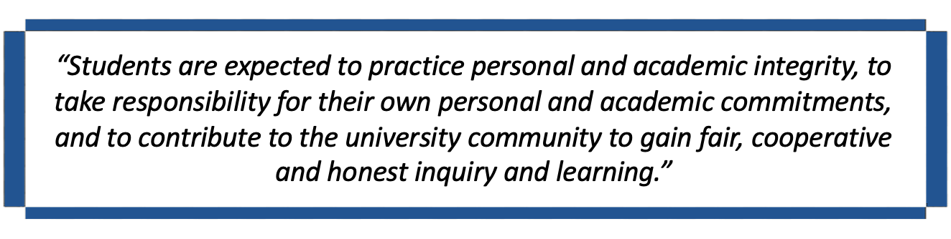

Violations of this code constitute academic misconduct, which includes plagiarism, cheating, unauthorized collaboration, use of unauthorized aids and academic forgery or fraud.

The University of Windsor advocates for academic integrity through honesty, education, and enforcement as outlined in Senate Bylaw 31: Academic Integrity.

Looking for further resources pertaining to academic integrity? Click HERE.

Indigenous Student Support Services

The Aboriginal Education Centre (AEC)-Turtle Island provides support to Indigenous students to reach their highest potential in a culturally supportive atmosphere. Services that the AEC provides include:

- Referral to various student support services on campus
- Cultural programming and events
- A lounge and area to socialize, study, or relax
- Volunteer and work opportunities

Black Student Support Services

The Black Student Support Coordinator is committed to supporting and advocating for the holistic success and overall well-being of Black, Caribbean and African students at the University of Windsor. The Black Student Support Coordinator will:

- Support students in navigating through various university processes and systems
- Provide general support, advocacy, and referrals to campus resources, or within the Windsor-Essex community
- Mentor individual Black students, providing direct encouragement, support, and active listening
- Connect students with additional UWindsor support services
- Advise on protocols and procedures of reporting racially motivated harassment or discrimination
To set up an appointment to meet with the Black Student Support Coordinator (Kaitlyn Ellsworth), send email to: blackstudentsupport@uwindsor.ca.

Student Wellness

The Office of Student Health, Counselling and Wellness Services provides medical services, counselling options, wellness programming and resources to support students in their university journey.

The Faculty of Graduate Studies features their own in-house counsellor that graduate students may make confidential one-on-one appointments to help cope more effectively with both short-term and long-term difficult/stressful situations. To book an appointment with the counsellor, call the Student Counselling Centre at 519-253-3000 ext. 4616.

After Hours Counselling Services:
- Keep.meSAFE – an online and telephone counselling service offered for international students (1-844-451-9700)
- Good2Talk at 1-866-925-5454 or Text: 686868

Visit Student Health, Counselling and Wellness for more wellness resources.

Academic Support

All graduate students are expected to familiarize themselves with the Graduate Calendar regarding registration, program requirements for graduate degrees, as well as important policies and academic regulations applicable to graduate students.

Graduate students should connect with the Graduate Coordinator in the Department in which they are pursuing graduate studies and/or the faculty supervisor to which they have been assigned for guidance on program requirements and important policies and regulations.

Help and Resources on using Brightspace can be found under Student FAQs.

Got questions? You will find answers to a variety of questions at:

Career Advising and Professional Development
The Faculty of Graduate Studies offers several professional development services facilitated by a career advisor. The career advisor can help you with career-related questions, including:

- Resume/cover letter/CV writing
- Job searching
- Interview prep
- LinkedIn profile critiquing
- Help with deciding next career steps
- Questions about navigating the labour market

Book an appointment with the career advisor through mySuccess or visit Room 313 Chrysler Hall Tower (Faculty of Graduate Studies).

The Faculty of Graduate Studies and the Office of Career Development and Experiential Learning have partnered to offer Propel, a graduate student professional development initiative aimed at preparing graduate students for both academic and industry careers.

The Centre for Teaching and Learning (CTL) also provides resources and services aimed at
GA/TA development: GA/TA and Graduate Students.

