The University of Windsor sits on the traditional territory of the Three Fires Confederacy of First Nations, which includes the Ojibwa, the Odawa, and the Potawatomi.
[Insert COURSE CODE] | [Insert COURSE TITLE] | [Insert TERM]
[Insert Department or School Name]

Classroom Meeting Time(s):
Classroom Location:

Instructor and GA/TA

Instructor Information GA/TA Information
Name | Email | Office Hours

GA/TA Office Location:
Name
Email
Telephone
Office Hours
Office Location

Course Description

Course Learning Outcomes
At the end of this course, students should be able to:

Course Materials

[Specify all costs for educational materials, such as textbooks.]

Required Reading(s):

Recommended Reading(s):

Curriculum and Weekly Schedule
Topics
Week 1
Week 2

Week 3

Week 4

Week 5

Week 6

Week 7

Week 8

Week 9

Week 10

Week 11

Week 12

Student Perceptions of Teaching (SPT) are to be completed by students during the last two weeks of classes, in accordance with Senate policy. Instructors should allow approximately 15 minutes at the beginning of a class period to complete the SPT online on an electronic device.

How to access and complete online Student Perceptions of Teaching (SPT)

Last day for Voluntary Withdraw is [insert date here].

Assessments

Assessment | Worth Value | Due Date

Final Examination Period: [insert dates for term here]
Additional Grading Procedures
[Specify any policies regarding grading in the course such as ‘curving’ of final grades, evaluation by observers or supervisors, mandatory completion of assignments, etc.]

Course Policy on Use of Generative AI Tools
[Specify course policy on use of generative artificial intelligence (AI) tools such as ChatGPT. Are such tools permitted or not permitted in the completion of assignments, tests, exams? If permitted, instructors should specify under what conditions/circumstances these tools are permitted.]

Use of Plagiarism Prevention Software

[Specify if plagiarism prevention software such as Turnitin will be used in the course.]

Academic Accommodations
The University of Windsor is committed to accommodating students with documented disabilities to ensure they have equitable access to the learning environment. Documented disabilities include:

- Learning disabilities
- Attention deficit/hyperactivity disorder
- Acquired brain injuries
- Vision, hearing, and mobility impairments
- Chronic medical conditions and psychiatric issues

Any student with a documented disability can register with Student Accessibility Services (SAS). See information on disability documentation on the SAS website.

An accommodation refers to any service, equipment, or arrangement that is put in place to support a student with a disability in the university setting and is meant to enable students to best perform the essential requirements of their academic program. Academic accommodations may include classroom accommodations and/or examination accommodations.

Visit Student Accessibility Services in the lower level of Dillon Hall. SAS can be reached by email at sas@uwindsor.ca or by phone at 519-253-3000 ex 6172.

Honesty Matters: Academic Integrity
Academic integrity is the cornerstone of positive learning. As a student in the Faculty of Arts, Humanities, and Social Sciences (FAHSS) you are part of a community of scholars that is committed to the fundamental values of honesty, trust, fairness, respect, and responsibility in the academic pursuit of your degree. This commitment to academic integrity is outlined in the Student Code of Conduct.
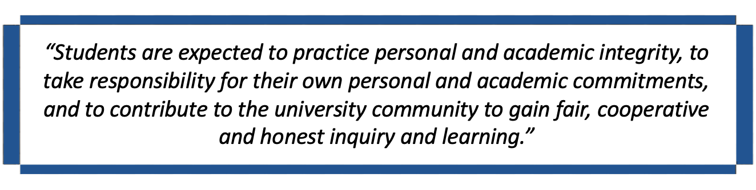
Violations of this code constitute academic misconduct, which includes plagiarism, cheating, unauthorized collaboration, use of unauthorized aid(s), and academic forgery or fraud.

The University of Windsor advocates for academic integrity through honesty, education, and enforcement as outlined in Senate Bylaw 31: Academic Integrity.

Looking for further resources pertaining to academic integrity? Click HERE.

Indigenous Student Support

The Aboriginal Education Centre (AEC)-Turtle Island provides support to Indigenous students to reach their highest potential in a culturally supportive atmosphere. Services that the AEC provides include:
- Referral to various student support services on campus
- Cultural programming and events
- A lounge and area to socialize, study, or relax
- Volunteer and work opportunities

Black Student Support

The Black Student Support Coordinator is committed to supporting and advocating for the holistic success and overall well-being of Black, Caribbean and African students at the University of Windsor. The Black Student Support Coordinator will:
- Support students in navigating through various university processes and systems
- Provide general support, advocacy, and referrals to campus resources, or within the Windsor-Essex community
- Mentor individual Black students, providing direct encouragement, support, and active listening
- Connect students with additional UWindsor support services
- Advise on protocols and procedures of reporting racially motivated harassment or discrimination
To set up an appointment to meet with the Black Student Support Coordinator (Kaitlyn Ellsworth), send email to: blackstudentsupport@uwindsor.ca.
Student Wellness

The University of Windsor is committed to fostering a thriving University community that actively promotes mental well-being and supports students to flourish in both their personal and academic lives.

Students sometimes face obstacles that can affect academic performance. If you experience difficulties and need help, it is important to reach out to someone.

For help addressing mental or physical health concerns on campus:
- Student Health Services at 519-973-7002
- Student Counselling Centre at 519-253-3000 ex 4616 or scc@uwindsor.ca
- Peer Support Centre at 519-253-3000 ex 4551 or psc@uwindsor.ca
- Therapy Assistance Online (TAO)
- Group Wellness Hub
- Coping and Healing
- Lancers Recover (alcohol and substance abuse recovery) at lancersrecover@uwindsor.ca
- Sexual Violence Prevention, Resistance and Support at svsupport@uwindsor.ca
- Good2Talk at 1-866-925-5454 or Text: 686868

Academic Support
Academic Advising

Connect with an academic advisor in your area of study for help with course selection and understanding the requirements of your program. This may be a dedicated faculty member, undergraduate chair, or department head.

You may also make an appointment with an academic advisor in the Central Advising Office or ask questions by sending an email to advising@uwindsor.ca.

Information regarding program requirements as well as a host of other things related to your academic journey at the University of Windsor can be found under Student FAQs on the FAHSS website.

Writing Support Desk
Located on the main floor of the Leddy Library, the Writing Support Desk can help with all your writing needs. Workshops and appointments available. Note: WSD is not a proofreading service; the goal is to teach students how to improve their writing, not to edit the work.

Skills to Enhance Personal Success (STEPS)
Resources and tutorials are geared towards helping to develop study skills to achieve academic success in a university setting. Free resources and online tutorials address effective reading and note taking; exam preparation; time management; and test anxiety.

Jumpstart: Skills Labs for Success
Sessions are aimed at providing transition support to first year students as they begin their educational journey. Need a refresher on a session? This can be accessed through the JumpStart eBook.

Help and Resources on using Brightspace can be found under Student FAQs.

Got questions? You will find answers to a variety of questions at:


Achieving Your Career Goals
It is never too early to start thinking about where you are headed next or to start planning your future!

Career Development & Experiential Learning (CDEL) will help you build bridges between the classroom and the world of work by supporting your career development and connecting you with resources and opportunities to prepare for whatever your goals after university might be.

- Meet with a career advisor for career planning, job search support, and preparing for further education
- Register for a career workshop
- Meet with a peer advisor for introductory tips and resources
- Access career tips and resources
- Create a professional photo for use on LinkedIn profile

Make the most of your UWindsor education by gaining valuable work experience!

- Get a part-time job on campus through the Ignite Work Study program
- Gain skills while volunteering through the VIP-Community Service Learning program
- Learn more about potential career options by job shadowing
- Participate in a student exchange program to expand experience globally

FAHSS LEAD Scholars

The LEAD Scholars Program recognizes students in good academic standing who have excelled beyond the classroom by participating in High Impact Practices (HIPs) throughout their undergraduate learning as a student in the Faculty of Arts, Humanities and Social Sciences.

FAHSS students can earn distinction as a LEAD Scholar by participating in activities under the areas of Leadership, Engagement, Application and Discovery.

- Leadership through peer mentoring and campus involvement.
- Engagement through service learning and study abroad.
- Application through internships and practicums.
- Discovery through undergraduate research and creative pursuits.

LEAD Scholars will receive a Bronze, Silver or, Gold medal based on the number of LEAD areas completed. For more information, please visit: FAHSS LEAD Scholars.

Bystander Initiative

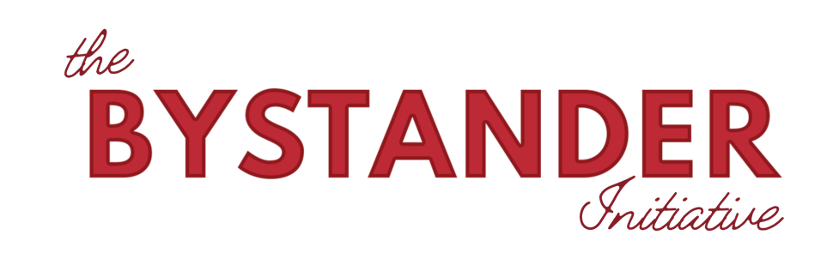
Prevent. Resist. Support. is the University of Windsor’s comprehensive campus-wide strategy for addressing campus-based sexual violence, and the Bystander Initiative is the prevention pillar of this strategy. Prevention is part of the University's ongoing efforts to foster respectful, inclusive, and safer learning and working environments across campus.

Bystander offers sexual violence prevention education through a 2.5 hr. on-line Canadian adaptation of the Bringing in the Bystander® workshop - an evidence-based, community strategy for preventing sexual violence.

In a highly interactive and supportive on-line learning environment, participants learn:

- the importance of bystander intervention before, during, and after an incident of sexual violence,
- how to overcome barriers to intervention, and
- how to effectively support survivors.

Participants who complete the training will earn a Certificate of Completion (can be added to enhance your resume or LinkedIn). Students may also receive course credit for taking a workshop in designated classes (workshop integration will be noted in participating course syllabi, where you can find additional details).

Register for a Bystander workshop on UWindsor’s mySuccess through the Prevent.Resist.Support EVENTS calendar!
To learn more about Bystander, including undergraduate courses (the most cross-listed courses on campus), visit the Bystander Initiative website.
If you have experienced sexual violence or have had any unwanted experience of a sexual nature, you deserve support. The Office of Sexual Violence Prevention, Resistance, and Support (OSVPRS) provides confidential support to the UWindsor community (including both students and employees). The OSVPRS can also help if you are looking for guidance on how to support someone else.

You can reach the OSVPRS by email at svsupport@uwindsor.ca

For more information you can visit the Support page of the OSVPRS website.

