

Graduate Supervision Resources
  - Your Guide to Downloadable and Linked Resources
  - for Graduate Supervision

Created by Stacia Heaton & Tracy Bhoola

CONTENTS
03  Welcome | 04  Principles for Graduate Supervision at Ontario Universities
06  Resources for Graduate Supervisors | 12  Resources for Graduate Students
17  Resources for Graduate Committees, Departments & Universities | 19  Selected Research  22  Contacts

Welcome

Welcome to Graduate Supervision Resources: Your Guide to Downloadable and Linked Resources for Graduate Supervision. This flipbook was created as a practical, user-friendly resource to support graduate supervisors, students, supervisory committees, departments, and institutions in fostering successful graduate education. Whether you are new to graduate supervision or an experienced faculty member seeking to refine your approach, this guide offers curated materials that reflect best practices and evolving expectations in graduate supervision across Ontario and Canada and align with the Principles for Graduate Supervision at Ontario Universities.
Each section includes downloadable PDFs and links to toolkits, guidelines, and evidence-based resources you can use directly in your supervisory work or share within your program or department. Organized by key themes in supervision, the flipbook is designed for ease of navigation and ongoing reference. By sharing and circulating these resources, we aim to build a culture of mutual learning, collegiality, and continuous improvement in graduate education. We invite you to explore, download, adapt, and share these materials as part of your own commitment to fostering respectful, inclusive, and effective supervisory relationships.
We invite you to contribute to this growing community by sharing open-access resources and practical tools from your own supervisory experience. Your insights help strengthen our collective efforts to support inclusive, ethical, and effective supervision practices across institutions.
Stacia and Tracy

Principles for Graduate Supervision at Ontario Universities
High quality academic supervision is a key driver of graduate research-based education and is central to ensuring a positive and successful graduate student experience. Respectful and productive relationships between supervisors and graduate students promote a thriving university research culture where students are supported to make meaningful contributions to their fields of specialization.
A good working relationship between supervisors and graduate students is built on common expectations and trust, and incorporates principles of academic integrity, freedom of inquiry, and expression free of any form of discrimination, intimidation, or harassment.
While it is important to acknowledge that graduate students are partners in the university research enterprise, it is equally important to recognize that the supervisor is the senior partner. Both the graduate supervisor and the graduate student have certain rights and responsibilities within the context of the supervisor–student working relationship. The best student outcomes occur when supervisors provide leadership and guidance that is respectful of the student’s personal and professional goals.
Although the graduate student bears the primary responsibility for their program success and intellectual growth, the onus is on the department, program, supervisor, supervisory committee, school/faculty of graduate studies and the university to foster an environment that is supportive of the inherent dignity and value of the supervisor and student and supports student success. The document outlines the responsibilities and standards of conduct for individuals and groups involved with graduate student supervision in research-oriented programs.
All parties responsible for graduate supervision are expected to adhere to the core values of graduate education, including:
- Integrity: All parties should hold themselves accountable to the highest standards of intellectual and personal integrity.
- Inclusion: Diversity is a driving force for academic excellence, and all parties should commit to fostering inclusive environments that respect diverse perspectives and backgrounds.
- Collaboration: Working collaboratively helps everyone remember that they are united in a common purpose


Supervisor Resources


Resources for Graduate Supervisors

Best Practices
Best Practices in Graduate Education | Western University
Best Practices in Mentorship | Wilfred Laurier University
Best Practices for Remote Supervision | Memorial University
Best Practices for Supervisors | University of Calgary
Best Practices- Supervisors of Grad Students with Family Responsibilities | University of Toronto
Characteristics of an Effective Supervisor | York University
Educator’s Accessibility Toolkit | Council of Ontario Universities
Graduate Research Studies Guide to Good Practices | Sherbrooke University
Good Practice in Supervision & Mentoring Postgrad Students | McMaster University
Indigenous Community Research Partnerships | Group for Ethics & Engagement in Indigenous Community Research Partnerships
Improving Supervisory Practice and Ideas for Reflection | McGill University
Interview Questions for Prospective Students | Brock University
Principles of Excellent Graduate Supervision: The UBC Guide | University of British Columbia
Supportive Listening | York University
Video: Mentorship in Graduate Supervision | McGill University

Expectations and Responsibilities Checklists

Discussion
Discussing Important Topics & Setting Mutual Expectations | Wildred Laurier University
Discussion Points for a Healthy Working Relationship between Students and Thesis Directors (Supervisors) | University of Ottawa
Discussion Topics to Inform Productive Supervisory Relationships | York University
Quick Tips for Difficult Conversations | York University
Supervisor Student Discussion Checklist | Toronto Metropolitan University

Expectations
Checklist of Expectations for Graduate Supervisors and Students | University of Calgary
Clarifying Expectations and Ideas for Reflection | McGill University
Concordia Student and Supervisor Framework | Concordia University
Expectations of Research Supervision | Brock University
Expectations of a Graduate Supervisor | University of Calgary
Getting the Supervisory Relationship off to a Good Start | McMaster University
Graduate Supervision Responsibilities & Expectations | Carleton University
Managing Mutual Expectations | University of Windsor
Productive Supervisory Relationships: Making Assumptions Explicit | Queen’s University
Setting Expectations Guide – Workbook | Queen’s University
Strong Start to Supervision Checklist | York University
Supervisor Checklist | Ontario Tech University
Student and Supervisor Checklist | University of New Brunswick
Supervisor and Student Expectations Checklist | Brock University
Student and Supervisor Responsibilities | Brock University

Intellectual Property
Copyright and Intellectual Property Checklist | Carleton University
Intellectual Property Awareness Checklist | University of Calgary
Intellectual Property Checklist | Brock University
Intellectual Property Checklist | York University
Intellectual Property Guidelines for Graduate Students and Supervisors | University of Toronto

Forms and Templates
Expectations Fillable Tool | McMaster University
Intellectual Property Form | Brock University
Plan of Study | Toronto Metropolitan University
Progress Tracking Form | McGill University

Guides and Guidelines
Communication Guidelines | McGill University
Creating Inclusive Campuses | Conference Board of Canada
Commentary 100 Ways: Indigenizing & Decolonizing Academic Programs | University of Regina
Decolonizing Academic Integrity: Knowledge Caretaking as Ethical Practice | University of Alberta
Effective Mentorship of Racialized Graduate Students | The University of British Columbia
E-thesis Format Specifications | Brock University
Faculty Guide: Resources for Supervision at McMaster | McMaster University
Faculty Resource Guide: Teaching Students with Disabilities | York University
Feedback and Ideas for Reflection | McGill University
FGS Graduate Supervision Guidelines | York University
Generative Artificial Intelligence Guide | University of Saskatchewan
Guide to Mentoring Graduate Students Across Cultures | Western University
Guidelines for Effective Remote Supervision | Queen’s University
Guidelines for Nominal Co-Supervision | Carleton University
Graduate Supervision Guidelines | Toronto Metropolitan University
The Indigenous Knowledge Implementation Packsack: A Handbook for Embedding Indigenous Ways of Knowing in Your Teaching | Negahneewin Research Centre
Information for Supervisors Regarding PhD Defences and External Examiners | University of Waterloo
Masters Supervisor Guidelines | Concordia University
PhD Supervisor Guidelines | Concordia University
Resolving Conflict in the Graduate Student/Supervisor Relationship | University of Calgary
Step-by-Step Guide for Keeping Track of Grad School Activities | Brock University
Student Accessibility Services Faculty Resource Guide | York University
Thesis Dissertation Format Guidelines | York University
Tracking Student Progress | McGill University
Using Zoom for Defences and MRP Presentations | Toronto Metropolitan University

Mental Health Supports and Student Concerns
Graduate Student Concerns | Toronto Metropolitan University
How Are You Feeling? | York University
Navigating Grad Student Concerns | Queen’s University
Supporting Students in Distress: A Response Guide for Graduate Supervisors | York University
Well-being Through the Supervisory Process: Supervisor Guide for Action | Simon Fraser University
Where Can You Go For Help? | York University

New to Supervision
New Supervisors Practical Advice and Ideas for Reflection | McGill University
Strong Start to Supervision Checklist | York University
Supervision for Supervisors | University of British Columbia

Policies and Principles
Graduate Studies Supervision Policy | OCAD
Monitoring Progress | Brock University
Oral Defence Examination Regulation | Nipissing University
Policy on Appointment of an External Examiner | University of Northern British Columbia
Principles of Excellent Graduate Supervision: The UBC Guide | University of British Columbia

Professional Skills Development & Training
Graduate Professional Skills Guide | York University
Individualized Development Plan (IDP) | York University
Supervisor Series: Basecamp | Ontario Tech University

Timelines
Arts Backwards Planning Tool and more faculty examples | University of Waterloo
Defence Timelines | Toronto Metropolitan University
Doctoral Defence Timelines | York University
Doctoral Timeline Guide | Ontario Tech University
Masters Timeline Guide | Ontario Tech University
Sample Program Timeline Gantt Charts | University of Lethbridge
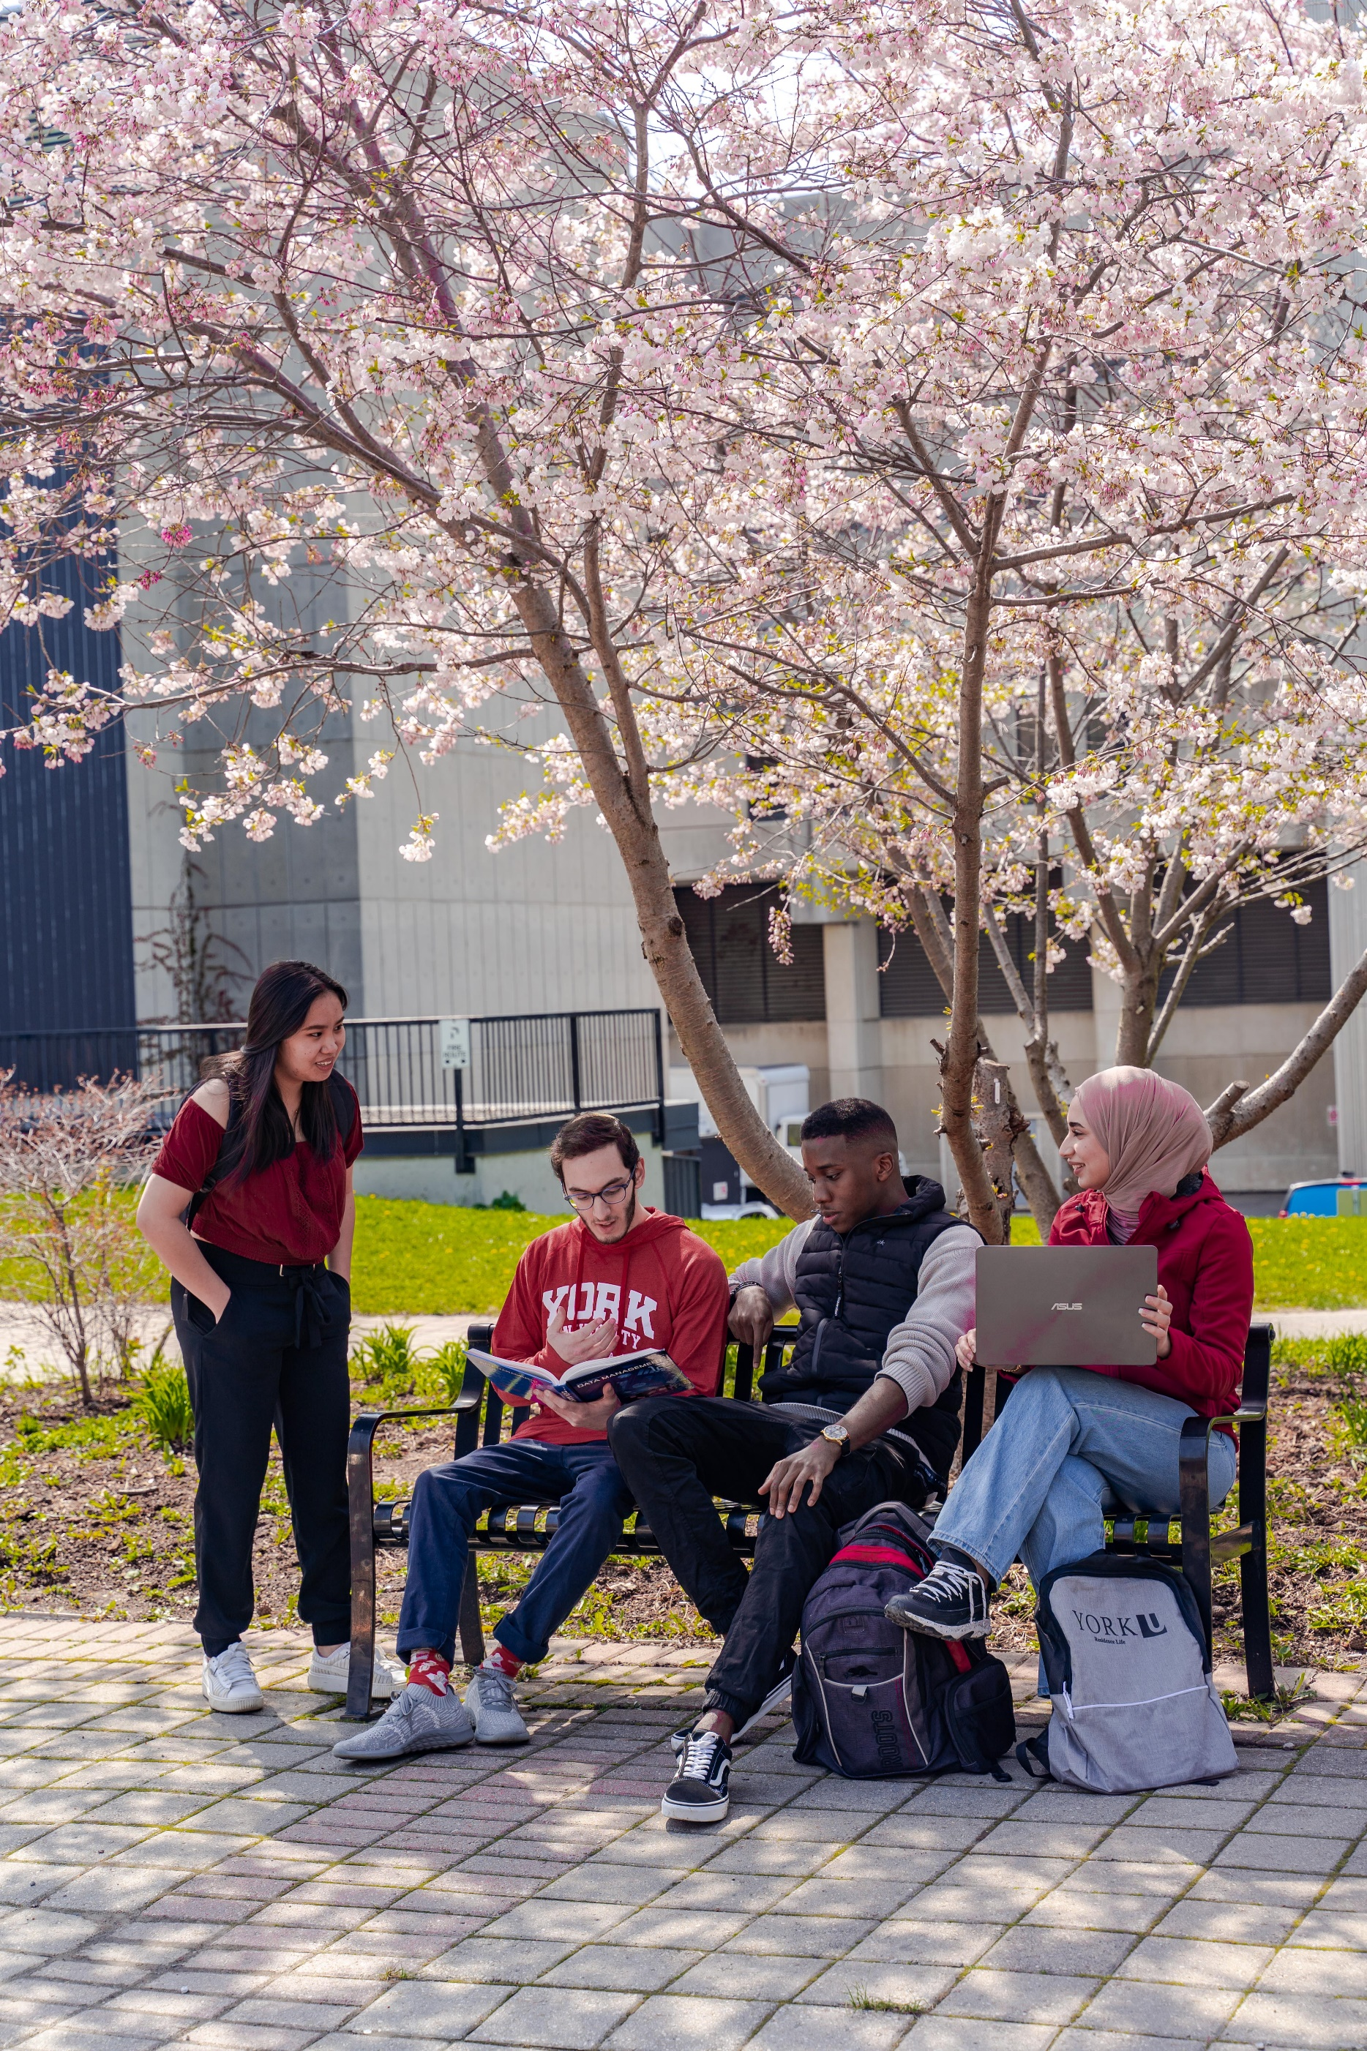

Student Resources

Resources for Graduate Students

Best Practices
Best Practices for Remote Supervision | Memorial University
Interview Questions for Prospective Students | Brock University
Questions to Ask a Supervisor | University of Ottawa
Responsible Conduct and Ethics in Research | Université Laval

Checklists and Guidelines
How to Choose a Supervisor | University of Toronto
How to Select a Research Topic | Carleton University
Intellectual Property Awareness Checklist | University of Calgary
Intellectual Property Guidelines for Graduate Students and Supervisors | University of Toronto
Manuscript Style Thesis Guidelines | Toronto Metropolitan University
Student and Supervisor Checklist | University of New Brunswick
Thesis MRP Dissertation Guidelines | Toronto Metropolitan University
When to Choose a Research Supervisor and a Supervisory Framework | Université de Montreal

Expectations and Responsibilities
Checklist of Expectations for Graduate Supervisors and Students | University of Calgary
Checklist for Masters/PhD Students: Completing Degree Requirements | University of Victoria
Concordia Student and Supervisor Framework | Concordia University
Discussing Expectations and Ideas for Reflection | McGill University
Discussion Points for a Healthy Working Relationship between Students and Thesis Directors (Supervisors) | University of Ottawa
Expectations of a Graduate Student | University of Calgary
Graduate Supervision Guidelines for Students | University of Toronto
Graduate Student Rights and Responsibilities | Brock University
Productive Supervisory Relationships: Making Assumptions Explicit | Queen’s University
Setting Expectations Guide – Workbook | Queen’s University
Student and Supervisor Responsibilities | Brock University
Supervision for Students | University of British Columbia

Funding
Watch Demystifying Funding: A Guide for Prospective Graduate Students Video | University of Waterloo
Grad Student Funding Guidelines Full Time Employment and Vacation | Toronto Metropolitan University

Handbooks and Resources
Accessibility for Students | Ontario Universities
Communicating with Your Supervisor | McGill University
Conflict Resolution | McGill University
Equity, Diversity and Inclusion Resources | Ontario Universities
Feedback and Self-Assessment and Ideas for Reflection | McGill University
Indigenous Studies Graduate Student Handbook 2022-23 | University of Manitoba
Graduates Facing Misconduct | Brock University
Graduate Handbook | Athabasca University
Indigenous Student Resources | Ontario Universities
Navigating Graduate Student Concerns | Queen’s University
Oral Defence Examination Regulation | Nipissing University
Staying on Track | McGill University
Theses Canada | Government of Canada
Understanding Intellectual Property | University of Waterloo

Mental Health Supports
How Are You Feeling? | York University
Graduate Students Mental Health and Wellbeing: A Toolkit | Canadian Federation of Students
Well-being Through the Supervisory Process: Graduate Student Guide for Action | Simon Fraser University
Where Can You Go For Help? | York University
Work-life Balance | McGill University

New to Graduate Studies
Beyond the Research: Navigating Graduate Supervision as a First-Generation LGBTQIA2S+ Student | Memorial University
Watch Finding a Supervisor: A Guide for Prospective Graduate Students | University of Waterloo
Watch How to Write a Statement of Interest | York University
Pathways to Success: Navigating Graduate School and Canadian Culture | York University
Preparing for the Canadian Classroom | York University
10 Things I Wish I had Known Before I Started My PhD blog | University of British Columbia
When to Choose A Supervisor | Université de Montréal

Professional Development
Developing Transferrable Skills Framework | McGill University
Grad Pro Skills | Concordia University
Graduate Postdoctoral and Professional Skills (GPPS) | York University
National Black Graduate Network | NBGN

Templates and Timelines
Graduate Student Planner | Brock University
Meeting Agenda Template | York University
Meeting Notes Template | York University
Plan of Study | Toronto Metropolitan University
Thesis Defence and Documents | Brock University
Timelines for Milestones | McGill University
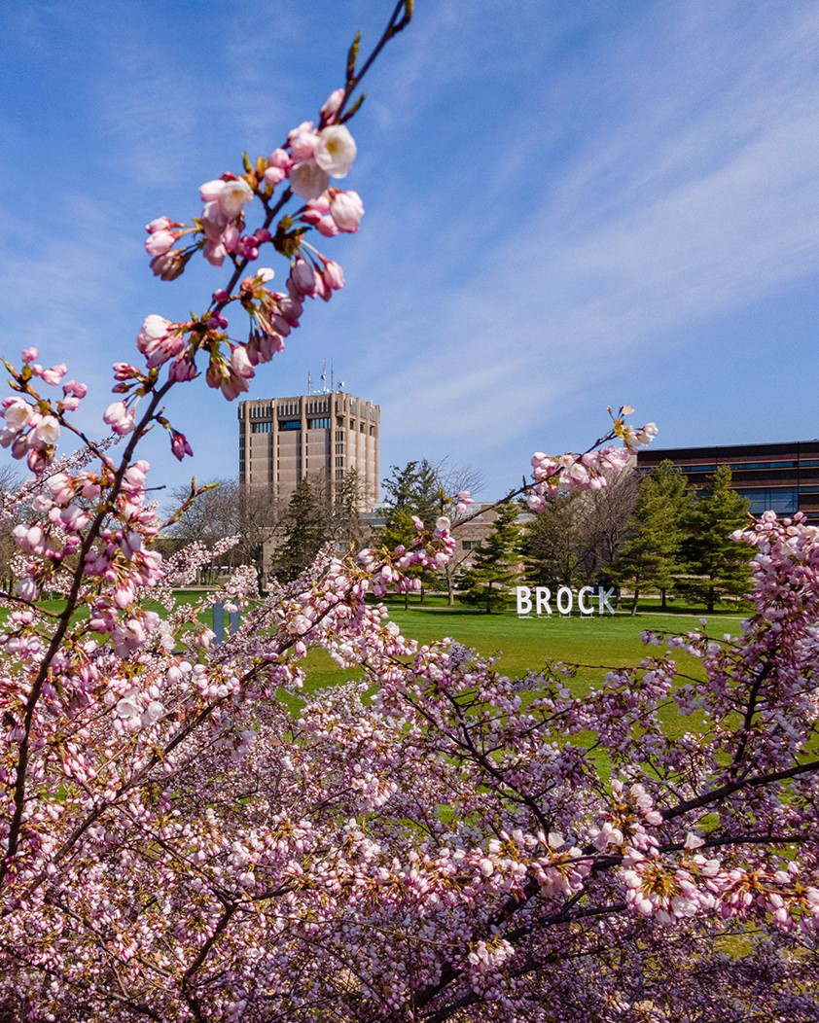

Committees, Departments, Universities Resources

Resources for Students

Resources for Graduate Committees, Departments, Universities

Advisory Committee Meetings: Roles and Expectations | Western University
Best Practices for Graduate Units | University of Toronto
Best Practices for Supervisory Committees | University of Calgary
Decolonizing Academic Integrity: Knowledge Caretaking as Ethical Practice | University of Alberta
Decolonizing Higher Education in Canada | UNESCO Canadian Commission
Grad Student Committee Meeting: Quick Reference Guide | University of Saskatchewan
Policy on Responsibilities of Advisors & Advisory Committees | University of Guelph
Roles and Responsibilities of Advisory Committees | University of Waterloo
Roles and Responsibilities of Departments | University of Waterloo
Supervision | University of British Columbia
Supervisory Committee and External Examiner Policy | Nipissing University
Supervision Guidelines for Programs | McMaster University
Supervision Guidelines for Supervisors | McMaster University
Supervision Guidelines for the Supervisory Committee | McMaster University
Top 10 Best Practices for Graduate Units: Improving Doctoral Program Time to Completion | University of Toronto
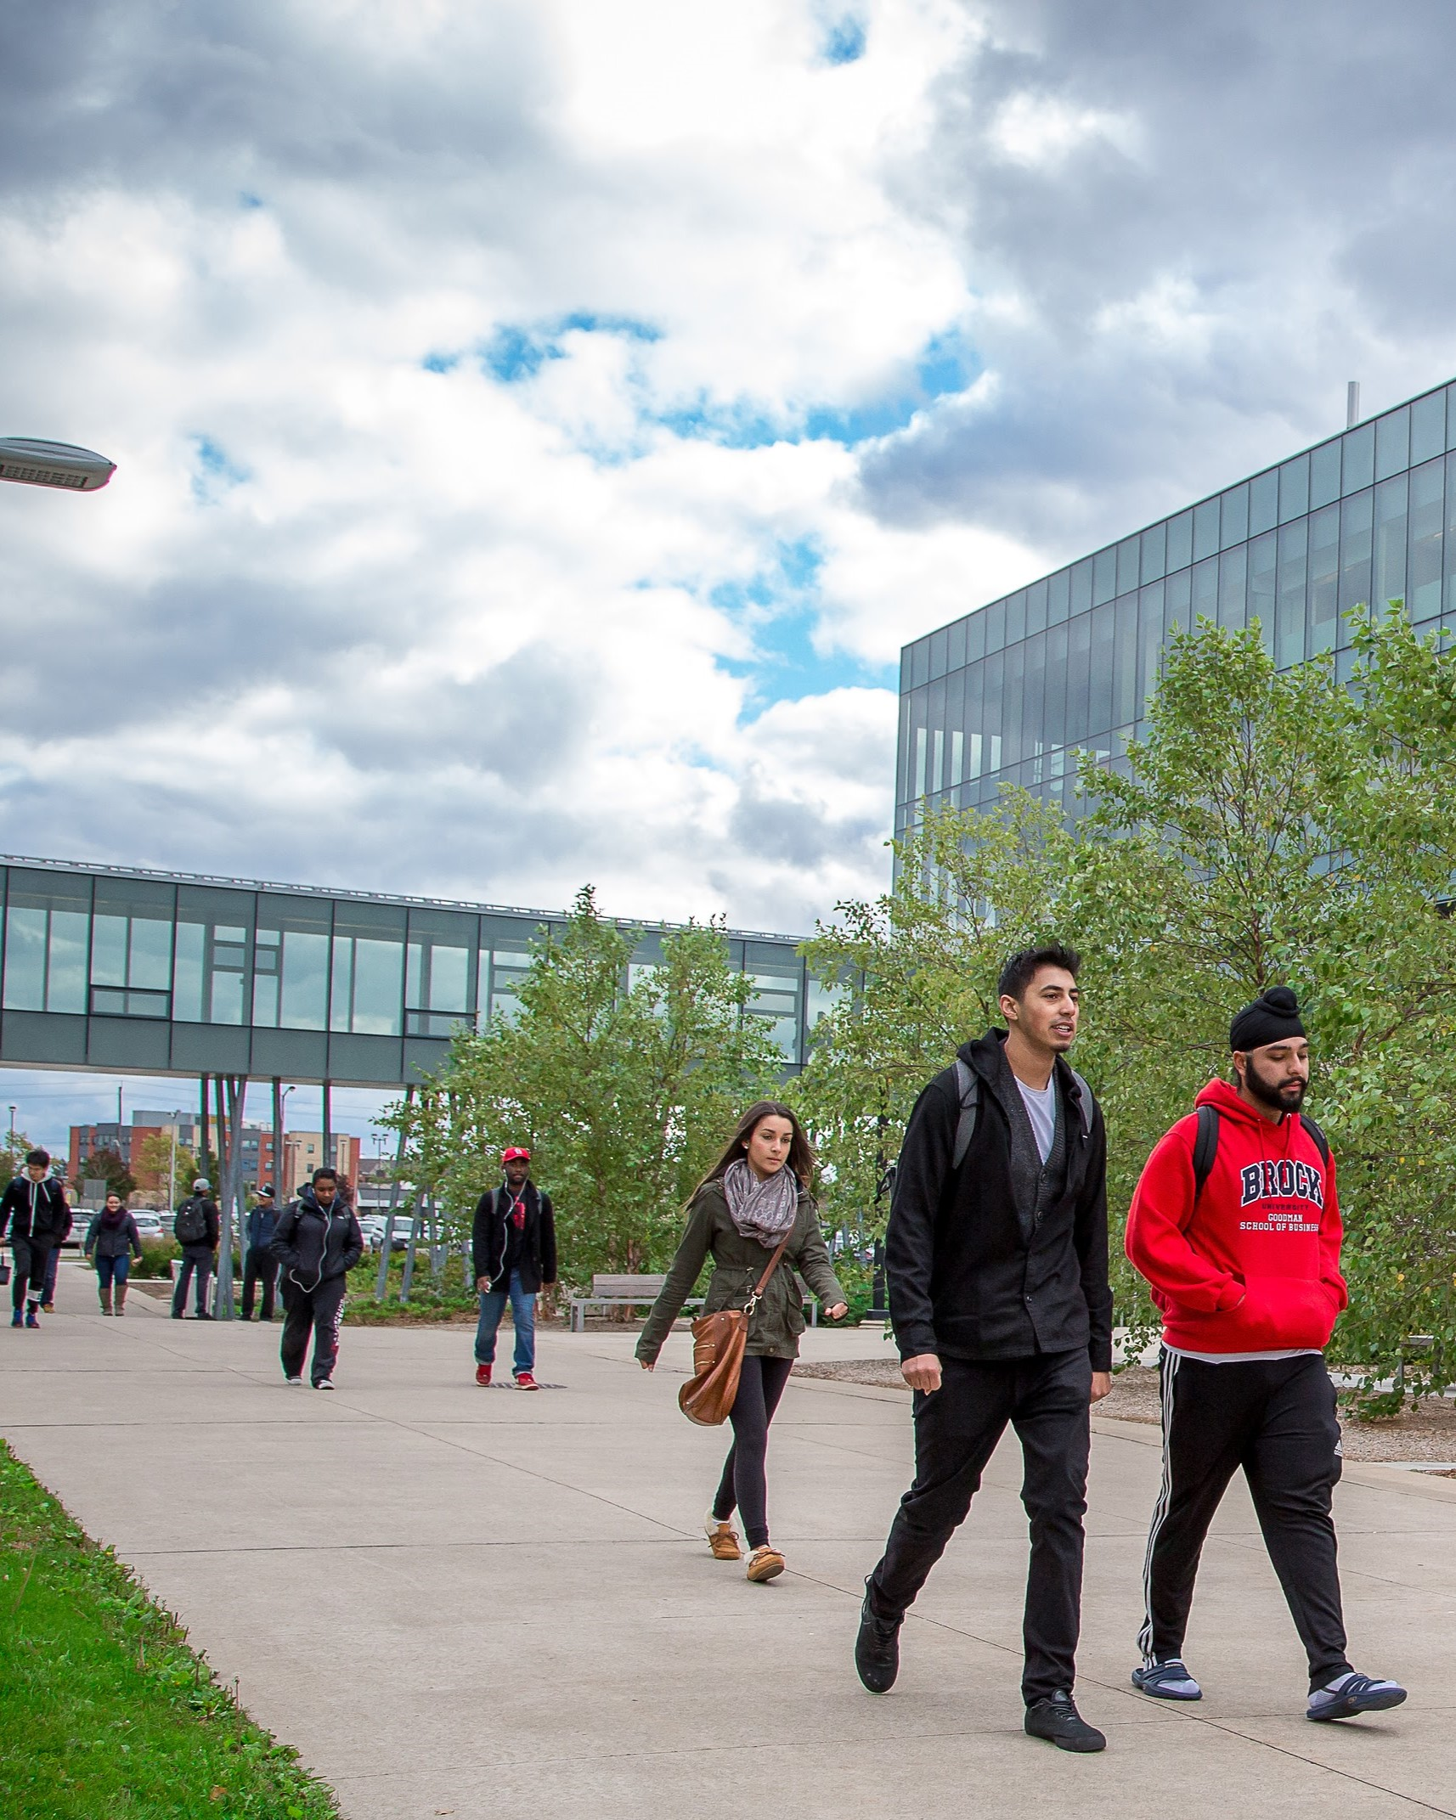

Selected Research

Selected Research

A Snapshot of the Experiences of Graduate Students with Disabilities who Identify as Aboriginal | NEADS
Breaking Grad: Building Resilience Among a Sample of Graduate Students Struggling with Stress and Anxiety via a Peer Coaching Model – An 8-Month Pilot Study | Western University
Conflict Between International Graduate Students and Faculty  Supervisors: Toward Effective Conflict Prevention and Management Strategies | University of Alberta and University of Saskatchewan
Confronting and Reimagining the Orientation of International Graduate Students: A Collaborative Autoethnography Approach | Universities of Regina, British Columbia, Fraser Valley, Laval and Ottawa
Educational Development for Quality Graduate Supervision | University of Calgary
Effective Mentorship of Racialized Graduate Students (EMRGS) | University of British Columbia
Graduate students as partners in academic development: Benefits, Challenges, and Lessons Learned | University of Calgary
Great Mentoring in Graduate School: A Guide | Council of Graduate Schools
How to Support Black Students in the Classroom | McMaster University
“I Am Not Complaining”: Listening to  International Students’ Requests and Complaints  as Expressions of Diverse Learning Needs | University of Calgary & Yorkville University
Making the Invisible Visible: Neurodivergent Students’ Experiences in Canadian Higher Education | Conference Board of Canada
Mentor Us: A Formal Mentoring Program for Nurses in Graduate Education | University of Alberta
Online supervision in a professional doctorate in education: Cultivating relational trust within learning alliances | University of Calgary
Professional Learning and Development Framework for Postdoctoral Scholars | University of Calgary
Reciprocal Mentorship as Trans-Systemic Knowledge: A Story of an Indigenous Student and a Non-Indigenous Academic Supervisor Navigating Graduate Research in a Canadian University | Christine Webster, Kathy Bishop
Reconciliation in Canadian Indigenous Graduate Education: Report for the Canadian Association for Graduate Studies 2020 | Melanie Braith, Mavis Reimer, and Jo-ann Archibald Q’um Q’um Xiiem
Relationships Matter: Supporting Aboriginal Graduate Students in British Columbia, Canada | Simon Fraser University & University of British Columbia
The Role of Intercultural Competence on Graduate Supervisor-Supervisee Relationship and Well-Being | University of Calgary
Understanding Accessibility in Graduate Education for Students with Disabilities in Canada: Final Report of The National Graduate Experience Taskforce | The National Educational Association Of Disabled Students


Contacts in Graduate Studies

Contacts

Ontario
Stacia Heaton | sheaton@brocku.ca | Manager Graduate Student Success | Brock University | Faculty of Graduate Studies
Tracy Bhoola | tbhoola@yorku.ca | Manager Graduate Supervision Support Hub | York University | Faculty of Graduate Studies
Andrea Cole | coleand@mcmaster.ca | Coordinator, Recruitment, Retention & Diversity | McMaster University | School of Graduate Studies

Outside of Ontario
Emily Pitcher | emily.pitcher@ubc.ca | Associate Director of Student Academic Support | University of British Columbia | Faculty of Graduate and Postdoctoral Studies
Megan Hebert | hebertm@uleth.ca | Manager, Graduate Student Engagement | University of Lethbridge | Faculty of Graduate Studies
Renee Polziehn | rpolzieh@ualberta.ca | Director of Professional Development | University of Alberta | Faculty of Graduate Studies and Research
Ross Swanson | ross.swanson@mcgill.ca | Academic Projects Manager | McGill University | Faculty of Graduate Studies
Krystal Zahara | krystalz@athabascau.ca | Coordinator, Graduate Thesis and Academic Records | Athabasca University | Graduate Studies

