Dear Well-wisher,

On September 25, 2021, at 8:00 AM, the University of Windsor Women’s Basketball Team will be hosting the first annual UWindsor Women's Basketball Golf Fundraiser at Ambassador Golf Club (1025 Sprucewood Ave, Windsor, ON)

Our event is intended to bring together people from all stages of leadership and all phases of life and career, to inspire and motivate our young and budding leaders. Our goal is to reconnect with the community and well-wishers of our Lancer Basketball team.

Apart from the 18 hole golf course coupled with multiple prizes and team events, there will be opportunities to learn, network, connect and meet with our coaches, current players, newcomers to the team. This event will also feature a Silent auction and a Raffle draw where our guests can bid on and win exciting prizes

All of the money raised will go into further empowering women, by helping fund our elite basketball program which includes coaching mentorship, and scholarships for our athletes. Our program allows our female athletes to be successful both on and off the court.

For us to accomplish our goals, we graciously ask if you would be able to sponsor our event. We offer a tiered sponsorship model; Title Sponsor “Bronze Baby Trophy”, Gold, Silver, and Blue level. Moreover, We also offer additional sponsorship opportunities such as food and beverages and raffle/silent auction item donations.

We hope that we can count on your help to make this year’s event one of our best yet. If you are interested or have any questions please contact the fundraising coordinators Alexa Neal and Aman Thomson at :

[neal5@uwindsor.ca](mailto:neal5@uwindsor.ca)

[thomso21@uwindsor.ca](mailto:thomso21@uwindsor.ca)

Sincerely,

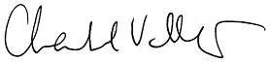

Chantal Vallée

Head Coach-Women's Basketball

University of Windsor

5-PEAT National Champions

2011, 2012, 2013, 2014, AND 2015

**Women’s Basketball Lancer Golf Tournament Sponsorship Opportunities**

*All sponsorships include :*

* Company featured on the event sponsor board and signage at event

|  |  |  |  |  |
| --- | --- | --- | --- | --- |
| **Corporate Sponsorship Packages** | | | | |
| **Sponsorship Level Line arrow Straight** | Title Sponsor “Bronze Baby Trophy” | Gold | Silver | Blue |
| **Line arrow Straight Cost** | $2500 | $1000+ | $500+ | $300+ |
| Lead Sponsor branding with company logo featured on display materials and Event Promotions |  |  |  |  |
| Complimentary Golf Foursome |  |  |  |  |
| Complimentary Golf Twosome |  |  |  |  |
| Tee Hole Sponsorship |  |  |  |  |
| Signage in the registration area |  |  |  |  |
| Opportunity to set up a corporate tent on the course |  |  |  |  |
| Special Mentioning in Women’s Basketball Newsletter and Social Media Pages |  |  |  |  |
| Opportunity to place promotional item in Golfer Gift bag |  |  |  |  |
| Letter of Acknowledgment and Exclusive team merchandise |  |  |  |  |
| Opportunity to sponsor a Prize at a hole |  |  |  |  |

ADDITIONAL SPONSORSHIPS

**Food and Beverage Sponsorship- in kind or $300-$500**

* Company name at the food table and on event poster board

**Raffle/ Silent auction Items - $100 or more**

* Company name announced at awarding of the prize, and throughout event promotions

Sponsorship Selection Form

***Please complete this form and send a cheque for the amount required to the address listed below. Select all sponsorship levels that you wish to provide:***

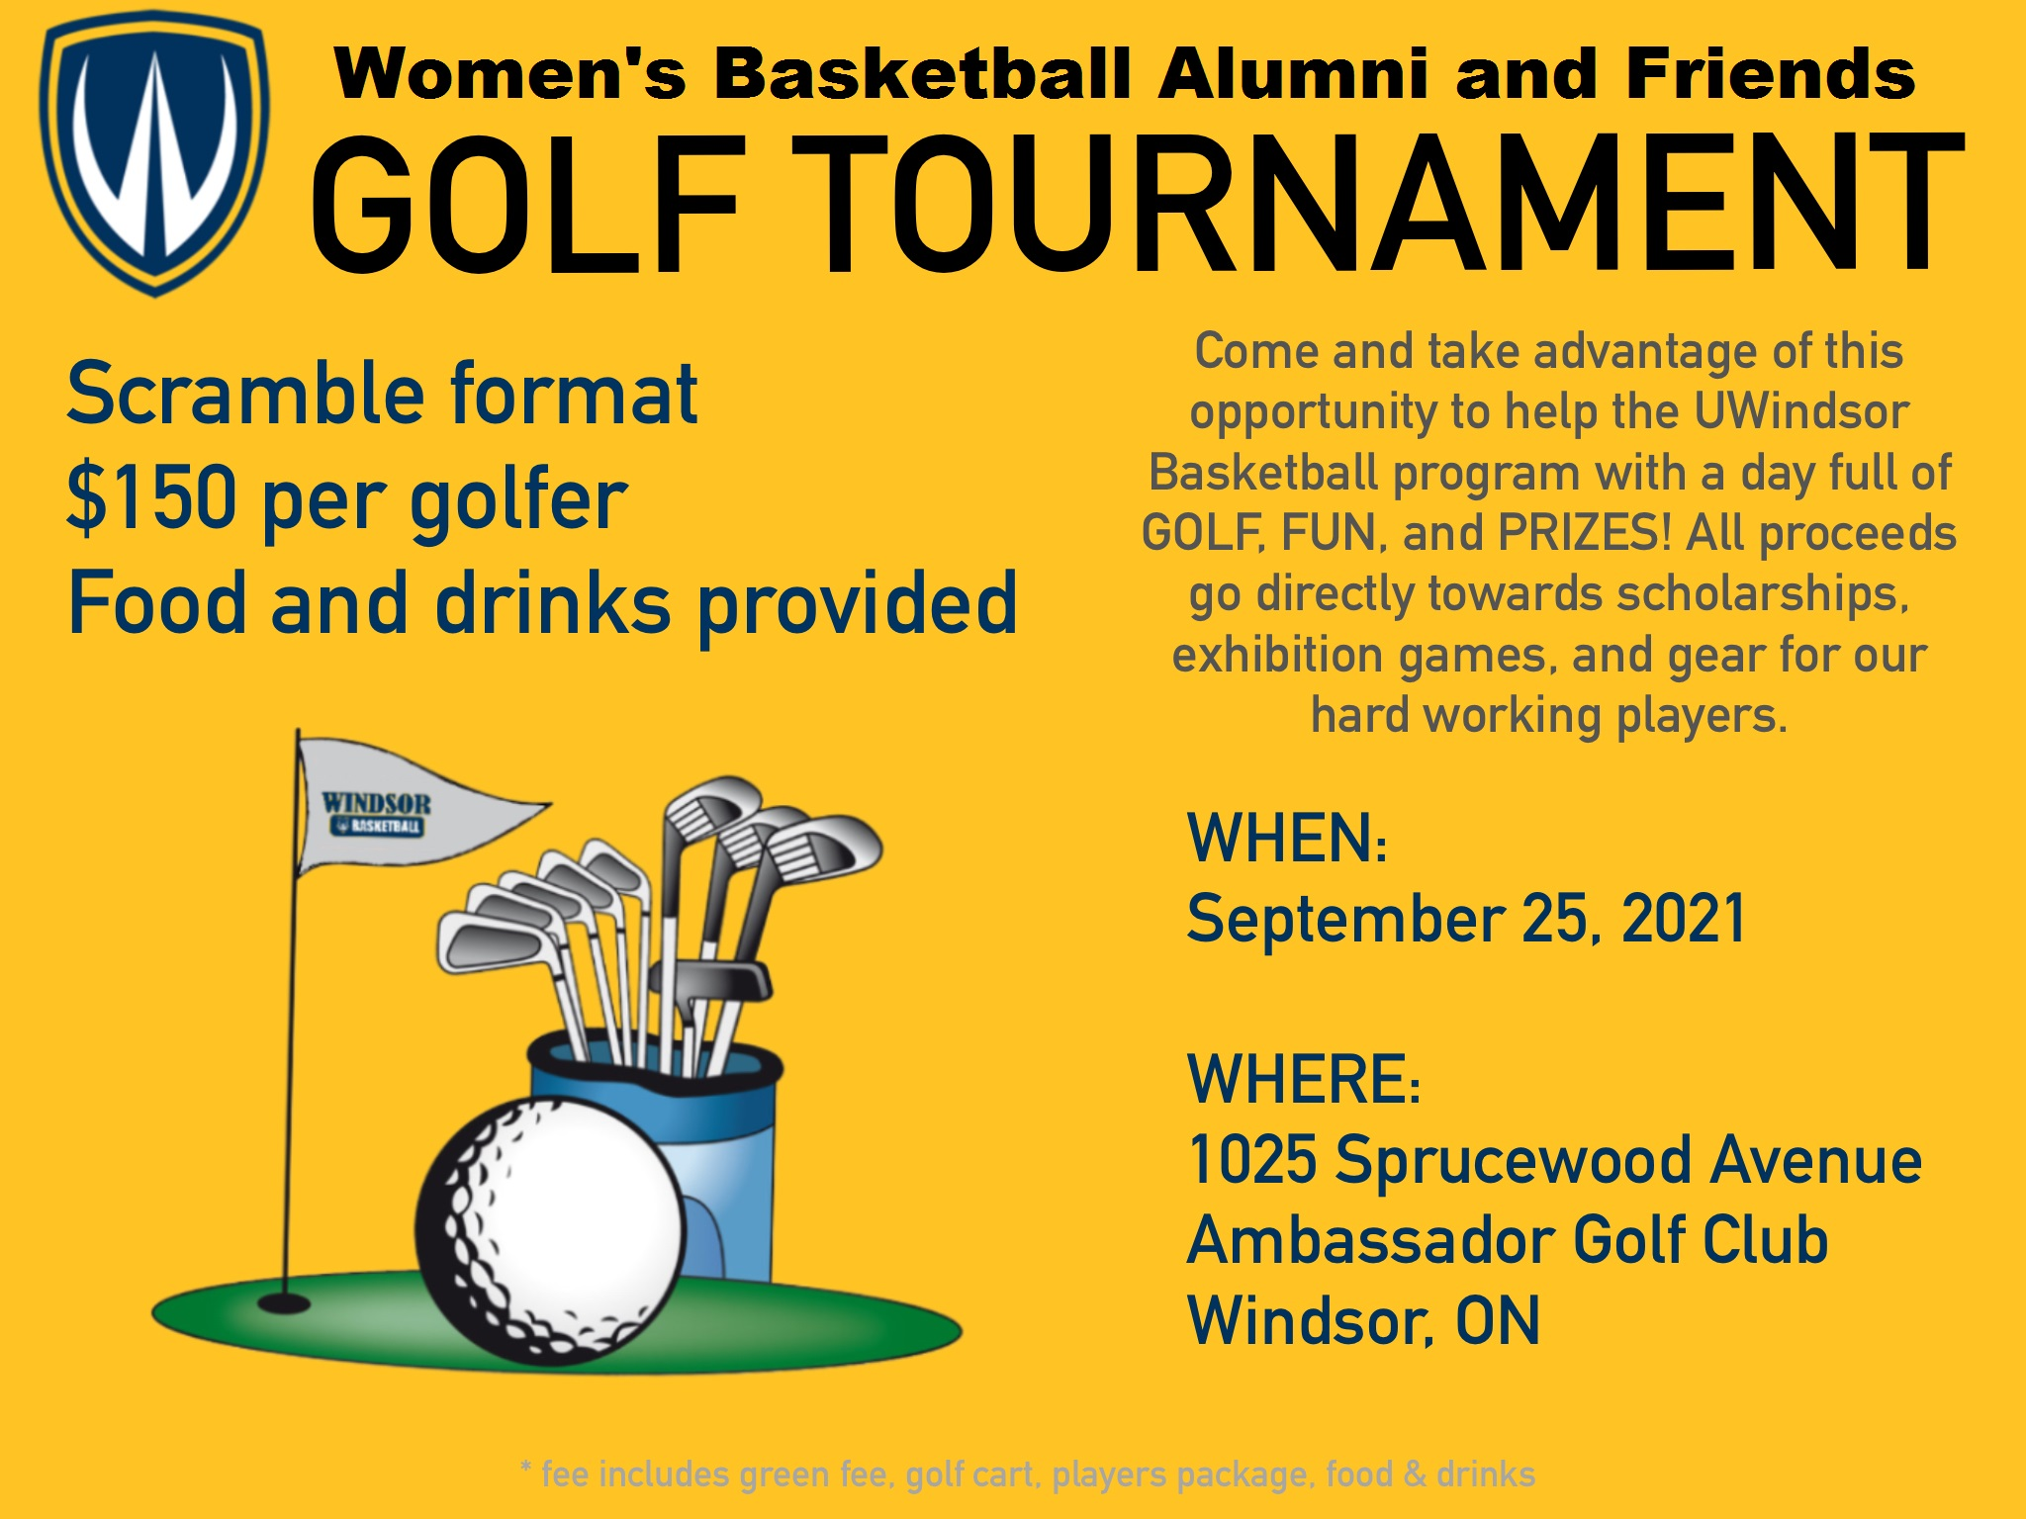

* Title Sponsorship “Bronze Baby Trophy” - $2,500
* Gold Level Sponsorship - $1,000+
* Silver Level Sponsorship - $500+
* Blue Level Sponsorship - $300+
* Food and Beverage Sponsorship- in kind or $300-$500
* Raffle/ Silent Auction item - $100 or more

Please indicate what prize you will be providing for the contest:

_

**Company Logo: Please email your company logo to** [**thomso21@uwindsor.ca**](mailto:thomso21@uwindsor.ca%20)  **or** [**neal5@uwindsor.ca**](mailto:neal5@uwindsor.ca) **in one of the following formats:**

**.gif, .jpg, .jpeg, .png, .tif, .ai or print ready .pdf**

Company Name:

Address:

Contact Person:

Email:

Phone: ______Fax:

Cheque Enclosed $

**\***Cheques should be made payable to the University of Windsor women's Basketball

**Address:**  ATT: Chantal Vallee, Department of Athletics, 401 Sunset Ave, N9B 3P4, Windsor, ON.

**Due before September 18, 2021**

**For more information please contact:**

**Alexa Neal, Fundraising Coordinator**

Women’s Basketball, University of Windsor

Phone : 514-348-3412, E-mail :

[neal5@uwindsor.ca](mailto:neal5@uwindsor.ca)

**Aman Thomson, Fundraising Coordinator**

Women’s Basketball, University of Windsor

Phone : 226-246-9990, E-mail :

[thomso21@uwindsor.ca](mailto:thomso21@uwindsor.ca)