How to Set Up a Journal TOC Alert Through Hein

U Windsor users may create your own account which can be used to monitor new journal articles.

- Create your own personal MyHein account which can be done once you are logged into HeinOnline. http://www.heinonline.org.lawlibrary.laws.uwindsor.ca/HOL/Welcome
- On the top right hand side of the welcome page there is a link to MyHein. From here you can create a personal account.

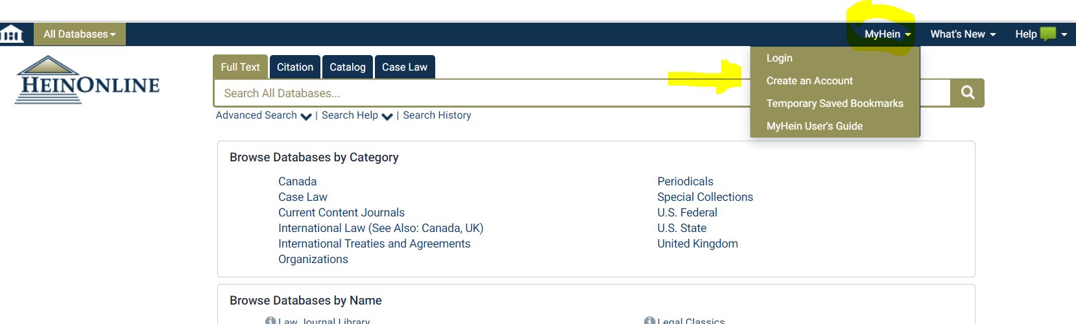

The MyHein registration page can be found at https://heinonline.org/HOL/MyHeinTest?controller=users&action=register_form&collection=.

- Create the eTOC alert. Visit MyHein Users Guide is located from this menu above, and at https://heinonline.org/HeinDocs/MyHeinUsersGuide.pdf.

- See Page 4 for information about creating an eTOC alert.

